Project Title: Foam Mitter Cloth
- Mitter cloth design that eliminates cloth being caught on rear wiper blade
- Patent Pending Design

Product Image:
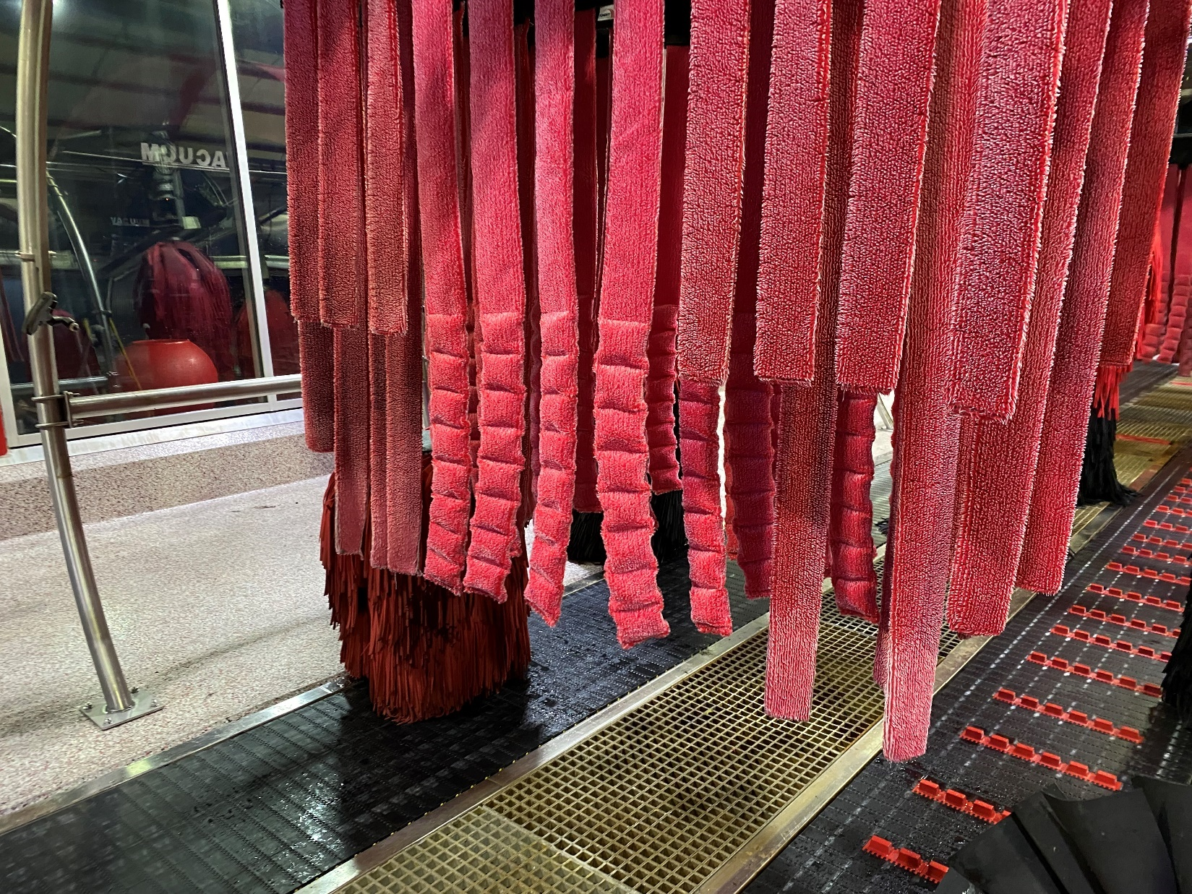

Project Background:
Why: Mitter cloth was getting caught behind wiper blades, leading to wiper blades being pulled from vehicles and damage claims. This improved product is designed to reduce or eliminate wiper claims.
Who: Project Lead: Andrew Kuper
What: Mitter cloth with foam inserts designed to prevent cloth from getting caught on rear wiper blades.
When: Available on webstore Q1 2022, Configurator release Q2 2022
Install Test Site(s): Hudsonville, MI; Waterloo, NE; LA114; FL57
Overview: 67” Mitter cloth is filled with stitched sections of foam in order to give the cloth structure and prevent it from sliding behind wiper blades. When applied in conjunction with proper wrap adjustments this significantly reduces damages claims related to wipers. For more information on wrap adjustments see Appendix C. This upgrade provides an option for sites wishing to reduce wiper damage claims without negatively impacting wash quality. P-MITTERCLOTH-67 replaces existing P-M2150-67 to prevent snagging and reduce wiper claims. Additional benefits include eliminating the need to bag rear wipers which eliminates a recurring cost, is more environmentally friendly, and increases safety for Team Members who no longer need to walk on the belt to bag wipers.

Criteria:
This mitter cloth may be used in all mitter curtain applications following the layout in Appendix A.

How to Order:
Part number P-MITTERCLOTH-67 should be ordered in the quantities needed per Appendix A. Each mitter curtain with this standard layout requires a quantity of 44.

PURCHASING: Please add note with cost information

Appendix A:

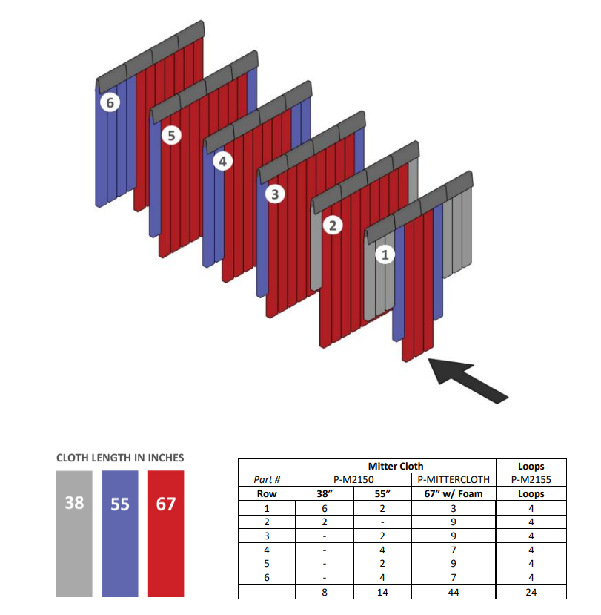

Appendix B:
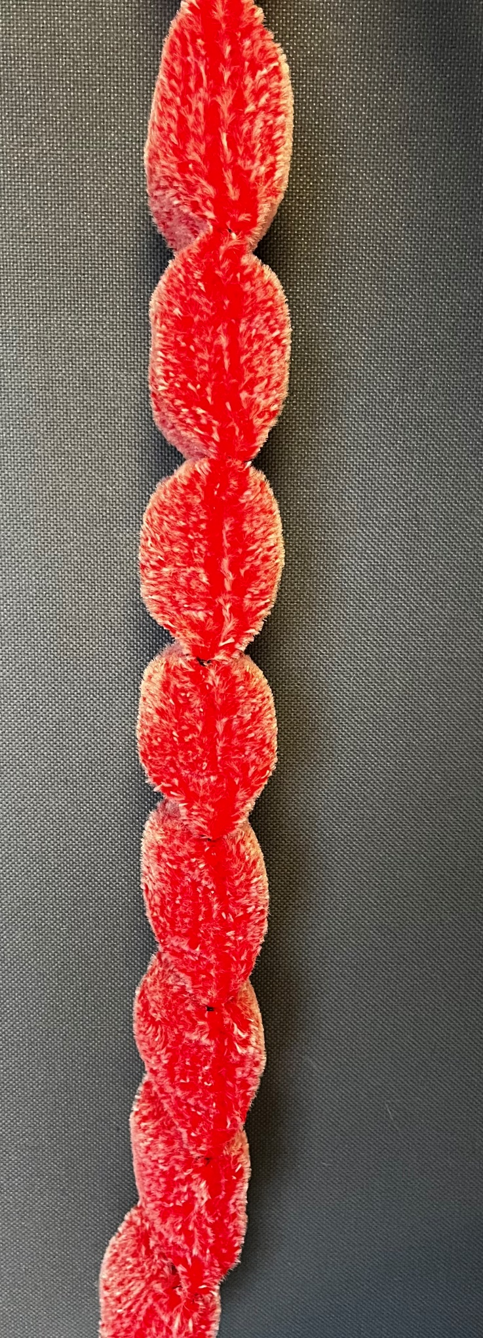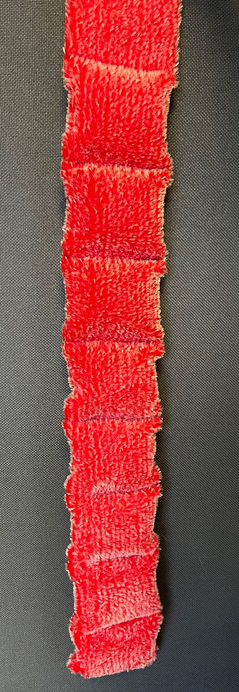

Appendix C:

NOTE: While P-MITTERCLOTH-67 is effective in reducing wiper claims related to mitter curtains, other wash components can still cause wiper damage. The next most common cause are combo wraps. In the event that wiper claims are still present after switching cloth out, please follow the troubleshooting steps below as needed:

- Adjust wrap bearings attached to combo frame
- Activate the air assist on the wrap during the swing around the rear of the vehicle to decrease arc swing length
- Adjust bump stop to decrease swing arc length

Test for function at each step, if Step 1 solves the issue it is not necessary to continue making adjustments.

