Project Title: Push Button Stations
- The new stainless-steel push-button station kits provide a new alternative to the plastic stations. The plastic stations had a high fail rate, due to cracking, poor seals, and breaking easily from daily use.
- The new station will be more durable, have a sleek new design, and will have a much better seal from water. These stations will directly replace the stations located on the PODs, and one on the wall (4 in total).
Product Image:
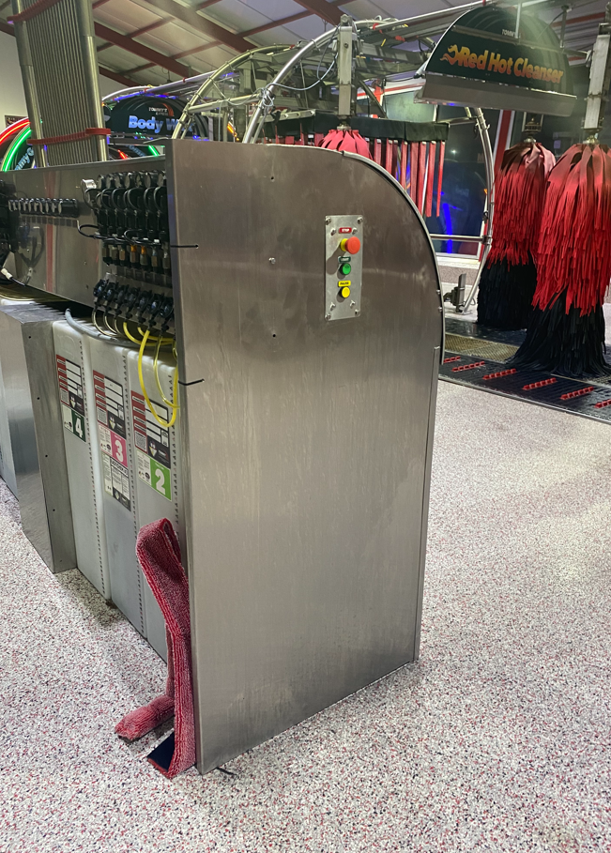

Project Background:
The push button stations are a change for more durability in the standard stations. They use all stainless-steel construction with a fully around gasket to prevent water leaks. The new push button stations also attach to the PODs in a unique way, utilizing the POD panels to provide a sleek, flush design. The stainless push button stations will directly replace the plastic versions that are currently part of the standard offering, which are mounted to each POD and wall. The retrofit kits are recommended for sites that are currently experiencing issues with the current push button stations.
Why: Providing a solution to failing plastic body push button stations
Who: Project Lead: David Bouwman
What: Stainless, watertight, push button station
Where: The retrofit kits are recommended for sites that are currently experiencing issues with the current push button stations. New 2022 sites will get the new version push button stations.
When: Retrofit kit target release date Q1 2022. Orderable in new washes Q1 2022.
Install Test Site(s):
Overview: There are 4 push button stations located at the Hudsonville TX site.
Criteria:
- May require an electrical contractor. It will be a low 24v line which can be done by experienced personnel.
- Retrofit kits are permanent and will not be able to go back to a plastic box.
How to Order:
- See Appendix A for a flow chart, on how to order push button stations.

Parts Affected:
- E-SE-C2058-a: Now is obsolete. Added to CCS-70174985-A and CCS-PODPBSS-A to replace these push button stations.
- CCS-FB3W-311Z: Now is obsolete and replaced with P-POD-PB-SS
- Versadial PODs- Franchise and non-Franchise PODs now include the push button stations.
  - Detergent POD: E-POD-DETER-A, TX-E-POD-DETER-A
  - Maintenance POD: E-POD-MAINT-A, TX-E-POD-MAINT-A
COST
- PRICE INCREASE REQUIRED: (Old style $115 per box)
  - TCWS Price
    - Detergent POD
      - Retrofit: $360.22
      - New: $321.76
    - Maintenance POD (start/stop AND fire hose)
      - Retrofit: $715.64
      - New: $648.32
    - Wall Mount: $321.76
    - Garage Door: $321.76

Appendix:

Appendix A: Ordering flowchart:

