MODEL 2900 Downflow

Service Manual

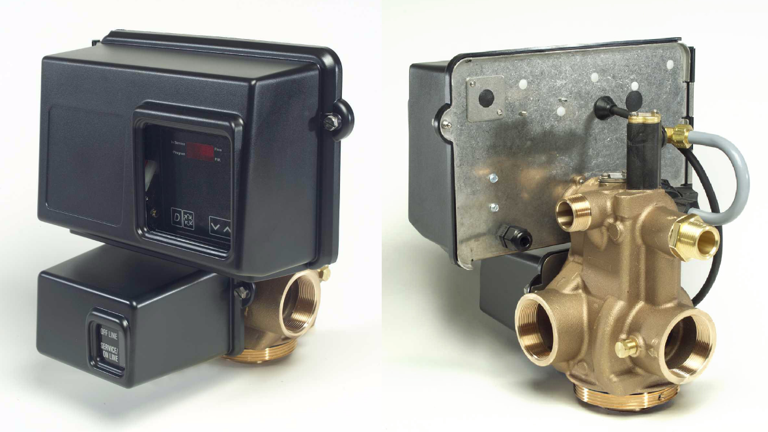

IMPORTANT: Fill in pertinent information on page 3 for future reference.

Table of Contents

General Commercial Pre-Installation Check List. 4
Installation Instructions 4

3200 Timer Setting Procedure 5
3210 Timer Settings 6

Regeneration Cycle Program Setting Procedure 7
3200 Timer Assembly 8

3210 Timer Assembly 10
Environmental Power Head 12

Lower Environmental Power Head 14
Designer Power Head 16

Lower Designer Power Head 18
Control Valve Body 20

1600 Brine System 22
1650 Brine System 23

1700 Brine System 24
1710 Brine System 26

2″ Meter Assembly 28
2″ Plastic Meter Assembly 29

2300 Safety Brine Valve 30
2310 Safety Brine Valve 31

2350 Safety Brine Valve 32
Service Valve Operator 33

Control Valve Side Mount Adapter 34
Service Assemblies 35

Service Instructions 36
Service Position 38

Backwash Position 39
Brine Position 40

Slow Rinse Position 41
Rapid Rinse 42

Brine Tank Fill Position 43
Flow Data & Injector Draw Rates 44

Environmental Backplate Line Drawing 46
Environmental Designer 47

System #4 - Typical Single Tank Installation With Optional Meter. 48
System #5 - Interlock - Typical Twin Tank Installation With Optional Meter Interlock

And No Hard Water Bypass 49
System #6 – Twin Series Regeneration 50

System #7 – Twin Alternator Installation 50
System #4-Single Valve Regeneration Immediate and Delayed Valve Wiring 51

System #4-With Remote Signal Start Valve Wiring 52
system #5-Interlocked Regeneration Valve Wiring 53

system #6-Series Regeneration Valve Wiring 54
system #7-Alternating Regeneration Valve Wiring 55

system #7-Alternating Regeneration Multi-Valve System Valve Wiring 56
IMPORTANT: The information, specifications and illustrations in this manual are based on the latest information available at the time of printing. The manufacturer reserves the right to make changes at any time without notice.

Job Specification Sheet
- JOB NO.
- MODEL NO.
- WATER TEST
- CAPACITY PER UNIT MAX. PER REGENERATION
- MINERAL TANK SIZE DIA. HEIGHT
- BRINE TANK SIZE & SALT SETTING PER REGENERATION:

- 2900 CONTROL VALVE SPECIFICATIONS
  - Type of Timer (see pages 18-21)
    - 7 day or 12 day
    - * 1,250 to 21,250 gallon meter or
      - 6,250 to 106,250 gallon meter
      - Other
    - Meter Wiring Package
- System #4 - 1 tank; 1 meter; immediate or delayed regeneration
- System #5 - 2 tanks; 2 meters; interlock
- System #6 - 2 tanks; 1 meter; series regeneration
- System #7 - 2 tanks; 1 meter; alternator
- Timer Program Settings (see pages 18 and 19)

  - Backwash
  - Brine & Slow Rinse
  - Rapid Rinse
  - Brine Tank Refill
- Drain Line Flow Controllergpm
min. min. min. min.

- Brine Line Flow Controller -
- Injector Size #
- A) Hard Water By-Pass
B) No Hard Water By-Pass

Page 3

Printed in U.S.A.

General Commercial Pre-Installation Check List

WATER PRESSURE: A minimum of 25 pounds of water pressure is required for regeneration valve to operate effectively.
ELECTRICAL FACILITIES: A continuous 110 volt, 60 Hertz current supply is required. Make certain the current supply is always hot and cannot be turned off with another switch.
EXISTING PLUMBING: Condition of existing plumbing should be free from lime and iron buildup. Piping that is built up heavily with lime and/or iron should be replaced. If piping is clogged with iron, a separate iron filter unit should be installed ahead of the water softener.
LOCATION OF SOFTENER AND DRAIN: The softener should be located close to a drain.
BY-PASS VALVES: Always provide for the installation of a by-pass valve.
CAUTION: Water pressure is not to exceed 120 p.s.i., water temperature is not to exceed 100° F, and the unit cannot be subjected to freezing conditions.

Installation Instructions

- Place the softener tank where you want to install the unit making sure the unit is level and on a firm base. (Maximum 4 feet apart for twin units.)
- All plumbing should be done in accordance with local plumbing codes. The pipe size for the drain line should be the same size as the drain line flow control female connection. Water meters are to be installed on soft water outlets. Twin units with (1) one meter shall be installed on common soft water outlet of units.
- Solder joints near the drain must be done prior to connecting the Drain Line Flow Control fitting. Leave at least 6” between the DLFC and solder joints when soldering when the pipes are connected on the DLFC. Failure to do this could cause interior damage to the DLFC.
- Teflon tape is the only sealant to be used on the drain fitting. The drain from twin units may be run through a common line.
- Make sure that the floor is clean beneath the salt storage tank and that it is level.
- Place approximately 1″ of water above the grid plate (if used) in your salt tank. Salt may be placed in the unit at this time.
- On units with a by-pass, place in by-pass position. Turn on the main water supply. Open a cold soft water tap nearby and let run a few minutes or until the system is free from foreign material (usually solder) that may have resulted from the installation.
- Place the by-pass in service position.
- Manually index the softener control into “service” position and let water flow into the mineral tank. When water flow stops, open a cold water tap nearby and let run until air pressure is relieved.
- Electrical: All electrical connections must be connected according to codes. Use electrical conduit if applicable. Remote meter systems and Twin meter system wiring diagrams are on pages 26-29.
- Plug into power supply.

MODEL 2900

3200 Timer Setting Procedure

How To Set Days On Which Water Conditioner Is To Regenerate:
Rotate the skipper wheel until the number “1” is at the red pointer. Set the days that regeneration is to occur by sliding tabs on the skipper wheel outward to expose trip fingers. Each tab is one day. Finger at red pointer is tonight. Moving clockwise from the red pointer, extend or retract fingers to obtain the desired regeneration schedule.

How To Set The Time Of Day:
Press and hold the red button in to disengage the drive gear.
Turn the large gear until the actual time of day is at the time of day pointer.
Release the red button to again engage the drive gear.

How To Manually Regenerate Your Water Conditioner At Any Time:
Turn the manual regeneration knob clockwise.
This slight movement of the manual regeneration knob engages the program wheel and starts the regeneration program.
The black center knob will make one revolution in the following approximately three hours and stop in the position shown in the drawing.
Even thought it takes three hours for this center knob to complete one revolution, the regeneration cycle of your unit might be set only one half of this time.
In any event, conditioned water may be drawn after rinse water stops flowing from the water conditioner drain line.

How to Adjust Regeneration Time:
  - Disconnect the power source.
  - Locate the three screws behind the manual regeneration knob by pushing the red button in and rotating the 24 hour dial until each screw appears in the cut out portion of the manual regeneration knob.
  - Loosen each screw slightly to release the pressure on the time plate from the 24 hour gear.
  - Locate the regeneration time pointer on the inside of the 24 hour dial in the cut out.
  - Turn the time plate so the desired regeneration time aligns next to the raised arrow.

SERVICE POSITION INDICATOR

RED TIME SET BUTTON
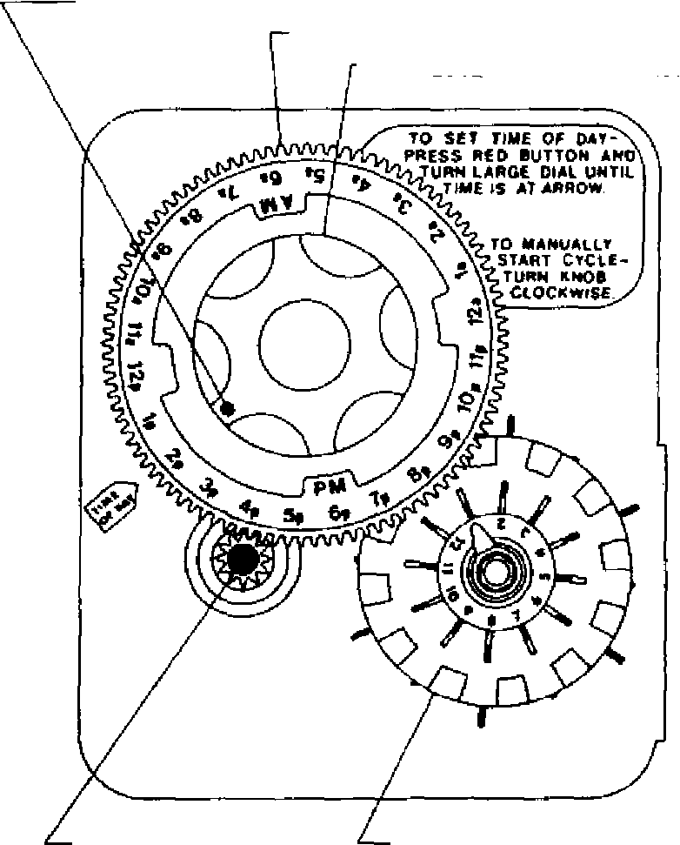

24 HR. GEAR
MANUAL REGENERATION KNOB

SKIPPER WHEEL, 12 DAY (SHOWS EVERY OTHER DAY REGENERATION)

  - Push the red button in and rotate the 24 hour dial. Tighten each of the three screws.
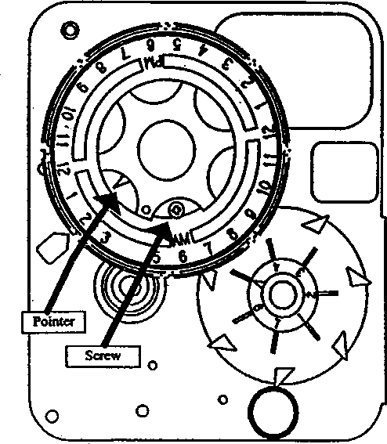

  - Push the red button and locate the pointer one more time to ensure the desired regeneration time is correct.
  - Reset the time of day and restore power to the unit.
3200 ADJUSTABLE REGENERATION TIMER

3210 Timer Settings

Typical Programming Procedure
Calculate the gallon capacity of the system, subtract the necessary reserve requirement and set the gallons available opposite the small white dot on the program wheel gear. Note, drawing shows 8,750 gallon setting. The capacity (gallons) arrow denotes remaining gallons exclusive of fixed reserve.

How To Set The Time Of Day:
Press and hold the red button in to disengage the drive gear.
Turn the large gear until the actual time of day is opposite the time of day pointer.
Release the red button to again engage the drive gear.

How To Manually Regenerate Your Water Conditioner At Any Time:
Turn the manual regeneration knob clockwise.
This slight movement of the manual regeneration knob engages the program wheel and starts the regeneration program.
The black center knob will make one revolution in the following approximately three hours and stop in the position shown in the drawing.
Even though it takes three hours for this center knob to complete one revolution, the regeneration cycle of your unit might be set for only one half of this time.
In any event, conditioned water may be drawn after rinse water stops flowing from the water conditioner drain line.

Immediate Regeneration Timers:
These timers do not have a 24 hour gear. Setting the gallons on the program wheel and manual regeneration procedure are the same as previous instructions.

* 24 HOUR GEAR
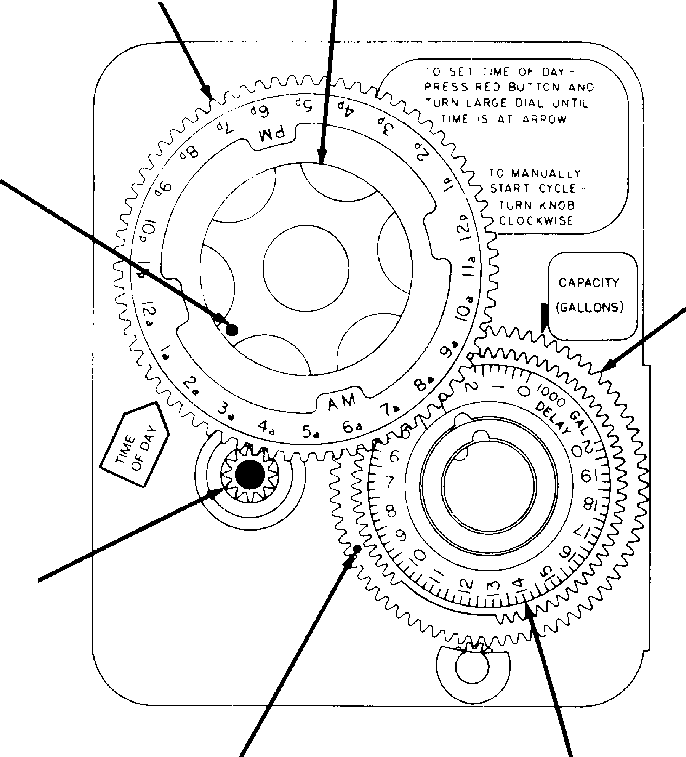

MANUAL REGENERATION KNOB

SERVICE POSITION INDICATOR

PROGRAM WHEEL

NOTE:
To set meter capacity rotate manual knob one - 360° revolution to set gallonage.

RED TIME SET BUTTON

WHITE DOT
GALLONS LABEL

* Immediate regeneration timers do not have 24 hour gear. No time of day can be set.

MODEL 3200 & 3210 TIMER SERIES

Regeneration Cycle Program Setting Procedure

(Brine Tank Refill Separate From Rapid Rinse)

How To Set The Regeneration Cycle Program:
The regeneration cycle program on your water conditioner has been factory preset, however, portions of the cycle or program may be lengthened or shortened in time to suit local conditions.
3200 & 3210 Series Timers (Figure to Right)
To expose cycle program wheel, grasp timer in upper left- hand corner and pull, releasing snap retainer and swinging timer to the right
To change the regeneration cycle program, the program wheel must be removed. Grasp program wheel and squeeze protruding lugs toward center, lift program wheel off timer. (Switch arms may require movement to facilitate removal.)
Return timer to closed position engaging snap retainer in back plate. Make certain all electrical wires locate above snap retainer post
Timer Setting Procedure for 3200 & 3210 Timer
How To Change The Length Of The Backwash Time:
The program wheel as shown in the drawing is in the service position. As you look at the numbered side of the program wheel, the group of pins starting at zero
BRINE & RINSE SECTION
(2 MIN. PER HOLE)
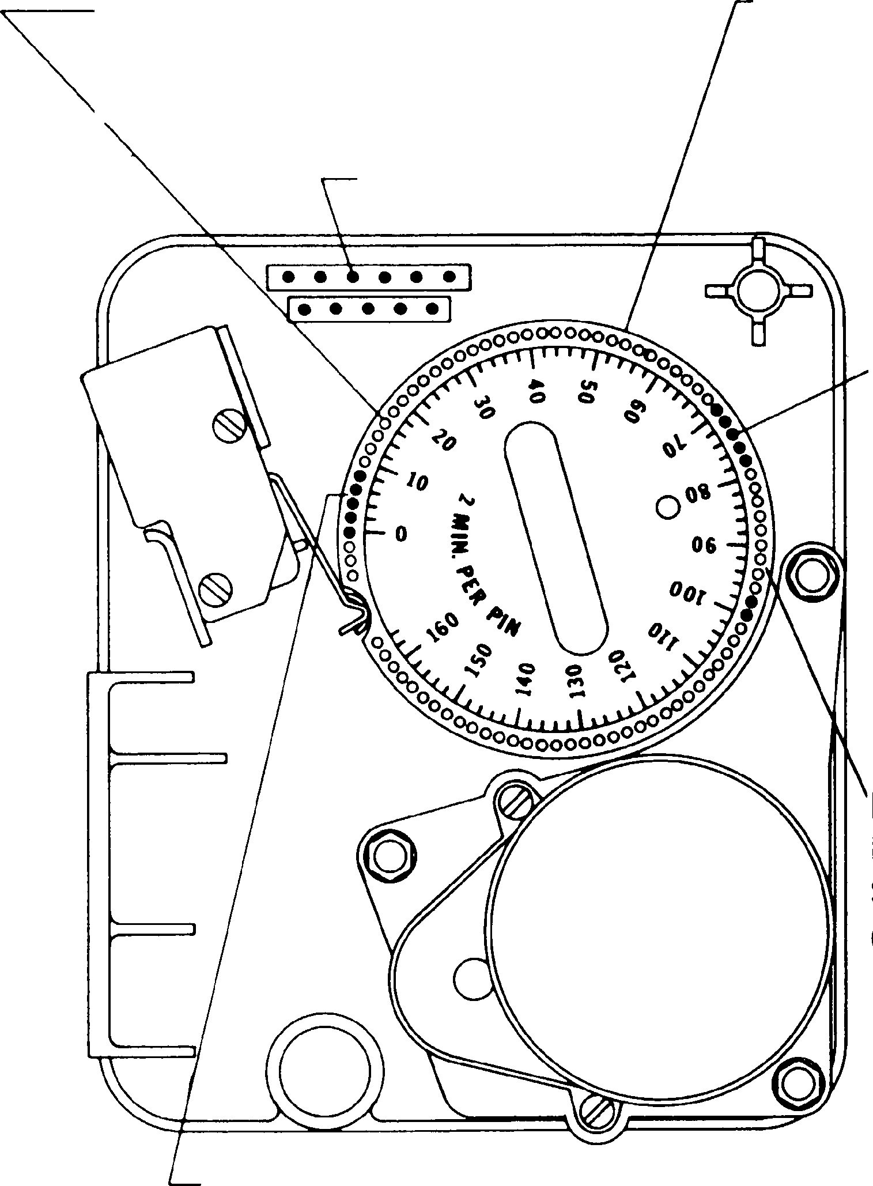

PIN STORAGE

BACKWASH SECTION
(2 MIN. PER PIN)
PROGRAM WHEEL FOR CONTROL OF REGENERATION CYCLE

RAPID RINSE SECTION (2 MIN. PER PIN)

BRINE TANK REFILL SECTION
(2 MIN.
PER HOLE)

determines the length of time your unit will backwash.
FOR EXAMPLE: If there are six pins in this section, the time of backwash will be 12 min. (2 min. per pin). To change the length of backwash time, add or remove pins as required. The number of pins times two equals the backwash time in minutes.
How To Change The Length Of Brine And Rinse Time:
The group of holes between the last pin in the backwash section and the second group of pins determines the length of time that your unit will brine and rinse (2 min. per hole.)
To change the length of brine and rinse time, move the rapid rinse group of pins to give more or fewer holes in the brine and rinse section. Number of holes times two equals brine and rinse time in minutes.
How To Change The Length Of Rapid Rinse:
The second group of pins on the program wheel determines the length of time that your water conditioner will rapid rinse. (2 min. per pin.)
To change the length of rapid rinse time, add or remove pins at the higher numbered end of this section as required. The number of pins times two equals the rapid rinse time in minutes.
How To Change The Length Of Brine Tank Refill Time:
The second group of holes in the program wheel determines the length of time that your water conditioner will refill the brine tank (2 min. per hole.)
To change the length of refill time, move the two pins at the end of the second group of holes as required.
The regeneration cycle is complete when the outer microswitch is tripped by the two pin set at end of the brine tank refill section.
The program wheel, however, will continue to rotate until the inner micro-switch drops into the notch on the program wheel.

3200 Timer Assembly
(See opposite page for parts list)

1 2
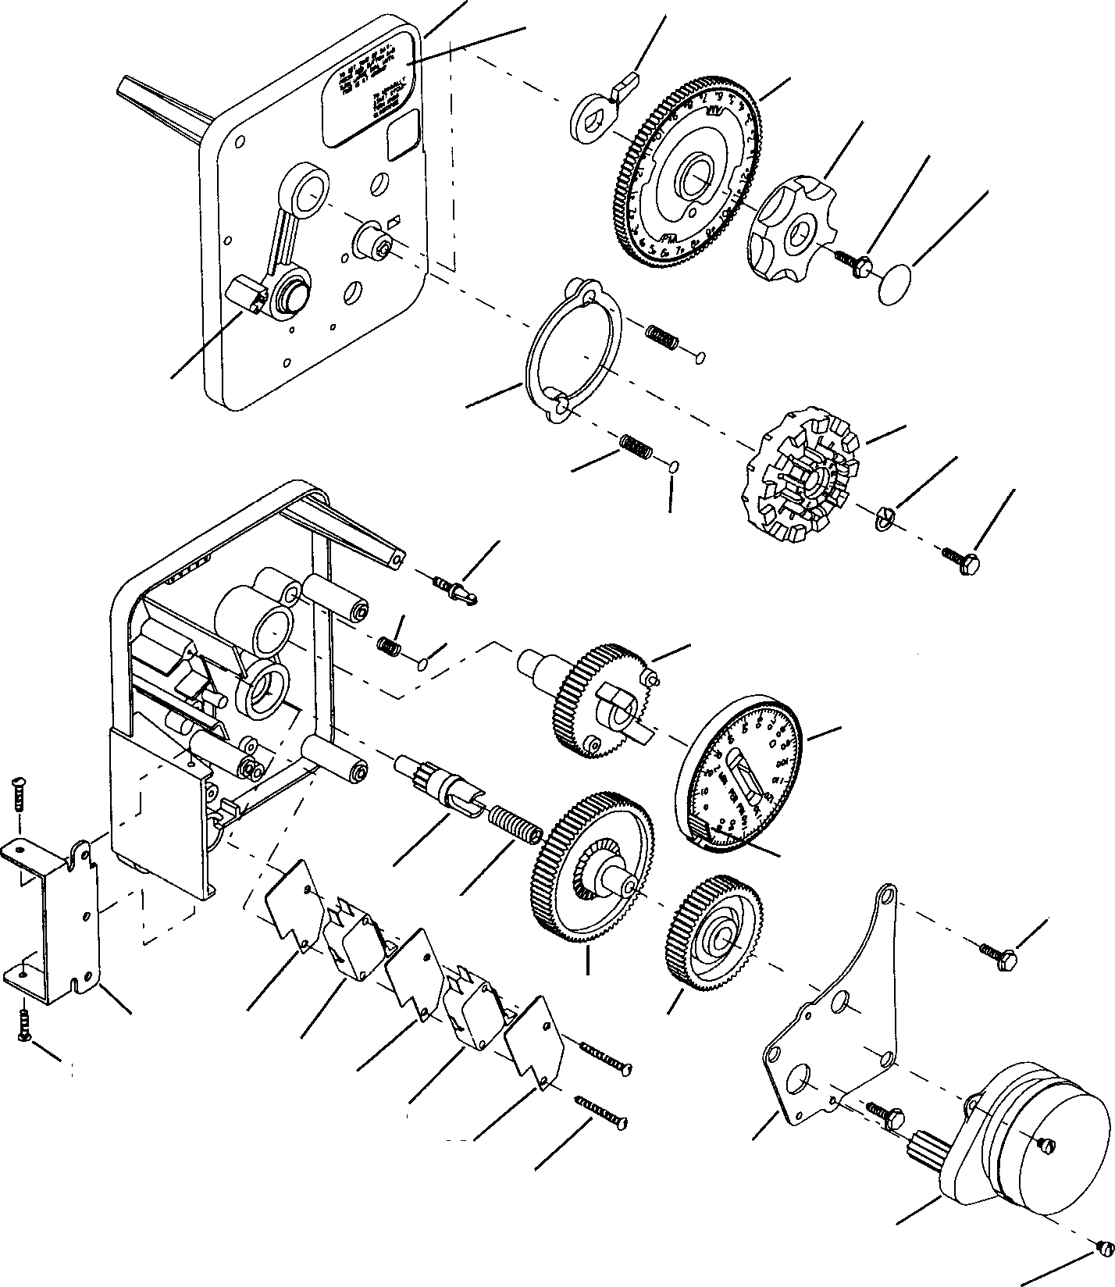

30
3
4
5
6

29
31 7
8
10 5
9 11

12
32 13

14

15
16
17 5

18
24 25 19
26
23 25
27
25 20
28

21

22

3200 Timer Assembly Parts List

Item No. No. Req’d Part No. Description

1 . . . . . . . . . . . 1 . . . . . . . . . . . 13870 Timer Housing
2 . . . . . . . . . . . 1 . . . . . . . . . . . 13011 Cycle Actuator Arm
3 . . . . . . . . . . . 1 . . . . . . . . . . . 40096-24 24 Hour Gear Assembly, 12 Midnight
40096-02 24 Hour Gear Assembly, 2 a.m.
4 . . . . . . . . . . . 1 . . . . . . . . . . . 13886-01 Knob
5 . . . . . . . . . . . 5 . . . . . . . . . . . 13296 Screw - Timer Knob and Motor Mtg. Plate
6 . . . . . . . . . . . 1 . . . . . . . . . . . 11999 Button Decal
7 . . . . . . . . . . . 1 . . . . . . . . . . . 14381 Skipper Wheel Assembly - 12 Day
14860 Skipper Wheel Assembly - 7 Day
8 . . . . . . . . . . . 1 . . . . . . . . . . . 13014 Regeneration Pointer
9 . . . . . . . . . . . 1 . . . . . . . . . . . 14265 Spring Clip
10 . . . . . . . . . . 2 . . . . . . . . . . . 13311 Spring - Skipper Wheel Detent
11 . . . . . . . . . . 2 . . . . . . . . . . . 13300 Ball - 1/4 in. Dia. Skipper Wheel
12 . . . . . . . . . . 1 . . . . . . . . . . . 15424 Spring - Main Gear Detent
13 . . . . . . . . . . 1 . . . . . . . . . . . 13911 Main Drive Gear
14 . . . . . . . . . . 1 . . . . . . . . . . . 19210 Program Wheel
15 . . . . . . . . . . 21 . . . . . . . . . . 15493 Roll Pin
16 . . . . . . . . . . 1 . . . . . . . . . . . 13018 Idler Shaft
17 . . . . . . . . . . 1 . . . . . . . . . . . 13312 Spring - Idler
18 . . . . . . . . . . 1 . . . . . . . . . . . 13017 Idler Gear
19 . . . . . . . . . . 1 . . . . . . . . . . . 13164 Drive Gear
20 . . . . . . . . . . 1 . . . . . . . . . . . 13887 Motor Mounting Plate
21 . . . . . . . . . . 1 . . . . . . . . . . . 18743 Motor - 120V., 60 Hz.
19659 Motor - 24V., 60 Hz.
22 . . . . . . . . . . 2 . . . . . . . . . . . 13278 Screw - Motor Mounting
23 . . . . . . . . . . 3 . . . . . . . . . . . 11384 Screw - Timer Hinge & Ground Wire
24 . . . . . . . . . . 1 . . . . . . . . . . . 13881 Hinge Bracket
25 . . . . . . . . . . 3 . . . . . . . . . . . 14087 Insulator
26 . . . . . . . . . . 1 . . . . . . . . . . . 10896 Switch
27 . . . . . . . . . . 1 . . . . . . . . . . . 15320 Switch
28 . . . . . . . . . . 2 . . . . . . . . . . . 11413 Screw - Switch Mounting
29 . . . . . . . . . . 1 . . . . . . . . . . . 14007 Decal - Time of Day
30 . . . . . . . . . . 1 . . . . . . . . . . . 14045 Decal - Instructions
31 . . . . . . . . . . 1 . . . . . . . . . . . 13864 Skipper Wheel Ring
32 . . . . . . . . . . 1 . . . . . . . . . . . 15066 Ball 1/4 in. Dia. Main Gear
Not Shown. . . . 1 . . . . . . . . . . . 13902 Harness
Not Shown. . . . 2 . . . . . . . . . . . 12681 Wire Connector
Not Shown. . . . 1 . . . . . . . . . . . 15354-01 Ground Wire

3210 Timer Assembly
(See opposite page for parts list)

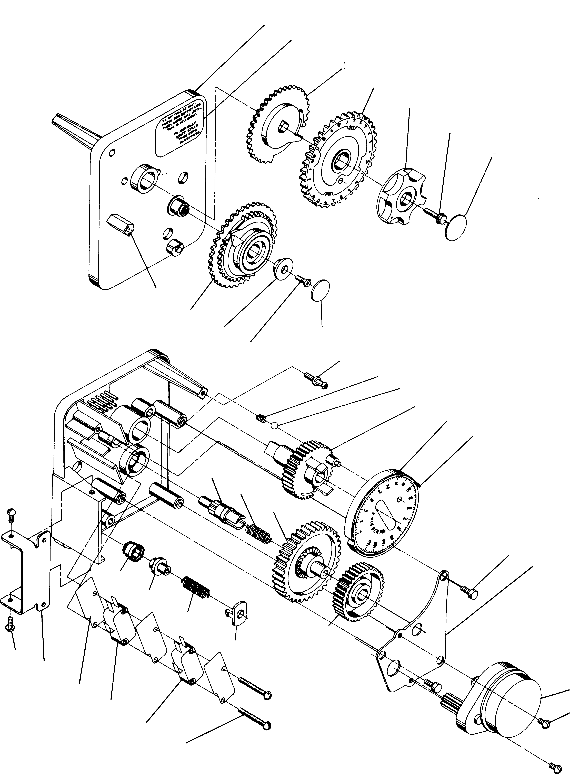1
38

2
3
5
6
7

37
8
9 7
10 11
12
13
14
15
16

18
19
20

6
23
26
27
28
21
31 29
32
33 24
34 25
35
36

3210 Timer Assembly Parts List

Item No. Quantity Part No. Description
1 . . . . . . . . . . . 1 . . . . . . . . . . . 13870-01 Timer Housing Assembly
2 . . . . . . . . . . . 1 . . . . . . . . . . . 13802 Cycle Actuator Gear
3 . . . . . . . . . . . 1 . . . . . . . . . . . 40096-24 24 Hour Gear Assembly, 12 Midnight
40096-02 24 Hour Gear Assembly, 2 A.M.
5 . . . . . . . . . . . 1 . . . . . . . . . . . 13886-01 Knob
6 . . . . . . . . . . . 4 . . . . . . . . . . . 13296 Screw - Timer Knob & Motor Plate Mtg.
7 . . . . . . . . . . . 2 . . . . . . . . . . . 11999 Button Decal
8 . . . . . . . . . . . 1 . . . . . . . . . . . 60405-50 . . . . . . . . . . . . . Program Wheel Assembly, 0-21,000
9 . . . . . . . . . . . 1 . . . . . . . . . . . 13806 Program Wheel Retainer
10 . . . . . . . . . . 1 . . . . . . . . . . . 13748 Screw - Program Wheel Mtg.
11 . . . . . . . . . . 1 . . . . . . . . . . . 14265 Spring Clip
12 . . . . . . . . . . 1 . . . . . . . . . . . 15424 Spring-Detent
13 . . . . . . . . . . 1 . . . . . . . . . . . 15066 Ball - 1/4 in. dia.
14 . . . . . . . . . . 1 . . . . . . . . . . . 13911 Main Drive Gear
15 . . . . . . . . . . 1 . . . . . . . . . . . 19210 Program Wheel Assembly
16 . . . . . . . . . . 21 . . . . . . . . . . 15493 Roll Pin
17 Not Assigned
18 . . . . . . . . . . 1 . . . . . . . . . . . 13018 Idler Shaft
19 . . . . . . . . . . 1 . . . . . . . . . . . 13312 Spring - Idler
20 . . . . . . . . . . 1 . . . . . . . . . . . 13017 Idler Gear
21 . . . . . . . . . . 1 . . . . . . . . . . . 13164 Drive Gear
23 . . . . . . . . . . 1 . . . . . . . . . . . 13887 Motor Mounting Plate
24 . . . . . . . . . . 1 . . . . . . . . . . . 18743 Motor - 110V., 60 Hz.
19659 Motor - 24V., 60 Hz.
25 . . . . . . . . . . 2 . . . . . . . . . . . 13278 Screw - Motor Mounting
26 . . . . . . . . . . 1 . . . . . . . . . . . 13830 Drive Pinion - Program Wheel
27 . . . . . . . . . . 1 . . . . . . . . . . . 13831 Clutch - Drive Pinion
28 . . . . . . . . . . 1 . . . . . . . . . . . 14276 Spring
29 . . . . . . . . . . 1 . . . . . . . . . . . 14253 Spring Retainer
30 Not Assigned
31 . . . . . . . . . . 3 . . . . . . . . . . . 11384 Screw - Timer Hinge & Ground Wire
32 . . . . . . . . . . 1 . . . . . . . . . . . 13881 Hinge Bracket
33 . . . . . . . . . . 3 . . . . . . . . . . . 14087 Insulator
34 . . . . . . . . . . 1 . . . . . . . . . . . 10896 Switch
35 . . . . . . . . . . 1 . . . . . . . . . . . 15320 Switch
36 . . . . . . . . . . 2 . . . . . . . . . . . 11413 Screw - Switch Mounting
37 . . . . . . . . . . 1 . . . . . . . . . . . 14007 Decal - Time of Day
38 . . . . . . . . . . 1 . . . . . . . . . . . 14045 Decal - Instructions
39 . . . . . . . . . . 1 . . . . . . . . . . . 13902 Harness - Not Shown
40 . . . . . . . . . . 2 . . . . . . . . . . . 12681 Wire Connector - Not Shown
41 . . . . . . . . . . 1 . . . . . . . . . . . 15354-01 Ground Wire - Not Shown
42 . . . . . . . . . . 1 . . . . . . . . . . . 15465 Caution Label - Not Shown
43 . . . . . . . . . . 1 . . . . . . . . . . . 14198 Capacity Label - Not Shown

Environmental Power Head (See opposite page for parts list)

23 24

28
25 26 27
29 30

32
22 33
34
35
31
36
21
20 37

17
19
1 2
16

10

9
8

14

13
15 12

11 40 39
38
39
7
6
5
4
3 61501-29002

Page 12
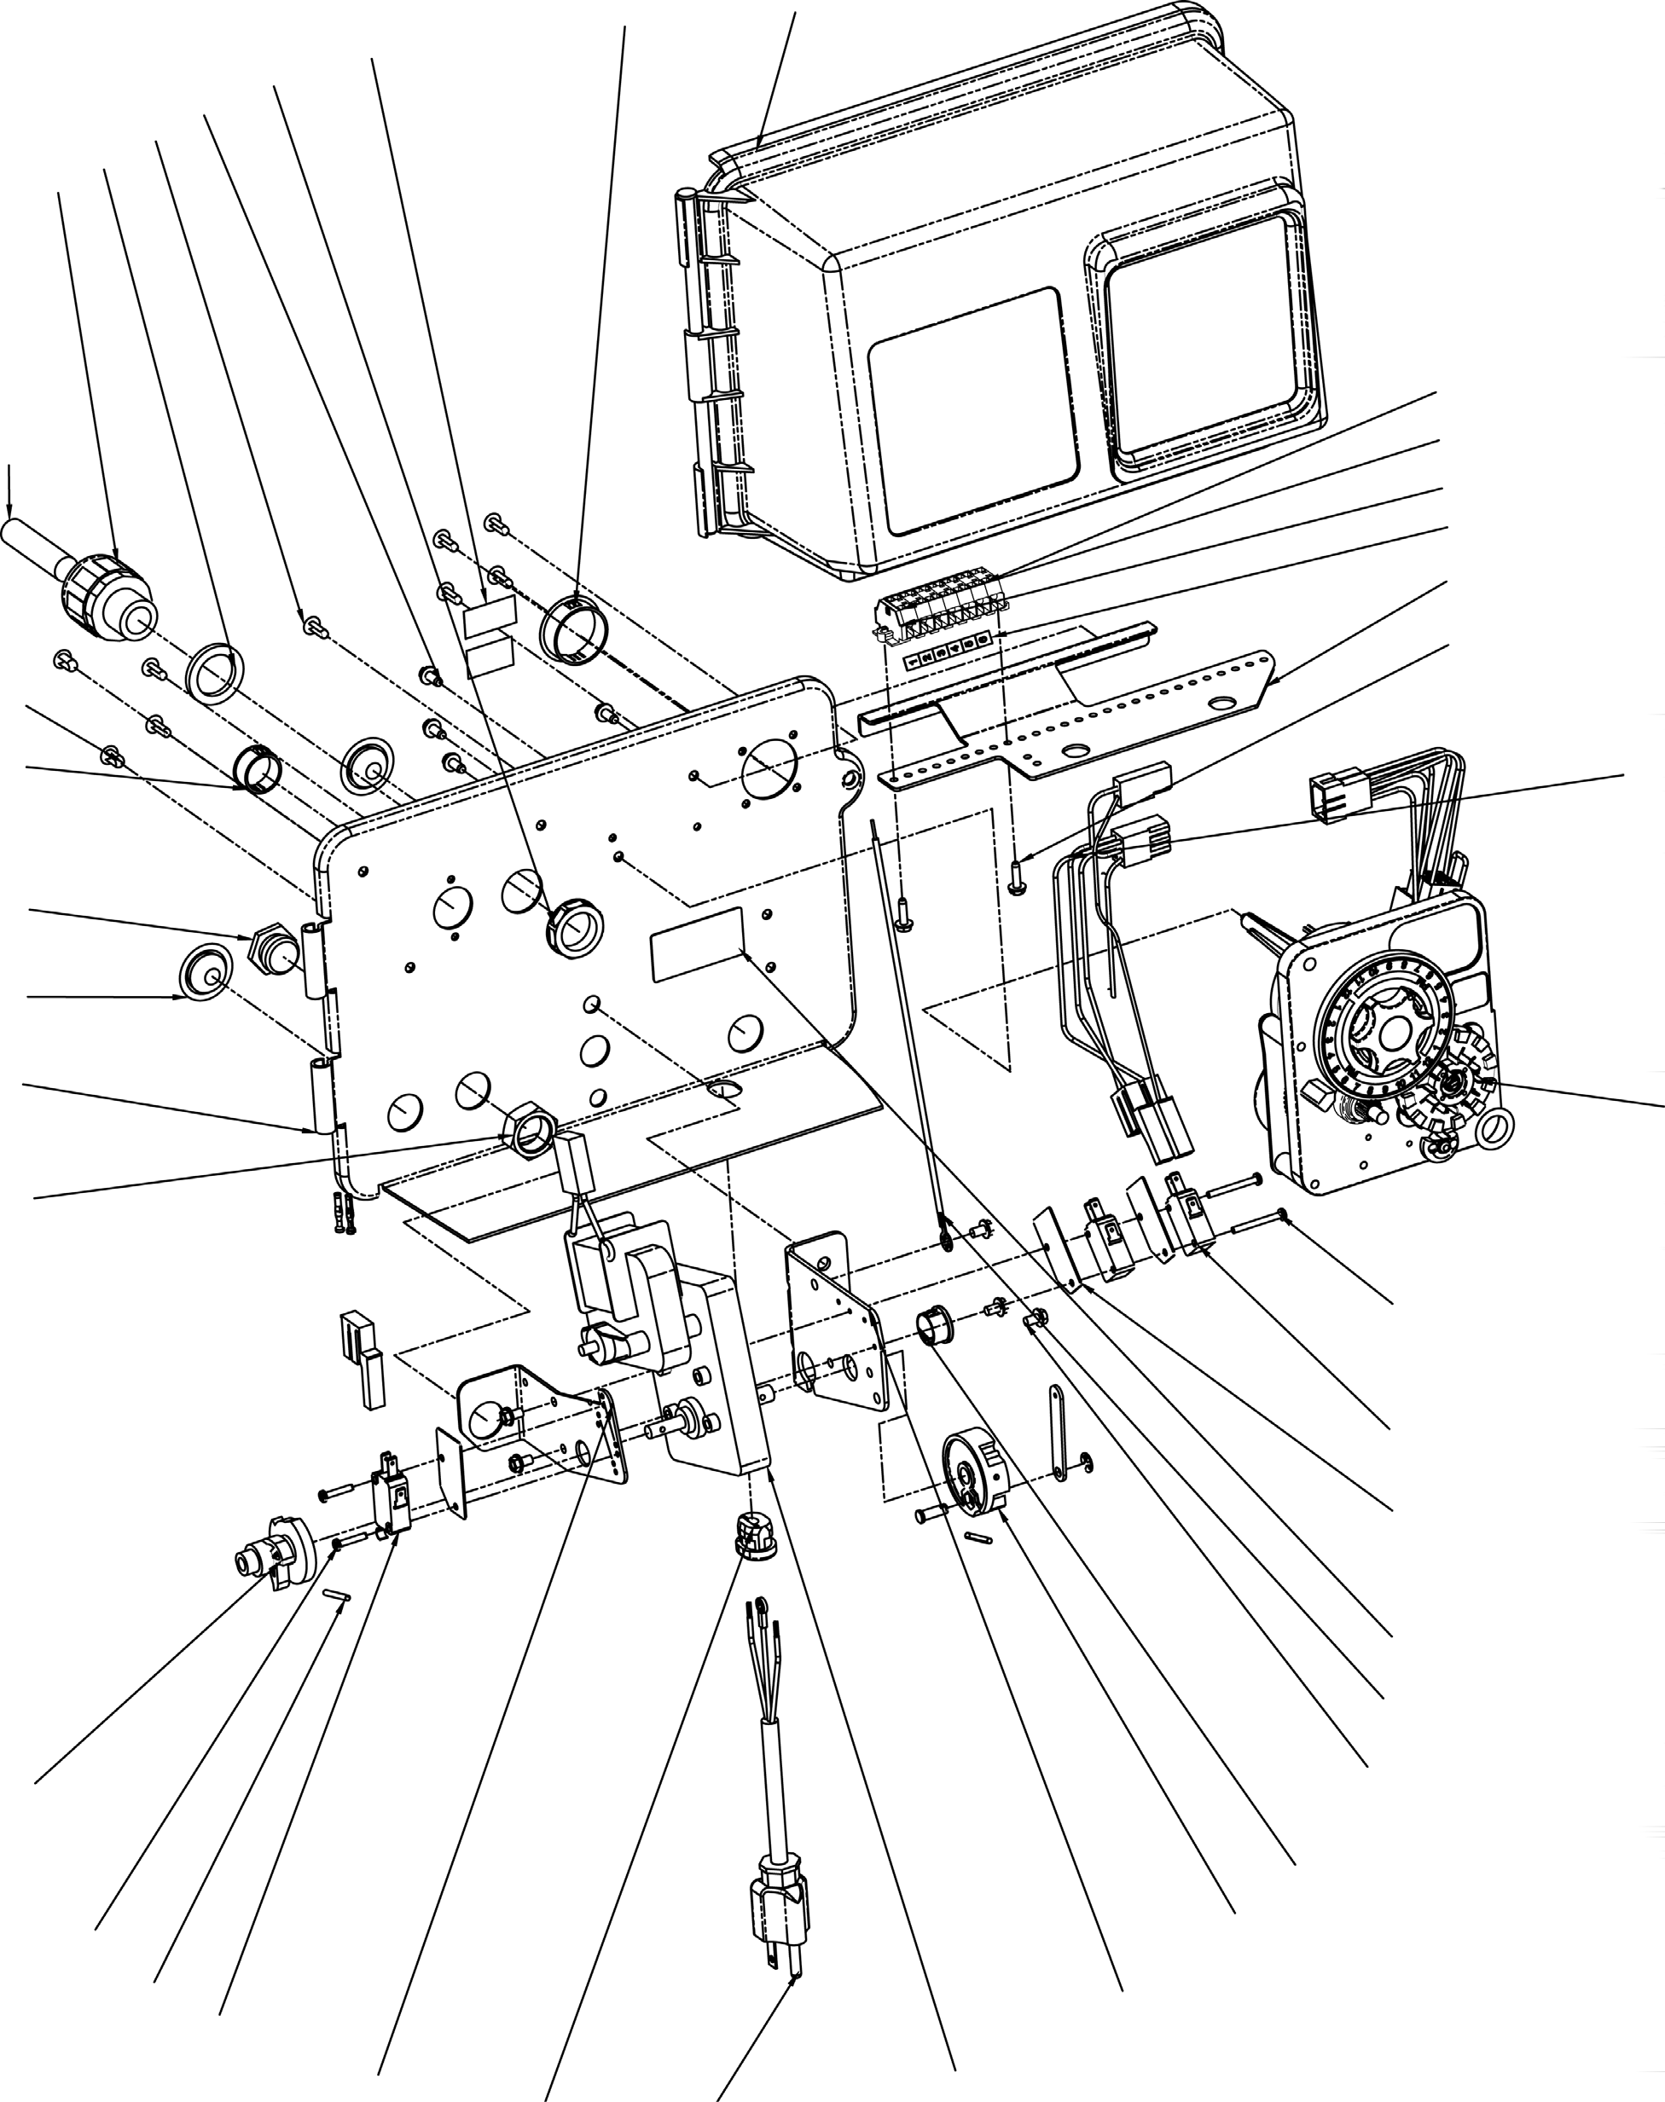

Environmental Power Head
Parts List

Item No. Quantity Part No. Description
1 . . . . . . . . . . . 1 . . . . . . . . . . . 18697-15 Back Plate, Hinged, 2900
2 . . . . . . . . . . . - . . . . . . . . . . . . 3200 Clock Timer Assy . . 3200 Clock Timer Assy
2 . . . . . . . . . . . 1 . . . . . . . . . . . 3200 Meter Timer Assy . . 3200 Meter Timer Assy
3 . . . . . . . . . . . 1 . . . . . . . . . . . 40384 Motor, Drive, Shaded Pole, 115V, 60HZ, Fam
4 . . . . . . . . . . . 1 . . . . . . . . . . . 10774 Bracket, Motor
5 . . . . . . . . . . . 1 . . . . . . . . . . . 60160-10 CAM Drive Assy, STF, Black
6 . . . . . . . . . . . 1 . . . . . . . . . . . 17904 Bushing, Heyco 1/2, Heyco #2073
7 . . . . . . . . . . . 5 . . . . . . . . . . . 10872 . . . . . . . . . . . . . . . Screw, Hex Wsh, 8-32 X 17/64
8 . . . . . . . . . . . 3 . . . . . . . . . . . 10302 Insulator, Limit Switch
9 . . . . . . . . . . . 2 . . . . . . . . . . . 10218 Switch, Micro
10 . . . . . . . . . . 2 . . . . . . . . . . . 14923 . . . . . . . . . . . . . . . Screw, Pan Hd Mach, 4-40 X 1
11 . . . . . . . . . . 1 . . . . . . . . . . . 11826-02 Bracket, Motor, Aux Switch
12 . . . . . . . . . . 1 . . . . . . . . . . . 10896 Switch, Miniature
13 . . . . . . . . . . 2 . . . . . . . . . . . 11805 . . . . . . . . . . . . . . . Screw, Rd Hd, 4-40 X 5/8 Type 1
14 . . . . . . . . . . 1 . . . . . . . . . . . 12777-02 Cam, Shut-off Valve
15 . . . . . . . . . . 2 . . . . . . . . . . . 10338 Pin, Roll, 2900/3900
16 . . . . . . . . . . 1 . . . . . . . . . . . 10269 Nut, Jam, 3/4-16
17 . . . . . . . . . . 1 . . . . . . . . . . . 10712 Fitting, Brine Valve
18 . . . . . . . . . . 1 . . . . . . . . . . . 14822 Harness, 2900
19 . . . . . . . . . . 2 . . . . . . . . . . . 19691 Plug, .750 Dia. Hole, Flush
20 . . . . . . . . . . 1 . . . . . . . . . . . 15806 Hole Plug, (Heyco)
21 . . . . . . . . . . 1 . . . . . . . . . . . 19801 Plug, .190 Hole
22 . . . . . . . . . . 1 . . . . . . . . . . . 18693 Conduit, Interdrive
23 . . . . . . . . . . 1 . . . . . . . . . . . 18691-01 Fitting, Conduit
24 . . . . . . . . . . 1 . . . . . . . . . . . 18692 Washer, Sealing - 3/8"
25 . . . . . . . . . . 7 . . . . . . . . . . . 19800 Plug (Hole Size: Dia .140)
26 . . . . . . . . . . 4 . . . . . . . . . . . 10300 . . . . . . . . . . . . . . . Screw, Slot Hex Wsh, 8-18 X 3/8
27 . . . . . . . . . . 1 . . . . . . . . . . . 18691-02 Nut, Conduit Fitting,1/2IN
28 . . . . . . . . . . 1 . . . . . . . . . . . 40038-03 Label, Voltage, 120V
29 . . . . . . . . . . 1 . . . . . . . . . . . 17421 Hole Plug, (Heyco)
30 . . . . . . . . . . 1 . . . . . . . . . . . 60219-02 Cover Assy, Environmental,Black W/Clear Window
31 . . . . . . . . . . 1 . . . . . . . . . . . 19772 Bracket, Terminal Block
32 . . . . . . . . . . 1 . . . . . . . . . . . 40174 Terminal Block, Green/Yellow
33 . . . . . . . . . . 6 . . . . . . . . . . . 40184 Terminal Block, Segment, Gray
34 . . . . . . . . . . 1 . . . . . . . . . . . 41085 Endplate, Terminal Block, Gray
35 . . . . . . . . . . 2 . . . . . . . . . . . 15250 Label, Terminal Strip
36 . . . . . . . . . . 2 . . . . . . . . . . . 13296 . . . . . . . . . . . . . . . Screw, Hex Washer, 6-20 X 1/2
37 . . . . . . . . . . 1 . . . . . . . . . . . 40400 Harness, Drive, DesignR/Envirmtl
38 . . . . . . . . . . 1 . . . . . . . . . . . 40175-01 Wire, Ground, 7.5 Long
39 . . . . . . . . . . 1 . . . . . . . . . . . 40084-12 Power Cord, 12' US, Round, 120V
40 . . . . . . . . . . 1 . . . . . . . . . . . 13547-02 Strain Relief, Round Cord
41 . . . . . . . . . . - . . . . . . . . . . . . 17967 (Not Shown) Fitting Assy, Liquid-Tight, Black

Lower Environmental Power Head (See opposite page for parts list)

19 13 16
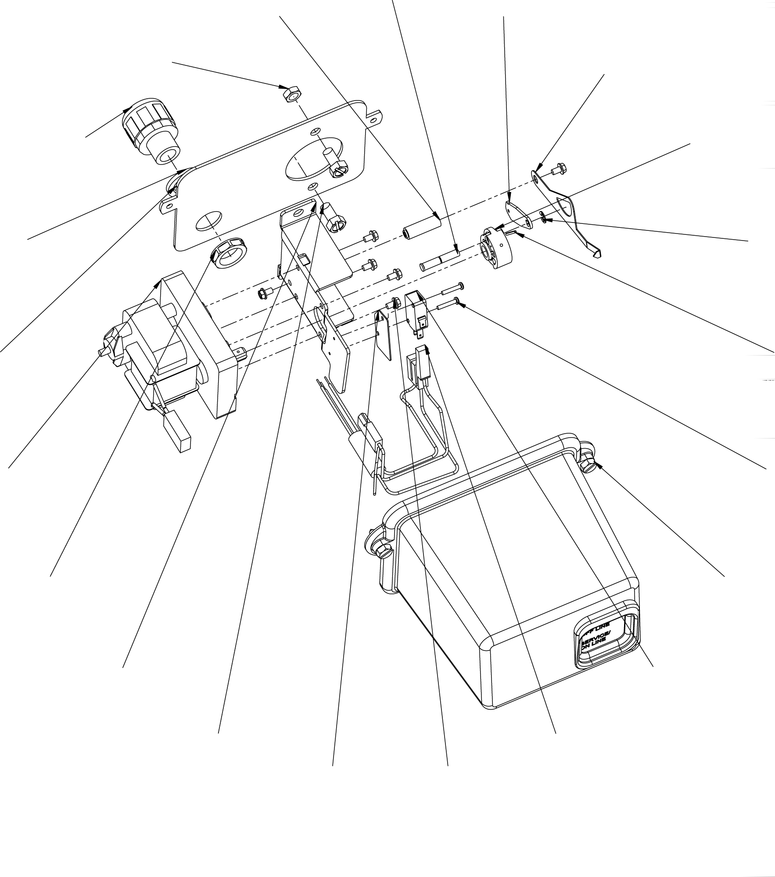

3 18

5 14

4 17

1 15

7 12

6 22

8 11

2 9
10 20

Lower Environmental Power Head Parts List

Item No. Quantity Part No. Description
1 . . . . . . . . . . . 1 . . . . . . . . . . . 18709 Back, Plate, Lower
2 . . . . . . . . . . . 2 . . . . . . . . . . . 11224 . . . . . . . . . . . . . . . Screw, Screw, Slotted Hex Head, 5/16 - 18 X 5/8
3 . . . . . . . . . . . 2 . . . . . . . . . . . 16346 Nut, Hex, Jam, 5/16-18, 18-8 S.S.
4 . . . . . . . . . . . 1 . . . . . . . . . . . 18692 Washer, Sealing - 3/8"
5 . . . . . . . . . . . 1 . . . . . . . . . . . 18691-01 Fitting, Conduit
6 . . . . . . . . . . . 1 . . . . . . . . . . . 18691-02 Nut, Conduit Fitting,1/2in
7 . . . . . . . . . . . 1 . . . . . . . . . . . 40387 Motor, Drive,115v,60hz,Sp, Fam 2
8 . . . . . . . . . . . 1 . . . . . . . . . . . 14769 Bracket, Motor,2900
9 . . . . . . . . . . . 1 . . . . . . . . . . . 40405 Harness, Lead, Sys#4, Designer
10 . . . . . . . . . . 1 . . . . . . . . . . . 10302 Insulator, Limit Switch
11 . . . . . . . . . . 1 . . . . . . . . . . . 10218 Switch, Micro
12 . . . . . . . . . . 2 . . . . . . . . . . . 19849 . . . . . . . . . . . . . . . Screw, Pan Hd, 4-40 X 5/8
13 . . . . . . . . . . 1 . . . . . . . . . . . 18746 Pin- Connecting Rod
14 . . . . . . . . . . 1 . . . . . . . . . . . 14775 Cam, Main Drive, 2900 Lower
15 . . . . . . . . . . 1 . . . . . . . . . . . 41022 Pin, Roll, 2900/3900
16 . . . . . . . . . . 1 . . . . . . . . . . . 14759 Link, Piston Rod
17 . . . . . . . . . . 1 . . . . . . . . . . . 10250 Ring, Retaining
18 . . . . . . . . . . 1 . . . . . . . . . . . 18725 Indicator, Service/Standby
19 . . . . . . . . . . 1 . . . . . . . . . . . 18726 Spacer, Indicator
20 . . . . . . . . . . 6 . . . . . . . . . . . 10872 . . . . . . . . . . . . . . . Screw, Hex Wsh,8-32 X 17/64
21 . . . . . . . . . . 6 . . . . . . . . . . . 14044 (Not Shown) Tie, Cable, Heyco, Vnt#4-18
22 . . . . . . . . . . 1 . . . . . . . . . . . 60217-02 Cover Assy, 2900, Lower, Black, Environmental

Designer Power Head
(See opposite page for parts list)

35
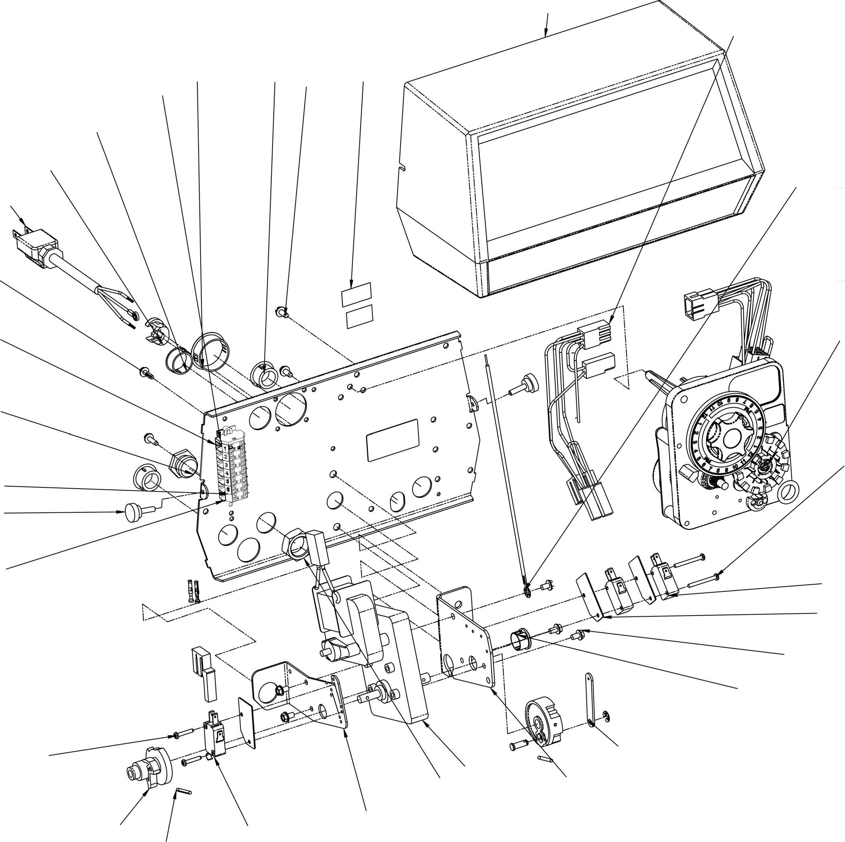

31

21 27 28 29 30
26

25
32

24

23

20 2

17

11
22

1

19

10
9

13

14 15 12
8

7

6

16 4 5
3

61501-29001

Page 16

Designer Power Head
Parts List

Item No. Quantity Part No. Description
1 . . . . . . . . . . . 1 . . . . . . . . . . . 40264 Backplate, SS/SVO, W/T-Screws, 2750,2850,2900
2 . . . . . . . . . . . 1 . . . . . . . . . . . 3200 Meter Timer Assy . . 3200 Meter Timer Assy
2 . . . . . . . . . . . - . . . . . . . . . . . . 3200 Clock Timer Assy . . 3200 Clock Timer Assy
3 . . . . . . . . . . . 1 . . . . . . . . . . . 11826-02 Bracket, Motor, Aux Switch
4 . . . . . . . . . . . 1 . . . . . . . . . . . 40384 Motor, Drive, Shaded Pole, 115V, 60HZ, Fam
5 . . . . . . . . . . . 1 . . . . . . . . . . . 10774 Bracket, Motor
6 . . . . . . . . . . . 1 . . . . . . . . . . . 60160-10 CAM Drive Assy, STF, Black
7 . . . . . . . . . . . 1 . . . . . . . . . . . 17904 Bushing, Heyco 1/2, Heyco #2073
8 . . . . . . . . . . . 5 . . . . . . . . . . . 10872 . . . . . . . . . . . . . . . Screw, Hex WSH, 8-32 X 17/64
9 . . . . . . . . . . . 3 . . . . . . . . . . . 10302 Insulator, Limit Switch
10 . . . . . . . . . . 2 . . . . . . . . . . . 10218 Switch, Micro
11 . . . . . . . . . . 2 . . . . . . . . . . . 14923 . . . . . . . . . . . . . . . Screw, Pan HD Mach, 4-40 X 1
12 . . . . . . . . . . 1 . . . . . . . . . . . 10896 Switch, Miniature
13 . . . . . . . . . . 2 . . . . . . . . . . . 11805 . . . . . . . . . . . . . . . Screw, RD HD, 4-40 X 5/8 Type 1
14 . . . . . . . . . . 2 . . . . . . . . . . . 12777-02 Cam, Shut-off Valve
15 . . . . . . . . . . 1 . . . . . . . . . . . 10338 Pin, Roll, 2900/3900
16 . . . . . . . . . . 1 . . . . . . . . . . . 10269 Nut, Jam, 3/4-16
17 . . . . . . . . . . 1 . . . . . . . . . . . 10712 Fitting, Brine Valve
18 . . . . . . . . . . 1 . . . . . . . . . . . 14822 Harness, 2900
19 . . . . . . . . . . 1 . . . . . . . . . . . 40174 Terminal Block, Green/Yellow
20 . . . . . . . . . . 6 . . . . . . . . . . . 40184 Terminal Block, Segment, Gray
21 . . . . . . . . . . 1 . . . . . . . . . . . 41085 Endplate, Terminal Block, Gray
22 . . . . . . . . . . 2 . . . . . . . . . . . 15250 Label, Terminal Strip
23 . . . . . . . . . . 2 . . . . . . . . . . . 13296 . . . . . . . . . . . . . . . Screw, Hex Washer, 6-20 X 1/2
24 . . . . . . . . . . 1 . . . . . . . . . . . 40084-12 Power Cord, 12'US, Round, 120V
25 . . . . . . . . . . 1 . . . . . . . . . . . 13547-02 Strain Relief, Round Cord
26 . . . . . . . . . . 1 . . . . . . . . . . . 15806 Hole Plug, (Heyco)
27 . . . . . . . . . . 1 . . . . . . . . . . . 17421 Hole Plug, (Heyco)
28 . . . . . . . . . . 1 . . . . . . . . . . . 13741 . . . . . . . . . . . . . . . Plug, 3/4", Knock-out, Heyco #2683
29 . . . . . . . . . . 2 . . . . . . . . . . . 10300 . . . . . . . . . . . . . . . Screw, Slot Hex Wsh, 8-18 X 3/8
30 . . . . . . . . . . 1 . . . . . . . . . . . 40038-03 Label, Voltage, 120V
31 . . . . . . . . . . 1 . . . . . . . . . . . 40400 Harness, Drive, Designr/Envirmtl
32 . . . . . . . . . . 1 . . . . . . . . . . . 40175-01 Wire, Ground, 7.5 Long
33 . . . . . . . . . . 1 . . . . . . . . . . . 17967 (Not Shown) Fitting Assy, Liquid-Tight, Black (Meter)
34 . . . . . . . . . . 1 . . . . . . . . . . . 15158 (Not Shown) TD Cable Guide (Meter)
35 . . . . . . . . . . 1 . . . . . . . . . . . 19291-020 Cover, Designer

Lower Designer Power Head (See opposite page for parts list)

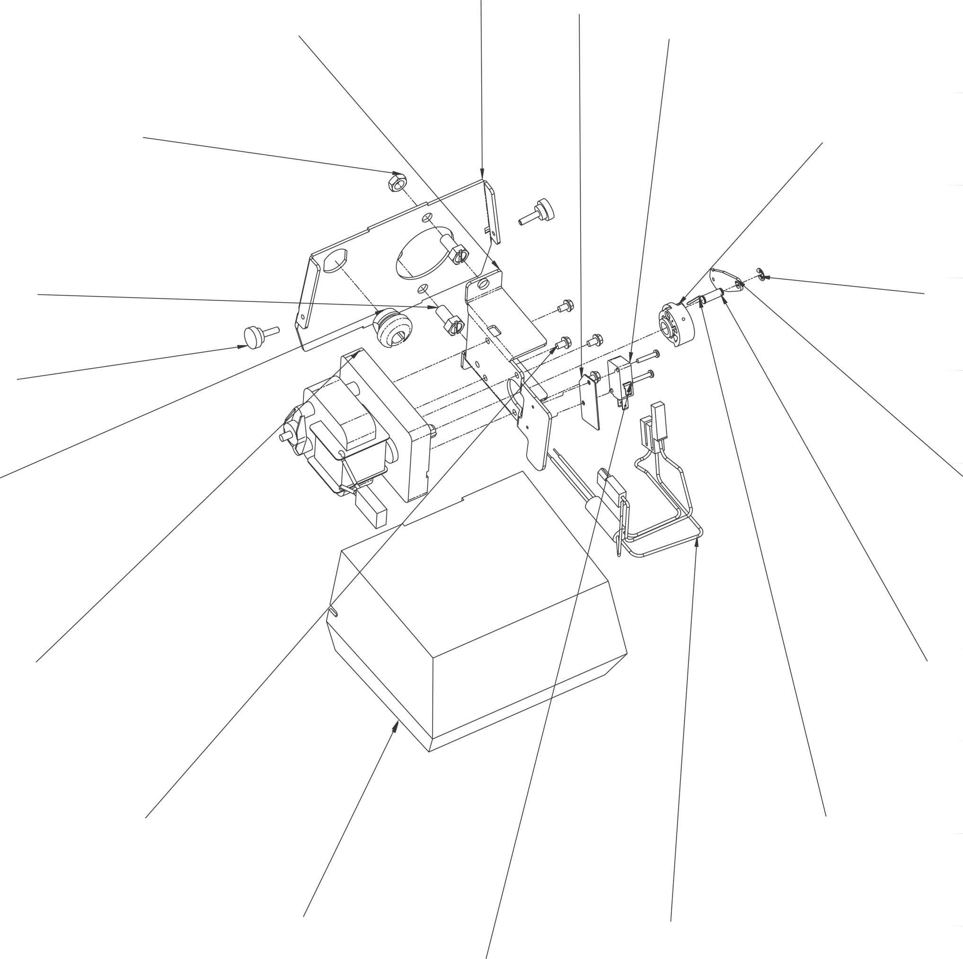5 8
1
2
14
13
4
10
3
7
19
6
9
16
11
18
15

12

61501-29003

Lower Designer Power Head Parts List

Item No. Quantity Part No. Description
1 . . . . . . . . . . . 1 . . . . . . . . . . . 14770 Backplate, Lower 2900
2 . . . . . . . . . . . 1 . . . . . . . . . . . 14769 Bracket, Motor, 2900
3 . . . . . . . . . . . 2 . . . . . . . . . . . 11224 . . . . . . . . . . . . . . . SCREW Slotted Hex Head, 5/16 - 18 x 5/8
4 . . . . . . . . . . . 2 . . . . . . . . . . . 16346 Nut, Hex, Jam, 5/16-18, 18-8 S.S.
5 . . . . . . . . . . . 1 . . . . . . . . . . . 14924 . . . . . . . . . . . . . . . SR 7W-2
6 . . . . . . . . . . . 1 . . . . . . . . . . . 40387 Motor, Drive, 115V, 60HZ, SP, Fam 2
7 . . . . . . . . . . . 1 . . . . . . . . . . . 10250 Ring, Retaining
8 . . . . . . . . . . . 1 . . . . . . . . . . . 14759 Link, Piston Rod
9 . . . . . . . . . . . 1 . . . . . . . . . . . 14784 Bearing, Connecting Rod
10 . . . . . . . . . . 1 . . . . . . . . . . . 14775 Cam, Main Drive, 2900 Lower
11 . . . . . . . . . . 1 . . . . . . . . . . . 41022 Pin, Roll, 2900/3900
12 . . . . . . . . . . 2 . . . . . . . . . . . 19849 . . . . . . . . . . . . . . . Screw, Pan Hd, 4-40 X 5/8
13 . . . . . . . . . . 1 . . . . . . . . . . . 10218 Switch, Micro
14 . . . . . . . . . . 1 . . . . . . . . . . . 10302 Insulator, Limit Switch
15 . . . . . . . . . . 1 . . . . . . . . . . . 40402 Harness, Lead, Sys#4, Designer
16 . . . . . . . . . . 4 . . . . . . . . . . . 10872 . . . . . . . . . . . . . . . Screw, Hex Wsh, 8-32 X 17/64
17 . . . . . . . . . . 1 . . . . . . . . . . . 14044 (Not Shown) Tie, Cable, Heyco, Vnt#4-18
18 . . . . . . . . . . 1 . . . . . . . . . . . 14800-02 Cover, Dust, Lower, 2900, Black
19 . . . . . . . . . . 2 . . . . . . . . . . . 19367 Screw, Designer Cover, Thumb

Control Valve Body
(See opposite page for parts list)

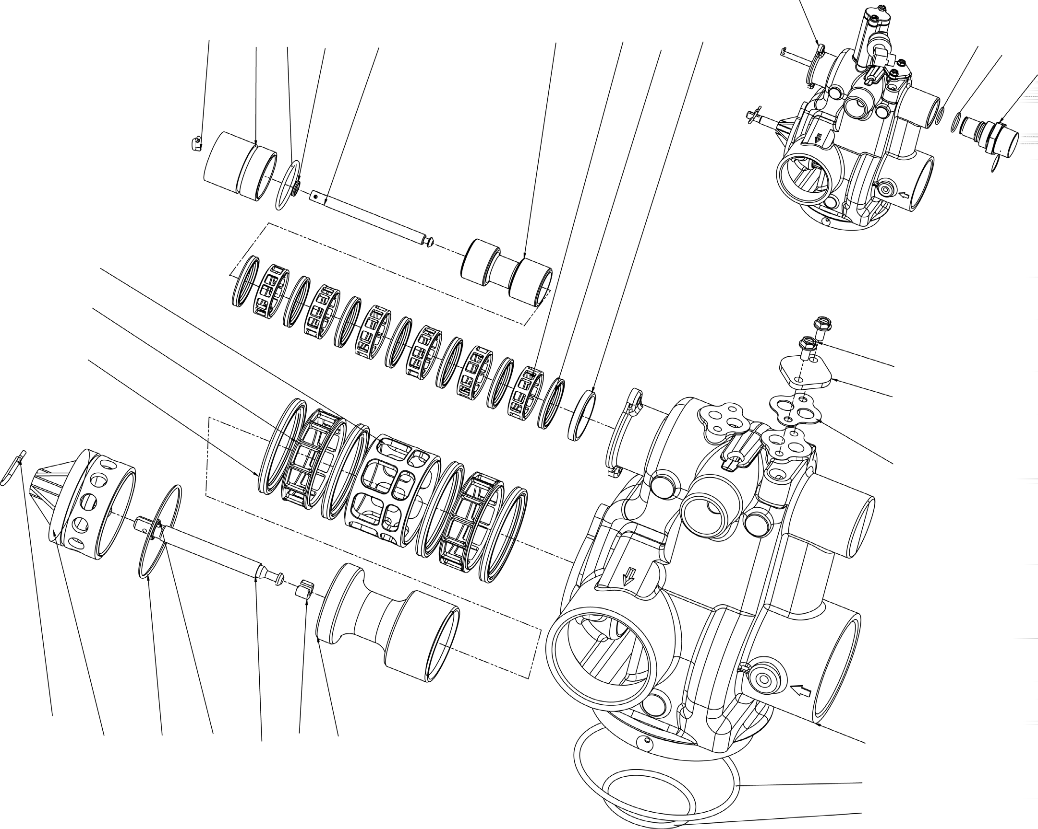
1
8
5
2
4
28 27
26
7
9
10
6
3
13
12
11
25
24
23
20
1
16
15
18
14
17
19
21
22

61500-290019454

Control Valve Body
Parts List

Item No. Quantity Part No. Description
1 . . . . . . . . . . . 1 . . . . . . . . . . . 41428 Valve Body, 2900 CPI, Machined
1 . . . . . . . . . . . - . . . . . . . . . . . . 41428-xx Valve Body, 2900 CPI, Machined, W/Soft Water Adapt
2 . . . . . . . . . . . 1 . . . . . . . . . . . 10757 Spacer, End
3 . . . . . . . . . . . 7 . . . . . . . . . . . 10545 Seal, Piston
4 . . . . . . . . . . . 6 . . . . . . . . . . . 11451 Spacer, 1 2 Hole
5 . . . . . . . . . . . 1 . . . . . . . . . . . 41425 Piston, 2900 CPI, Upper, D/F
5 . . . . . . . . . . . - . . . . . . . . . . . . 14451 Piston, 2750
6 . . . . . . . . . . . 1 . . . . . . . . . . . 14309 Retainer, Piston Rod
7 . . . . . . . . . . . 1 . . . . . . . . . . . 41424 Rod, Piston
8 . . . . . . . . . . . 1 . . . . . . . . . . . 41131 End Plug
9 . . . . . . . . . . . 1 . . . . . . . . . . . 10909 Ppin, Connecting Rod Spring
10 . . . . . . . . . . 1 . . . . . . . . . . . 10209 . . . . . . . . . . . . . . . Quad Ring,-010
11 . . . . . . . . . . 1 . . . . . . . . . . . 40078 O-ring, 28MM X 2MM
12 . . . . . . . . . . 4 . . . . . . . . . . . 11720 Seal, Piston, 2900/3150
13 . . . . . . . . . . 2 . . . . . . . . . . . 10369 Spacer, 2", 2900/3150
14 . . . . . . . . . . 1 . . . . . . . . . . . 14753 Spacer, 2900
15 . . . . . . . . . . 1 . . . . . . . . . . . 14757 Piston No HWBP 2900
16 . . . . . . . . . . 1 . . . . . . . . . . . 14818 Ring, Piston Rod, Snap
17 . . . . . . . . . . 1 . . . . . . . . . . . 14758 Piston Rod
18 . . . . . . . . . . 1 . . . . . . . . . . . 14922 . . . . . . . . . . . . . . . O-ring, -035
19 . . . . . . . . . . 1 . . . . . . . . . . . 14926 . . . . . . . . . . . . . . . Quad ring "O" ring-012
20 . . . . . . . . . . 1 . . . . . . . . . . . 14813 Connecting Link Pin
21 . . . . . . . . . . 1 . . . . . . . . . . . 13575 . . . . . . . . . . . . . . . O-ring, -240
22 . . . . . . . . . . 1 . . . . . . . . . . . 13577 . . . . . . . . . . . . . . . O-ring, -226
23 . . . . . . . . . . 1 . . . . . . . . . . . 14805 Gasket, Injector Body
24 . . . . . . . . . . 1 . . . . . . . . . . . 11893 Cap, Injector, SS
25 . . . . . . . . . . 2 . . . . . . . . . . . 15137 . . . . . . . . . . . . . . . Screw, Hex Washer Head, #10 - 24 X 3/8
26 . . . . . . . . . . - . . . . . . . . . . . . 41448 Adapter, Softwater Regen, 2900
27 . . . . . . . . . . - . . . . . . . . . . . . 16924 . . . . . . . . . . . . . . . O-ring, -018
28 . . . . . . . . . . - . . . . . . . . . . . . 19292 . . . . . . . . . . . . . . . O-ring, -020

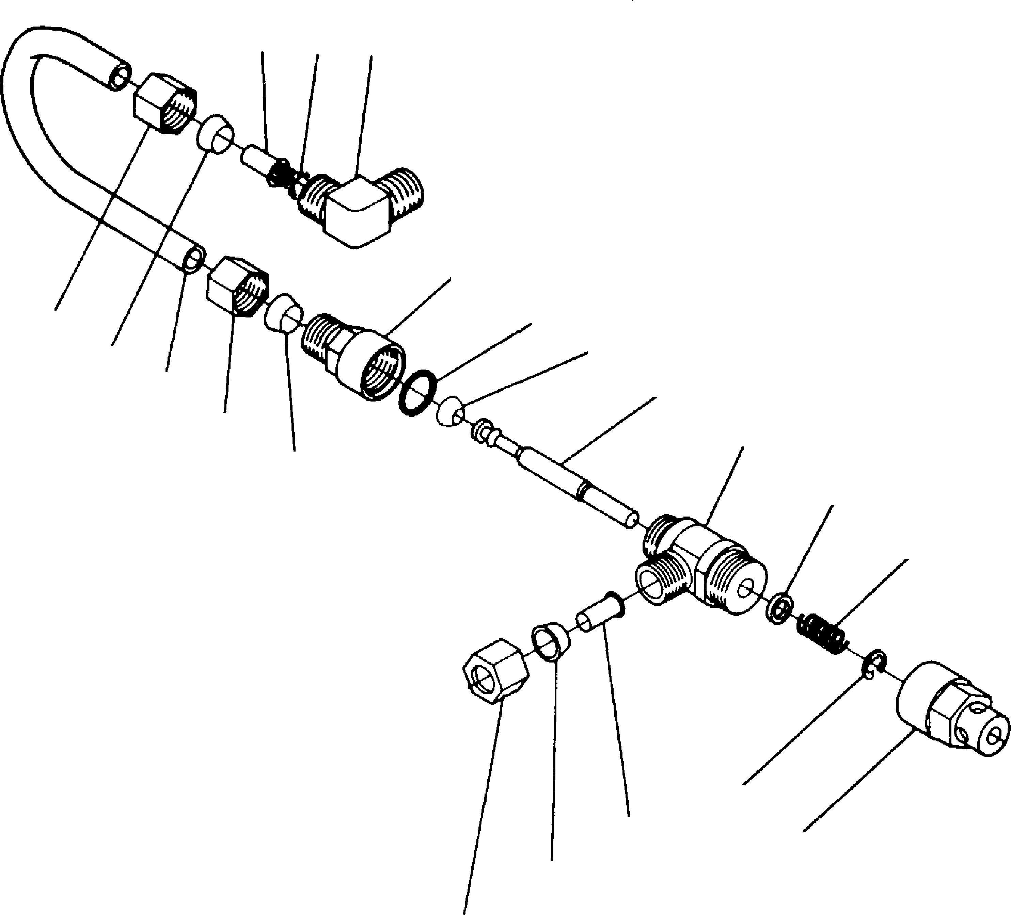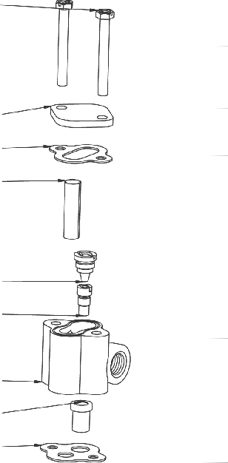16
1 2 3
15
4
14
5
13
6
12
4
11
5
10
9
7
3
5
8
7
8
24

1
1
19

20
21

22
23

4

Item No. Quantity Part No. Description
1 . . . . . . . . . . . . 1 . . . . . . . . . . . . . 10328 90° Elbow - ¼ Pipe Thd. to 3/8″ Tube
2 . . . . . . . . . . . . 1 . . . . . . . . . . . . . 12767 Brine Line Screen
3 . . . . . . . . . . . . 2 . . . . . . . . . . . . . 10332 Insert Sleeve 3/8″ Tube)
4 . . . . . . . . . . . . 3 . . . . . . . . . . . . . 10329 Fitting Nut (3/8″ Tube)
5 . . . . . . . . . . . . 3 . . . . . . . . . . . . . 10330 Derlin Sleeve (3/8″ Tube)
6 . . . . . . . . . . . . 1 . . . . . . . . . . . . . 15221 Brine Valve Tube
7 . . . . . . . . . . . . 1 . . . . . . . . . . . . . 10250 Retaining Ring
8 . . . . . . . . . . . . 1 . . . . . . . . . . . . . 11749 Stem Guide
9 . . . . . . . . . . . . 1 . . . . . . . . . . . . . 10249 Brine Valve Spring
10 . . . . . . . . . . . . 1 . . . . . . . . . . . . . 12550 Quad Ring
11 . . . . . . . . . . . . 1 . . . . . . . . . . . . . 12748 Brine Valve Body
12 . . . . . . . . . . . . 1 . . . . . . . . . . . . . 12552 Brine Valve Stem
13 . . . . . . . . . . . . 1 . . . . . . . . . . . . . 12626 Brine Valve Seat
14 . . . . . . . . . . . . 1 . . . . . . . . . . . . . 11982 O-Ring
15 . . . . . . . . . . . . 1 . . . . . . . . . . . . . 60020-25 BLFC.25GPM
60020-50 BLFC .50 GPM
60020-100 BLFC 1.0 GPM
16. . . . . . . . . . . 2. . . . . . . . . . . . 10692. . . . . . . . . . . . . . . . Screw, Slotted, Indented Hex Head, #10 - 24 X 5/6
17. . . . . . . . . . . 1. . . . . . . . . . . . 11893 Cap, Injector, SS
18. . . . . . . . . . . 1. . . . . . . . . . . . 10229 Gasket, Injector Body
19. . . . . . . . . . . 1. . . . . . . . . . . . 10227 Screen, Injector
20. . . . . . . . . . . 1. . . . . . . . . . . . 10913 Nozzle, Injector, Std
21. . . . . . . . . . . 1. . . . . . . . . . . . 10914 Injector Throat, Std
22. . . . . . . . . . . 1. . . . . . . . . . . . 17776 Body, Injector, 1600
23. . . . . . . . . . . 1. . . . . . . . . . . . 16221 Disperser, Air
24. . . . . . . . . . . 1. . . . . . . . . . . . 14805 Gasket, Injector Body

Page 22

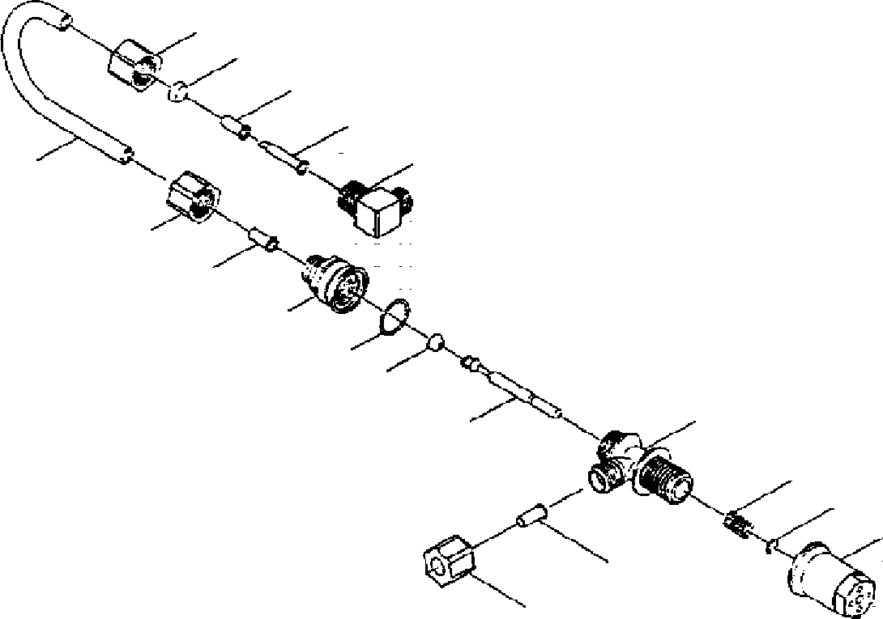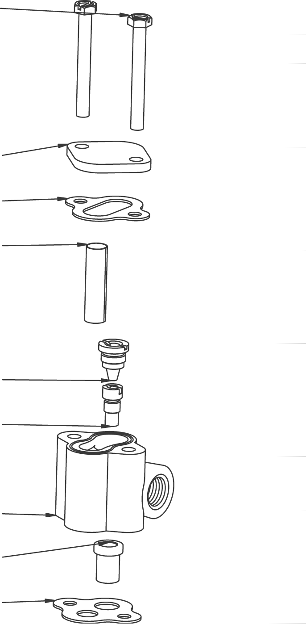17
5
4
3
2
6
1
7
3
16
8
9
10
15
14
13
3
11
8
9
25

1
1
20

21
22

12 23
24

Item No. Quantity Part No. Description 60011 Brine Valve Assembly, Includes Items 3-15 (Less BLFC 60010-)
1 . . . . . . . . . . . 1 . . . . . . . . . . . 10328 Elbow, 90 1/4 NPT x 3/8
2 . . . . . . . . . . . 1 . . . . . . . . . . . 12767 Screen, Brine Line
3 . . . . . . . . . . . 3 . . . . . . . . . . . 10332 nsert, 3/8
4 . . . . . . . . . . . 1 . . . . . . . . . . . 10330 Sleeve, 3/8 Nut Brine
5 . . . . . . . . . . . 1 . . . . . . . . . . . 10329 Tube Fitting, 3/8 Nut Brine
6 . . . . . . . . . . . 1 . . . . . . . . . . . 40027 Tube, Brine Valve
7 . . . . . . . . . . . 1 . . . . . . . . . . . 19625 Assy., GFN Nut
8 . . . . . . . . . . . 1 . . . . . . . . . . . 16924 O-Ring
9 . . . . . . . . . . . 1 . . . . . . . . . . . 12626 Seat, Brine Valve
10 . . . . . . . . . . 1 . . . . . . . . . . . 12552 Brine Valve Stem, 1600
11 . . . . . . . . . . 1 . . . . . . . . . . . 19625 Assy., GFN Nut
12 . . . . . . . . . . 1 . . . . . . . . . . . 17906 Guide, Brine Valve Stem
13 . . . . . . . . . . 1 . . . . . . . . . . . 10250 Retaining Ring
14 . . . . . . . . . . 1 . . . . . . . . . . . 10249 Spring, Brine Valve
15 . . . . . . . . . . 1 . . . . . . . . . . . 17884 Brine Valve Body Assy., Plastic
16 . . . . . . . . . . . 1 . . . . . . . . . . . . . 60020-25 BLFC.25GPM
60020-50 BLFC .50 GPM
60020-100 BLFC 1.0 GPM
17 . . . . . . . . . . 2 . . . . . . . . . . . 10692 . . . . . . . . . . . . . . . Screw, Slotted, Indented Hex Head, #10 - 24 X 5/6
18 . . . . . . . . . . 1 . . . . . . . . . . . 11893 Cap, Injector, SS
19 . . . . . . . . . . 1 . . . . . . . . . . . 10229 Gasket, Injector Body
20 . . . . . . . . . . 1 . . . . . . . . . . . 10227 Screen, Injector
21 . . . . . . . . . . 1 . . . . . . . . . . . 10913 Nozzle, Injector, Std
22 . . . . . . . . . . 1 . . . . . . . . . . . 10914 Injector Throat, Std
23 . . . . . . . . . . 1 . . . . . . . . . . . 17776 Body, Injector, 1600
24 . . . . . . . . . . 1 . . . . . . . . . . . 16221 Disperser, Air
25 . . . . . . . . . . 1 . . . . . . . . . . . 14805 Gasket, Injector Body

27
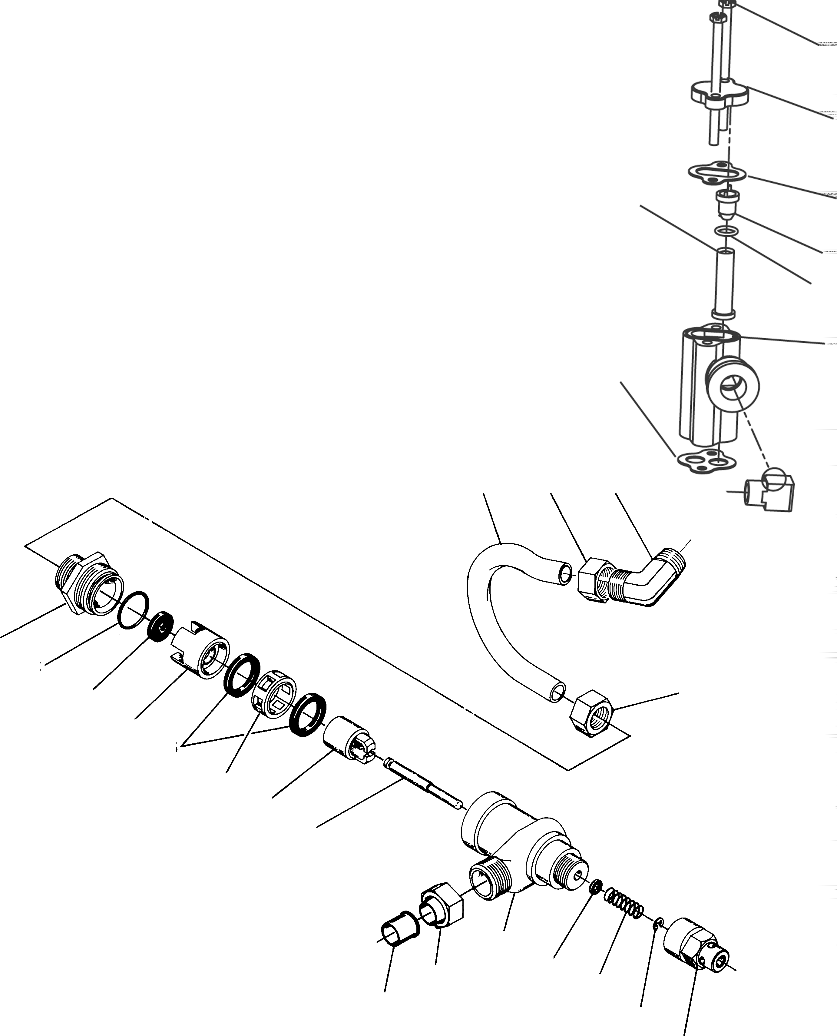

26

22 25

24
23

21
20

17 15 16

1
2
3 15
4
5
6
7
8

18
14 19
9
10 11

12 13

1700 Brine System Parts List

Item No. Quantity Part No. Description
1 . . . . . . . . . . . 1 14792 End Plug
2 . . . . . . . . . . . 1 . . . . . . . . . . . 13201 O-Ring - End Plug
3 . . . . . . . . . . . 1 . . . . . . . . . . . 12085 Flow Washer 1.2 GPM
12086 Flow Washer 1.5 GPM
12087 Flow Washer 2.0 GPM
12088 Flow Washer 2.4 GPM
12089 Flow Washer 3.0 GPM
12090 Flow Washer 3.5 GPM
12091 Flow Washer 4.0 GPM
12092 Flow Washer 5.0 GPM
4 . . . . . . . . . . . 1 . . . . . . . . . . . 14785 Flow Control Retainer
5 . . . . . . . . . . . 2 . . . . . . . . . . . 14811 Piston Seals
6 . . . . . . . . . . . 1 . . . . . . . . . . . 14798 Spacer
7 . . . . . . . . . . . 1 . . . . . . . . . . . 14795 Brine Valve Piston
8 . . . . . . . . . . . 1 . . . . . . . . . . . 14797 Brine Valve Stem
9 . . . . . . . . . . . 1 . . . . . . . . . . . 14790 Brine Valve Body
10 . . . . . . . . . . 1 . . . . . . . . . . . 12550 Quad Ring - Brine Stem
11 . . . . . . . . . . 1 . . . . . . . . . . . 15310 Spring - Brine Valve
12 . . . . . . . . . . 1 . . . . . . . . . . . 10250 Retaining Ring
13 . . . . . . . . . . 1 . . . . . . . . . . . 15517 Stem Guide
14 . . . . . . . . . . 1 . . . . . . . . . . . 15415 Insert
15 . . . . . . . . . . 2 . . . . . . . . . . . 15414 Nut Ferrule 1/2″
16 . . . . . . . . . . 1 . . . . . . . . . . . 15413 Elbow
17 . . . . . . . . . . 1 . . . . . . . . . . . 15416 Brine Tube
18 . . . . . . . . . . 2 . . . . . . . . . . . 16123 Tube Nut 1/2″
19 . . . . . . . . . . 2 . . . . . . . . . . . 16124 Ferrule 1/2″
20 . . . . . . . . . . 1 . . . . . . . . . . . 16974 Fitting, Brass, Female 3/4″ x 3/4″ Slip - Not Shown
21 . . . . . . . . . . 1 . . . . . . . . . . . 11893 Injector Cover
22 . . . . . . . . . . 1 . . . . . . . . . . . 10229 Injector Cover Gasket
23 . . . . . . . . . . 1 . . . . . . . . . . . 17777 Injector Body
24 . . . . . . . . . . 1 . . . . . . . . . . . *14802 Injector Throat
25 . . . . . . . . . . 1 . . . . . . . . . . . *14801 Injector Nozzle
26 . . . . . . . . . . 1 . . . . . . . . . . . 14803 Injector Screen
27 . . . . . . . . . . 2 . . . . . . . . . . . 14804 Screw, Hex Head Mach, #10 - 24 X 2 3/4" 18-8 SS
*Injector Throat *Injector Nozzle Size Color 14802-03C . . . . . 14801-03C . . . . #3C Yellow
14802-04C . . . . . 14801-04C . . . . #4C Green
14802-05C . . . . . 14801-05C . . . . #5C White
14802-06C . . . . . 14801-06C . . . . #6C Red
14802-07C . . . . . 14801-07C . . . . #7C Black

1710 Brine System

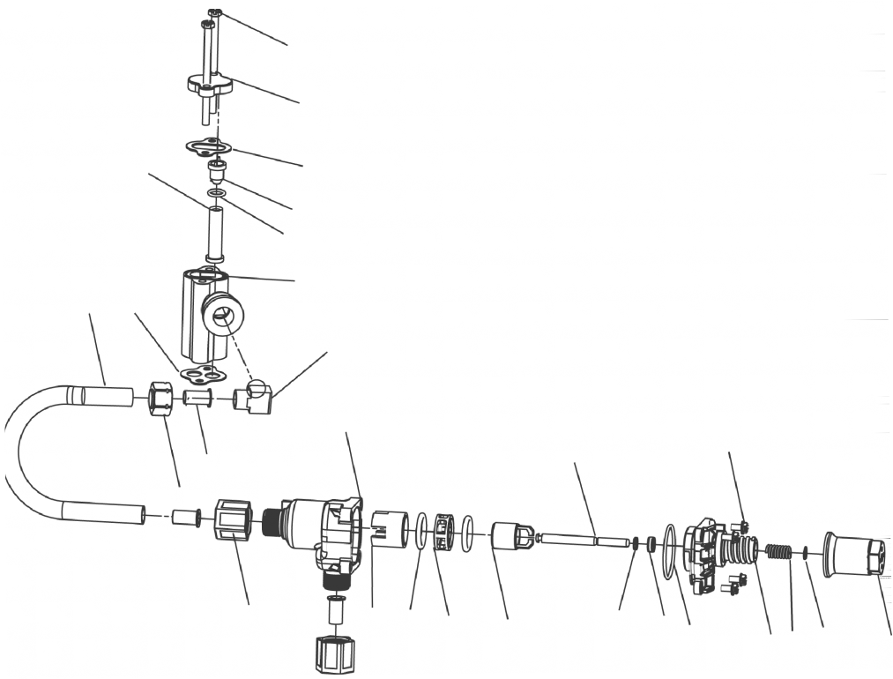
28
27
26
25
24
23
22
20
21
29
1
14
6
19
18
15
2
3
8
4
9
5
10
13
12
11
7

60604

1710 Brine System Parts List

Item No. Quantity Part No. Description
1 . . . . . . . . . . . 1 . . . . . . . . . . . 41202 1700 Plastic Brine,Top
2 . . . . . . . . . . . 1 . . . . . . . . . . . 14785-01 Retainer, Flow Control
3 . . . . . . . . . . . - . . . . . . . . . . . . 14811 O-Ring, -210, 560CD
4 . . . . . . . . . . . 1 . . . . . . . . . . . 14798 Spacer, 2900
5 . . . . . . . . . . . 1 . . . . . . . . . . . 14795 Piston, Brine Valve
6 . . . . . . . . . . . 1 . . . . . . . . . . . 41203 Brine Valve Stem
7 . . . . . . . . . . . 1 . . . . . . . . . . . 41201 1700 Plastic Brine, Bottom
8 . . . . . . . . . . . 1 . . . . . . . . . . . 12550 . . . . . . . . . . . . . . . Ring, Quad -009
9 . . . . . . . . . . . 5 . . . . . . . . . . . 17908 Sleeve, Brine Valve Stem
10 . . . . . . . . . . 3 . . . . . . . . . . . 41547 O-Ring, 2mmx35mm
11 . . . . . . . . . . 2 . . . . . . . . . . . 15310 Spring, Brine Valve
12 . . . . . . . . . . 2 . . . . . . . . . . . 10250 Ring, Retaining
13 . . . . . . . . . . 1 . . . . . . . . . . . 17906 Guide, Brine Valve Stem
14 . . . . . . . . . . 2 . . . . . . . . . . . 14202-01 Screw, Hex Wsh Mach, 8-32 X 5/16"
15 . . . . . . . . . . 2 . . . . . . . . . . . 41056 Nut Assembly, 1/2"
16 . . . . . . . . . . 1 . . . . . . . . . . . 19151 Washer, Flow, 1.0 Gpm (not shown)
17 . . . . . . . . . . 1 . . . . . . . . . . . 41493-00 Label, Blfc, 1710 (not shown)
18 . . . . . . . . . . 1 . . . . . . . . . . . 16460 Tube, Brine, 2900
19 . . . . . . . . . . 1 . . . . . . . . . . . 15414 Nut, 2900, W/Sleeve
21 . . . . . . . . . . 1 . . . . . . . . . . . 19925 Gasket, Injector Body
22 . . . . . . . . . . 1 . . . . . . . . . . . 17777-03 Body, Injector, 1700
23 . . . . . . . . . . 1 . . . . . . . . . . . 14802-++C Throat, Injector
24 . . . . . . . . . . 1 . . . . . . . . . . . 13771 . . . . . . . . . . . . . . . O-ring, -012
25 . . . . . . . . . . 1 . . . . . . . . . . . 14801-++C Nozzle, Injector
26 . . . . . . . . . . 1 . . . . . . . . . . . 10229 Gasket, Injector Body
27 . . . . . . . . . . 1 . . . . . . . . . . . 10228 Cap, Injector
28 . . . . . . . . . . 2 . . . . . . . . . . . 14804 Screw, Hex Head Mach, #10 - 24 X 2 3/4" 18-8 SS
29 . . . . . . . . . . 1 . . . . . . . . . . . 15413 Fitting, Elbow, Male, 1/2T X 3/8NPT

2″ Meter Assembly

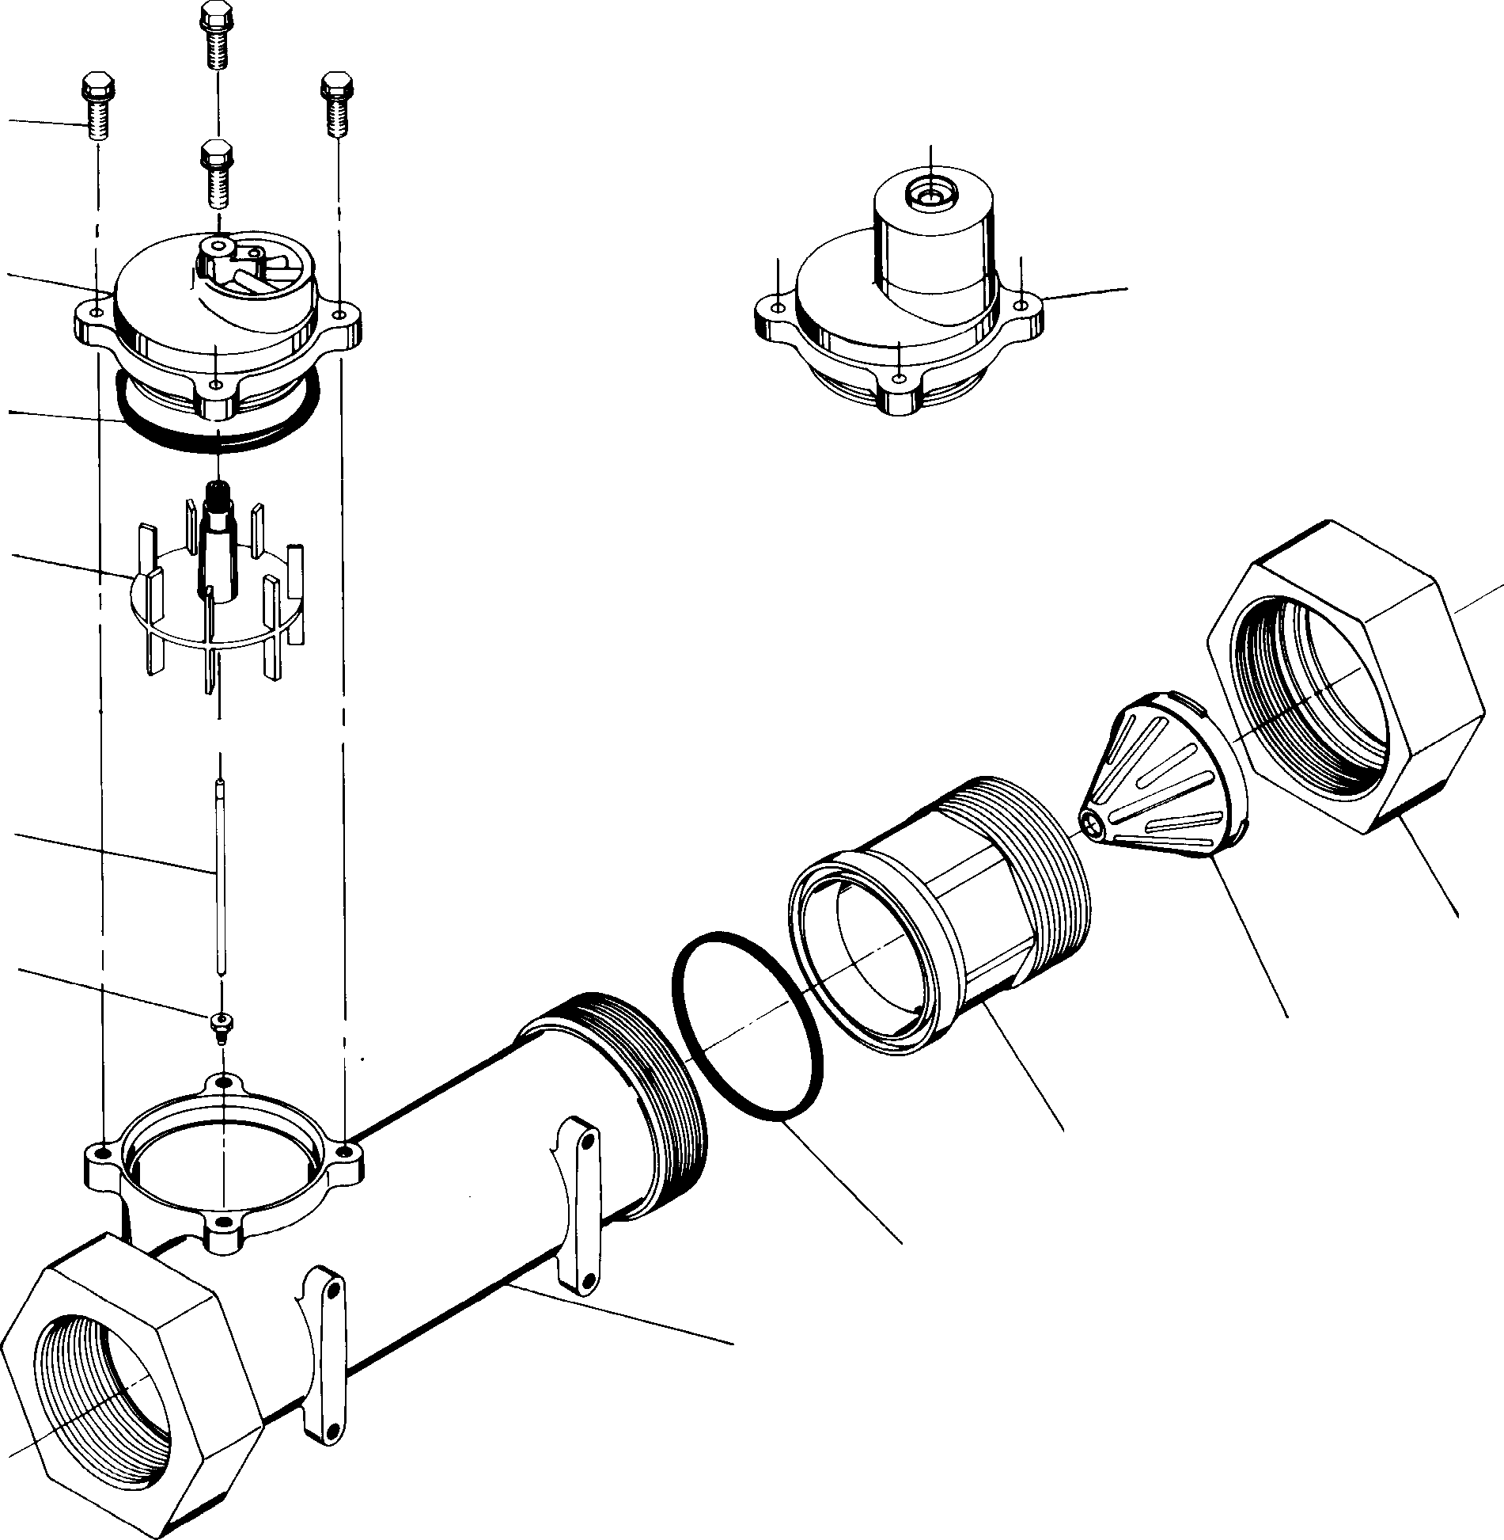8
7B
12
11
10
9
1

7A

6

5

3

2

Item No. Quantity Part No. Description
1 . . . . . . . . . . . 1 14456 Meter Body
2 . . . . . . . . . . . 1. . . . . . . . . . . . 15532 Impeller Shaft Retainer
3 . . . . . . . . . . . 1. . . . . . . . . . . . 15432 Impeller Shaft
4 Not Assigned
5 . . . . . . . . . . . 1. . . . . . . . . . . . 15374 Impeller
6 . . . . . . . . . . . 1. . . . . . . . . . . . 13847 O-Ring - Meter Cover
7A . . . . . . . . . . 1. . . . . . . . . . . . 15218 Meter Cover Assembly (Standard)
7B . . . . . . . . . . 1. . . . . . . . . . . . 15237 Meter Cover Assembly (Extended Range)
8 . . . . . . . . . . . 4. . . . . . . . . . . . 12112 Screw - Meter Cover
9 . . . . . . . . . . . 1. . . . . . . . . . . . 14679 O-Ring - Quick Connect
10. . . . . . . . . . . 1. . . . . . . . . . . . 14568 Nipple - Quick Connect
11. . . . . . . . . . . 1. . . . . . . . . . . . 14680 Flow Straightener
12. . . . . . . . . . . 1. . . . . . . . . . . . 14569 Nut - Quick Connect

2″ Plastic Meter Assembly

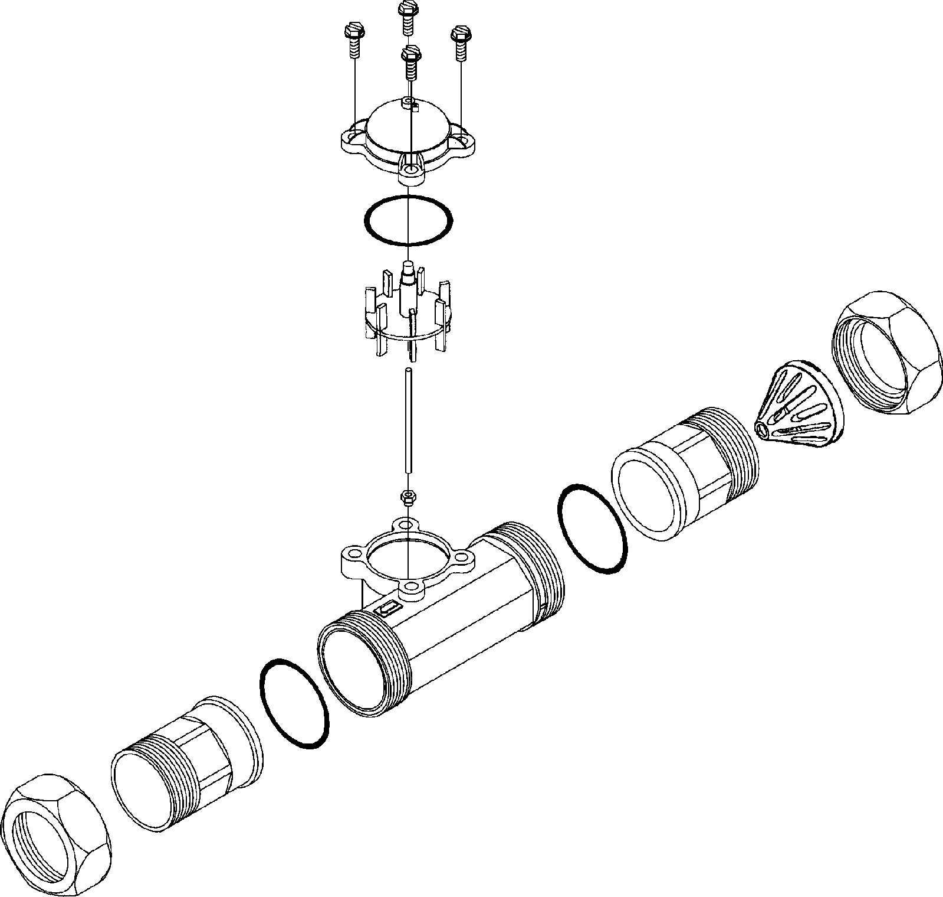13
8
7
6
5
3

2
11
4
9
1
9
10
12
13

Item No. Quantity Part No. Description
1 . . . . . . . . . . . . 1 . . . . . . . . . . . . 17689 Body, Meter, 2″ Plastic
2 . . . . . . . . . . . . 1 . . . . . . . . . . . . 15532 Shaft, Impeller Seat
3 . . . . . . . . . . . . 1 . . . . . . . . . . . . 15432 Shaft, Impeller
4 . . . . . . . . . . . . 1 . . . . . . . . . . . . 60620 Meter Assembly, 2″ (Standard Range)
. . . . . . . . . . . . 1 . . . . . . . . . . . . 60621 Meter Assembly, 2″ (Extended Range)
. . . . . . . . . . . . . . . . . . . . . . . . . 60625 Meter Assembly, 2″ (Electronic)
5 . . . . . . . . . . . . 1 . . . . . . . . . . . . 15374 Impeller Assembly, 2″ Meter
6 . . . . . . . . . . . . 1 . . . . . . . . . . . . 13847 O-Ring, -137, Meter
7 . . . . . . . . . . . . 1 . . . . . . . . . . . . 14038 Meter Cap Assembly (Standard Range)
1 . . . . . . . . . . . . 15150 Meter Cap Assembly (Extended Range)
1 . . . . . . . . . . . . 14716 Meter Cap Assembly (Electronic)
8 . . . . . . . . . . . . 4 . . . . . . . . . . . . 12473 . . . . . . . . . . . . . . . . .Screw, Hex Washer, 10-24 x 5/8
9 . . . . . . . . . . . . 2 . . . . . . . . . . . . 40666 Seal, Face, 2″, Plastic
10A . . . . . . . . . . 1 . . . . . . . . . . . . 17987-001 Fitting, Nipple, 2″, Plastic, NPT, Machined
10B . . . . . . . . . . 1 . . . . . . . . . . . . 17987-101 Fitting, Nipple, 2″, Plastic, BSP, Machined
11A . . . . . . . . . . 1 . . . . . . . . . . . . 17987-000 Fitting, Nipple, 2″, Plastic, NPT
11B . . . . . . . . . . 1 . . . . . . . . . . . . 17987-100 Fitting, Nipple, 2″, Plastic, BSP
12 . . . . . . . . . . . 1 . . . . . . . . . . . . 14680 Flow Straightener
13 . . . . . . . . . . . 2 . . . . . . . . . . . . 17988 Nut, 2″ Meter

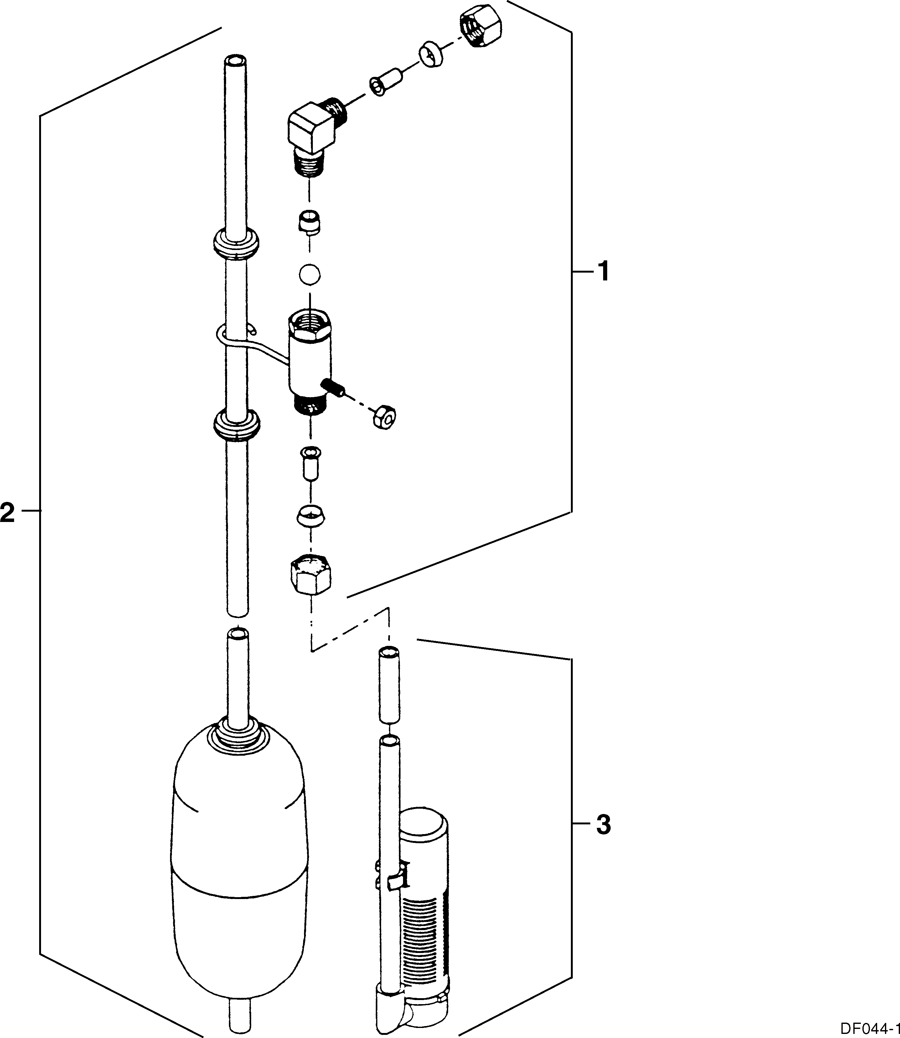

Item | Quantity | Part Number | Description
1 | 1 | 60027-FFA | 2300 safety brine valve, fitting facing arm
 |  | 60027-FFS | 2300 safety brine valve, fitting facing stud
2 | 1 | 60028-30 | float assembly blue/white
 |  | 60026-30SAN | float assembly green/green, hot water
3 | 1 | 60002 | #500 air check
 |  | 60003 | #500 air check, hot water

2310 Safety Brine Valve

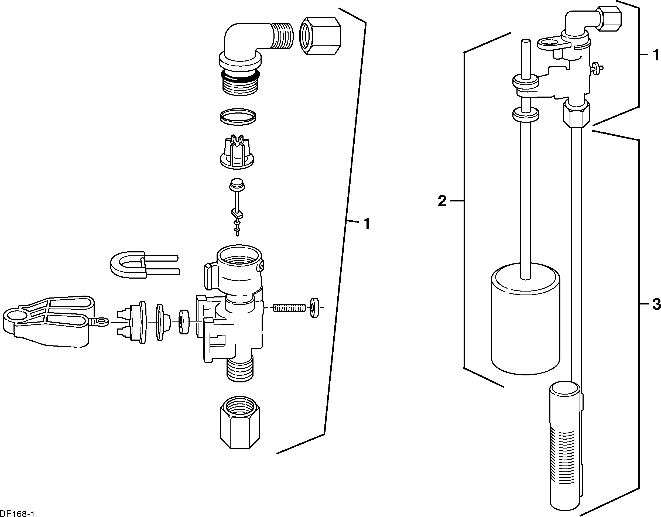

Item | Quantity | Part Number | Description
1 | 1 | 60014 | 2310 safety brine valve
2 | 1 | 60068 | 2310 float assembly
 |  | 60026-30 | float assembly red/white (float fill)
3 | 1 | 60002 | #500 air check

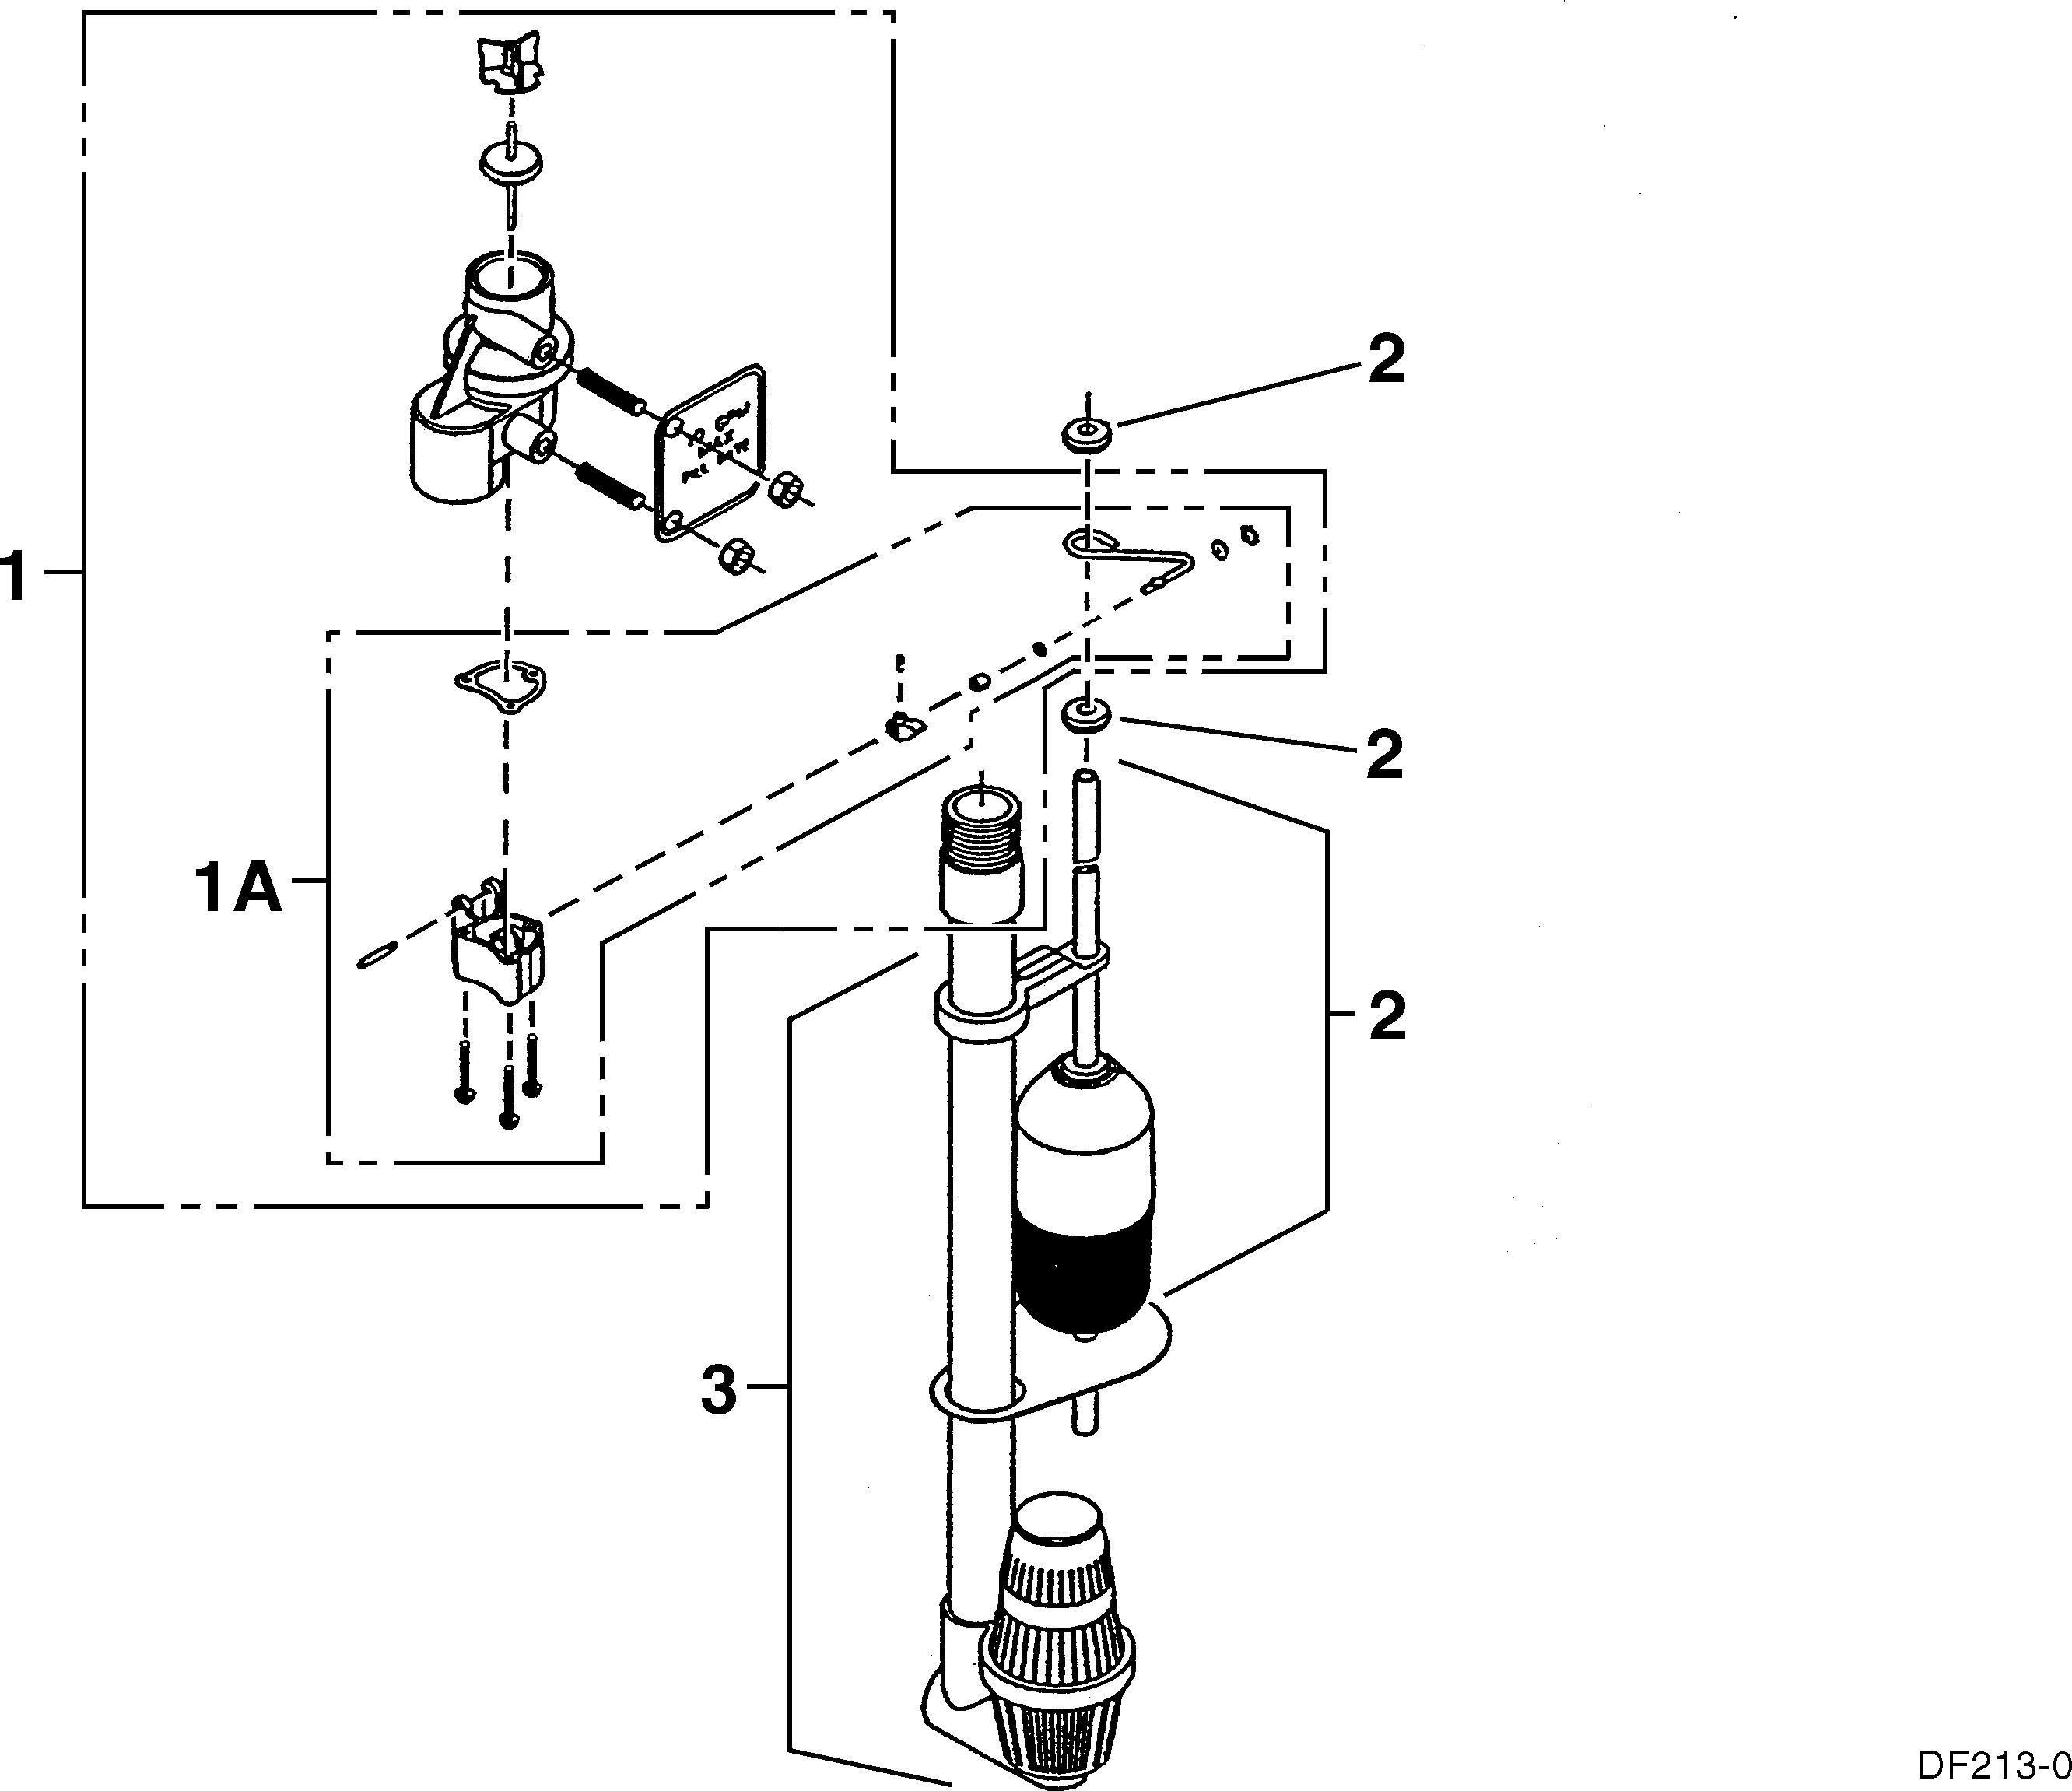

Item | Quantity | Part Number | Description
1 | 1 | 60038 | 2350 safety brine valve
1A | 1 | 61024 | 2350 actuator assembly
2  3 | 1  1 | 60026-30  60076-30SAN  60009-00 | float assembly red/white  float assembly green/green (hot water) #900 air check
 | 1 | 60009-01 | #900 air check hot water
Not Shown  4 |  | 18603 | 2350 fittings for 1700 brine system
5 |  | 18602 | #900 fittings for 1700 brine system

MODEL 2900

Service Valve Operator

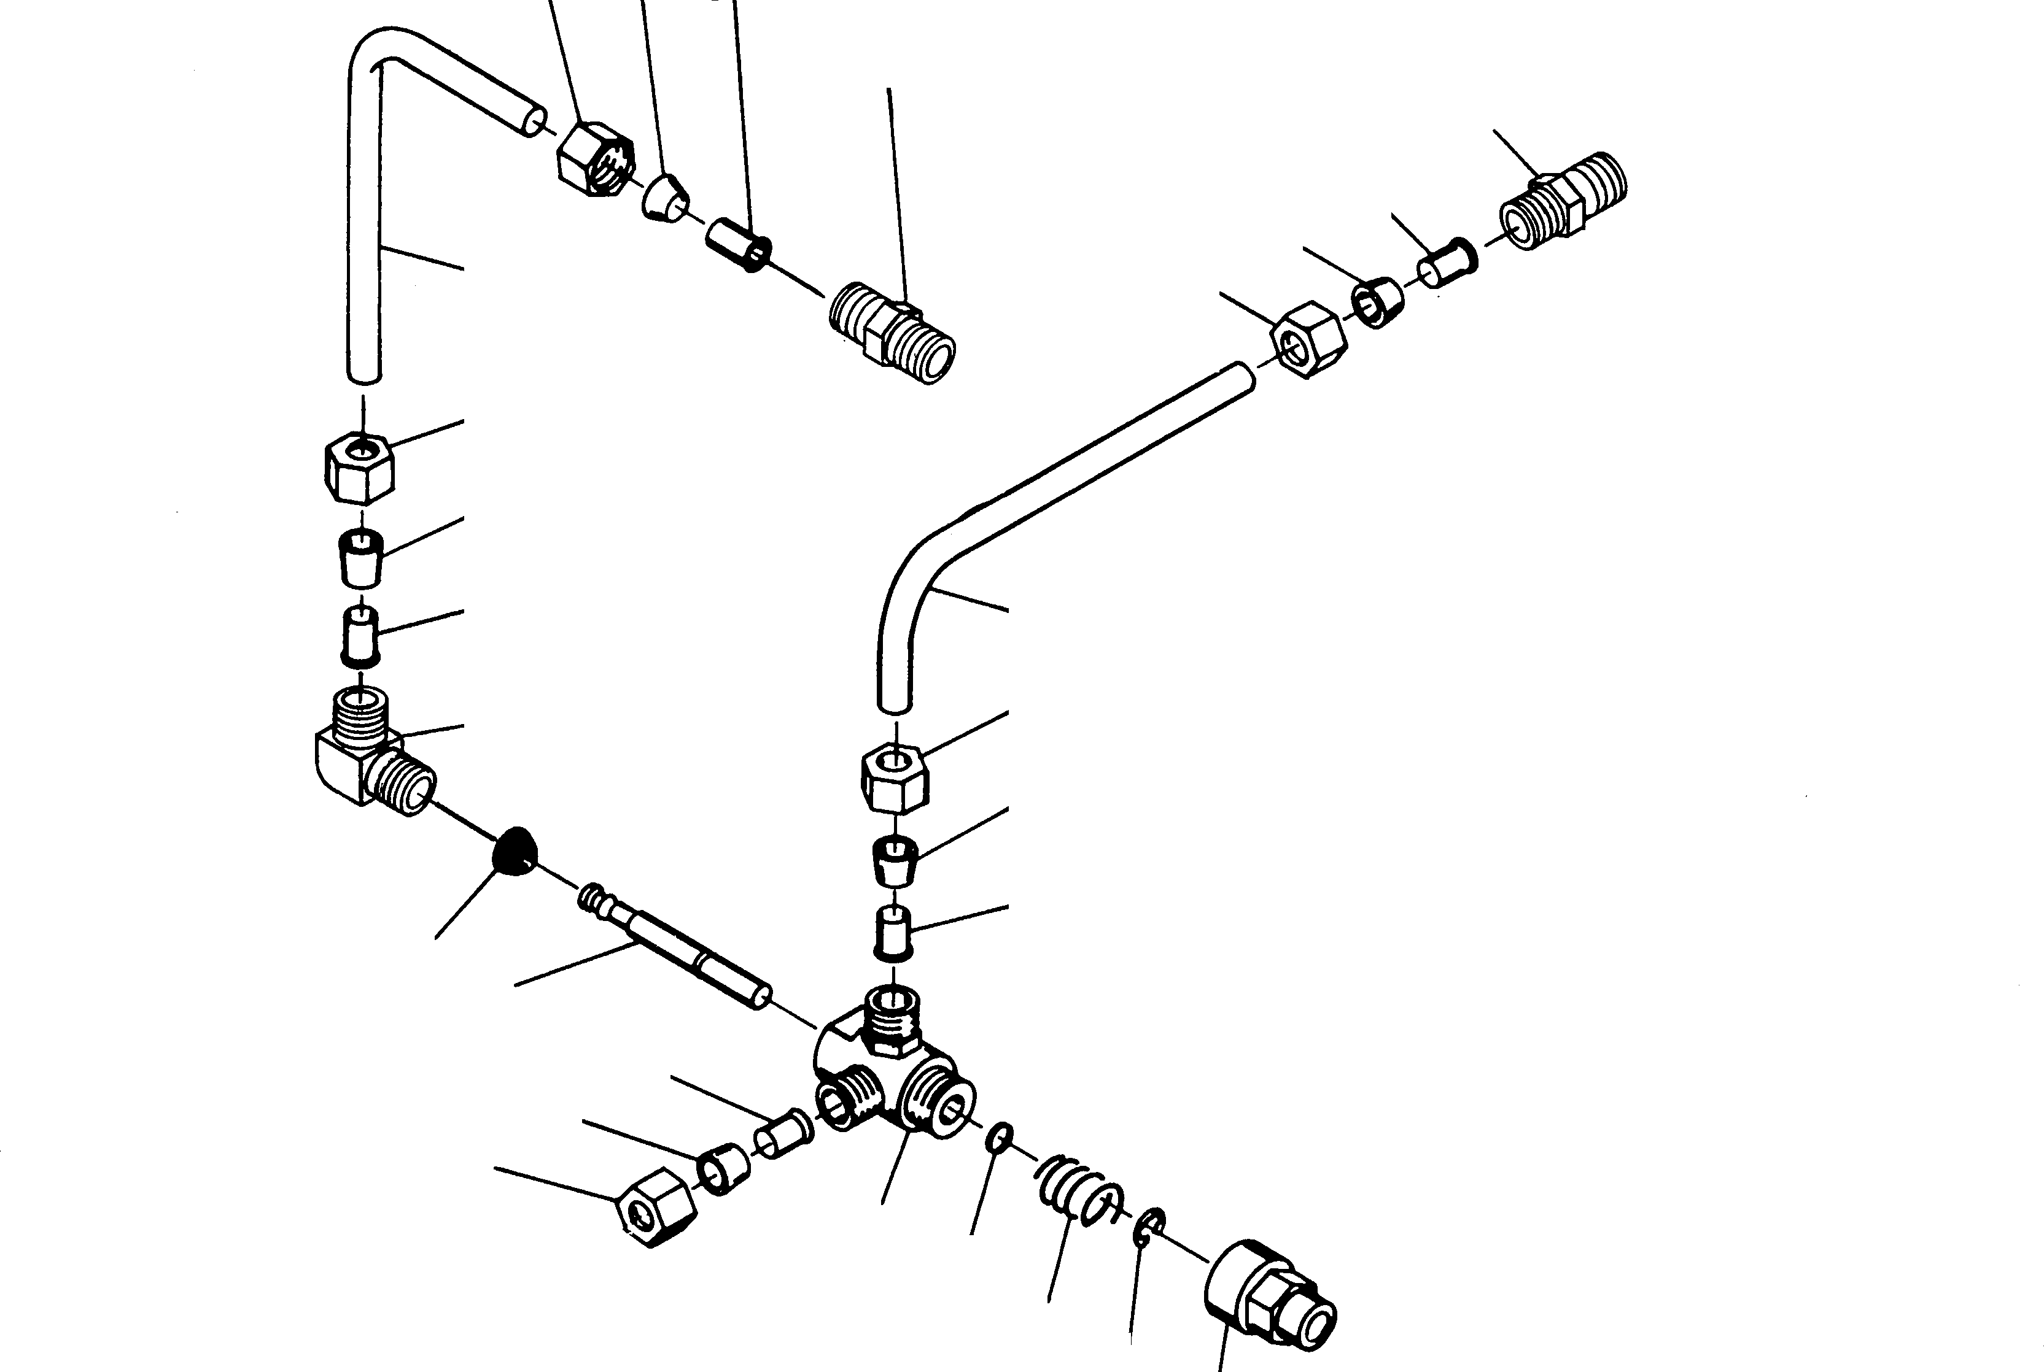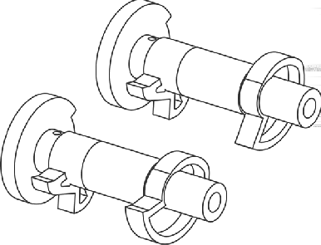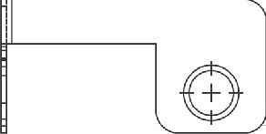
10 9 8
13
13
8
12
10
9
10
9
8

11
14a
12
10
9
8
14b
7
6
8
15
10
9
5 4
3 2
1

PARTS LIST
Item No. Quantity Part No. Description
1 . . . . . . . . . . . 1. . . . . . . . . . . . 11749 Guide, Brine Valve Stem
2 . . . . . . . . . . . 1. . . . . . . . . . . . 10250 Retaining Ring
3 . . . . . . . . . . . 1. . . . . . . . . . . . 10249 Spring, Brine Valve
4 . . . . . . . . . . . 1. . . . . . . . . . . . 12550 Quad Ring
5 . . . . . . . . . . . 1. . . . . . . . . . . . 10785 Service Actuator Assembly - .25 gpm
6 . . . . . . . . . . . 1. . . . . . . . . . . . 12552 Brine Valve Stem, 1600
7 . . . . . . . . . . . 1. . . . . . . . . . . . 12626 Seat, Brine Valve
8 . . . . . . . . . . . 5. . . . . . . . . . . . 10332 Insert,
9 . . . . . . . . . . . 5. . . . . . . . . . . . 10330. . . . . . . . . . . . . . . . Sleeve, 3/8″ Delrin
10. . . . . . . . . . . 5. . . . . . . . . . . . 10329. . . . . . . . . . . . . . . . Nut, 3/8″ Brass
11. . . . . . . . . . . 1. . . . . . . . . . . . 10328 Elbow, 90° 1/4″ NPT x 3/8″
12. . . . . . . . . . . 2. . . . . . . . . . . . 12897 Tube
13. . . . . . . . . . . 2. . . . . . . . . . . . 16730. . . . . . . . . . . . . . . . Connector, Male 1/8″ NPT to 3/8″ T
14a. . . . . . . . . . 1. . . . . . . . . . . . 12472 Cam Assy. Tri stack, After Rapid Rinse
14b . . . . . . . . . 1. . . . . . . . . . . . 15770 Cam Assy. Tri stack, After Brine Tank Fill
15. . . . . . . . . . . 1. . . . . . . . . . . . 12114 Bracket, Motor Outboard

Page 33

Printed in U.S.A.

Control Valve
Side Mount Adapter

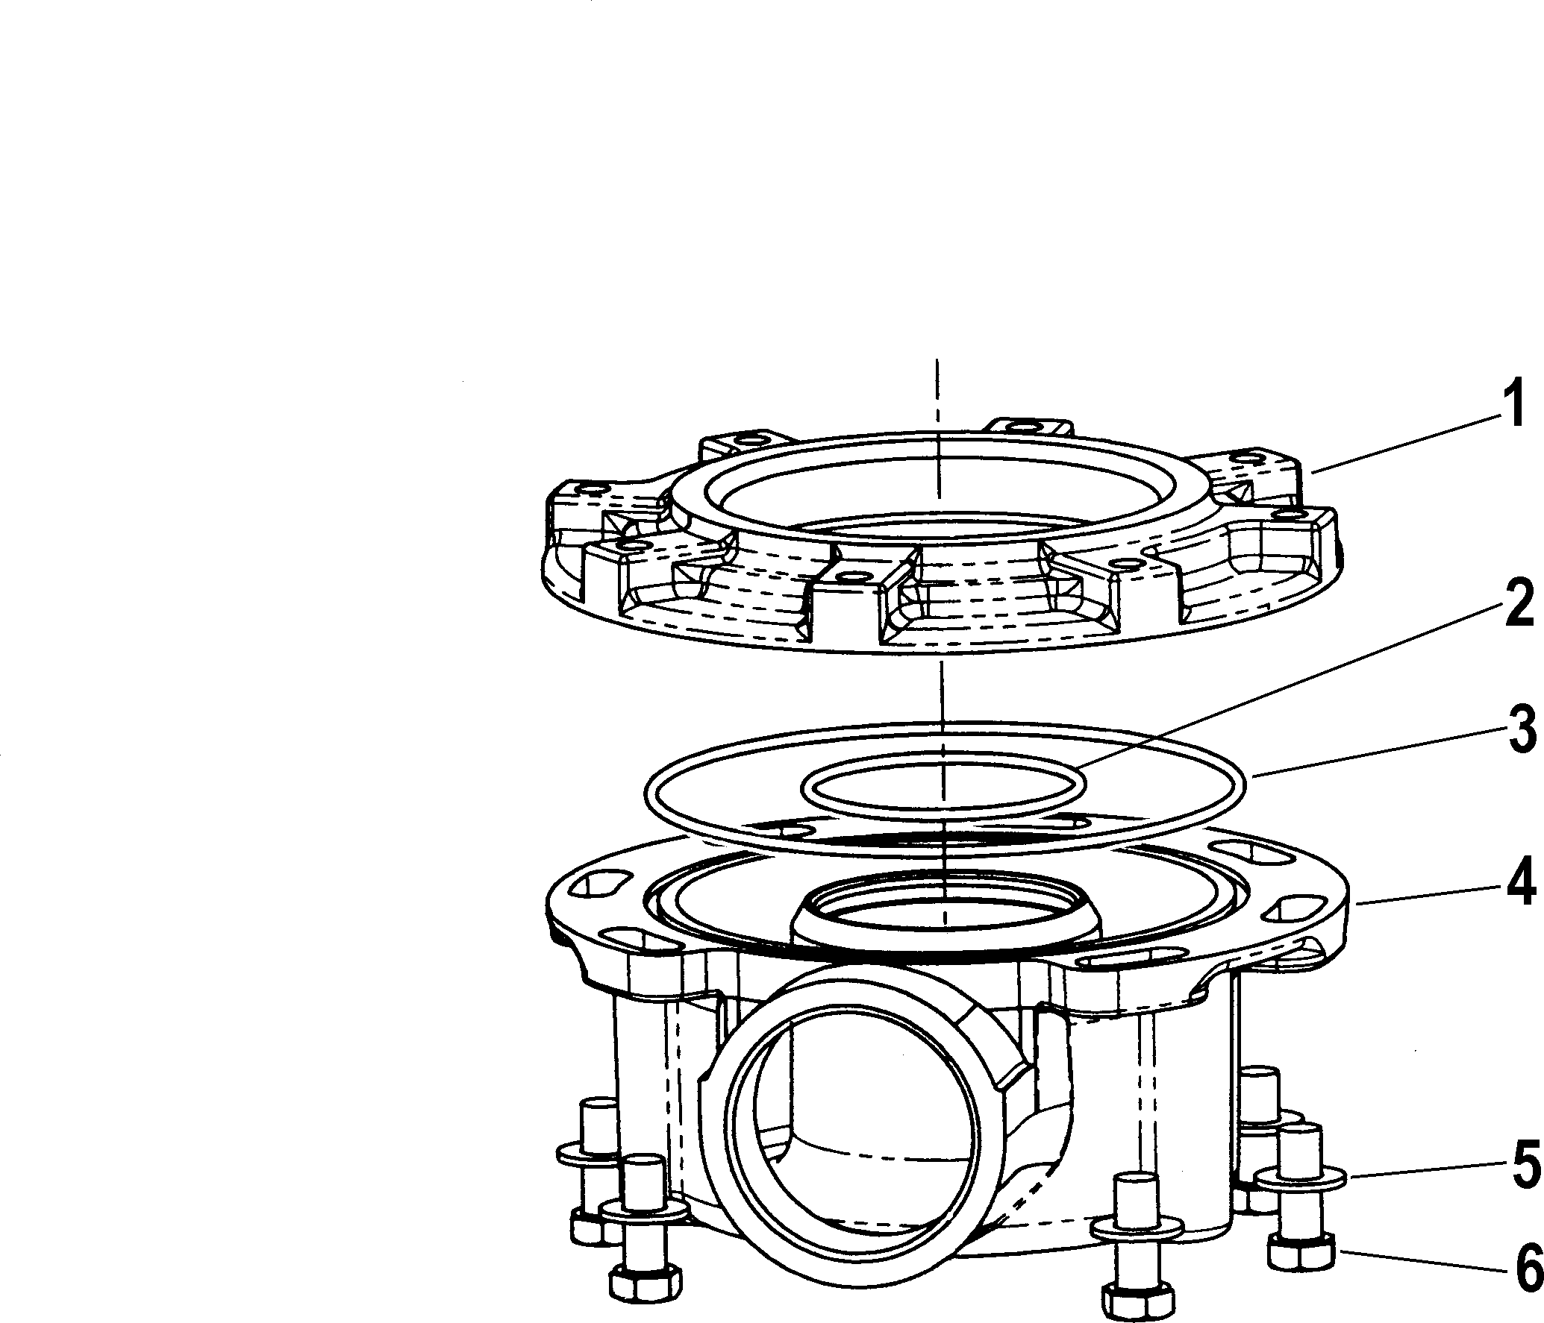7

Item No. Quantity Part No. Description
1 . . . . . . . . . . . 1 . . . . . . . . . . . 40316 Adaptor, Side Mount
2 . . . . . . . . . . . 1 . . . . . . . . . . . 40372 . . . . . . . . . . . . . . . O-Ring - 142
3 . . . . . . . . . . . 1 . . . . . . . . . . . 40368 . . . . . . . . . . . . . . . O-Ring - 160
4 . . . . . . . . . . . 1 . . . . . . . . . . . 40310 Base, Rotating
5 . . . . . . . . . . . 7 . . . . . . . . . . . 40375 Washer
6 . . . . . . . . . . . 7 . . . . . . . . . . . 19768 Screw
7 . . . . . . . . . . . 1 . . . . . . . . . . . 61415 Assembly

MODEL 2900

Service Assemblies

ADAPTERS |  | METERS
61525 | Treated Water Regen Adapter Assembly | 60393 | 2” Meter brass standard range
61415 | Sidemount Adaper Assembly | 60394 | 2” Meter brass extended range
61415NP | Sidemount Adaper Assembly, Nickel Plated | 60616 | 2” Meter brass electronic
61415-20 | Sidemount Adaper Assembly, BSP/Metric | 60620 | 2” Meter plastic standard range
61415-20NP | Sidemount Adaper Assembly, BSP/Metric, Nickel Plated | 60621 | 2” Meter plastic Extended range
 |  | 60625 | 2” Meter plastic electronic
AIR CHECKS |  | 15474-02 | 1 ½” low flow sleeve only
60002 | #500 Air Check
60003 | #500 Air Check Hot Water | PISTON ASSEMBLIES
60009 | # 900 Commercial Air Check | 61540 | Top piston
60009-01 | # 900 Commercial Air Check Hot Water | 61540-01 | Top piston, Hot Water
 |  | 61550 | Lower piston, Hard Water By-Pass
AUXILARY MICRO SWITCH 61550-01 Lower piston, By-Pass, Treated Water Regen
60320-02 | 3200 Series Timer | 61550-02 | Lower piston, By-Pass, Treated Water Regen, Hot Water
60320-11 | Lower Drive (2nd Switch) | 61550-03 | Lower Piston, By-Pass, Hot Water
60230-08 | Lower Drive (3rd Switch) | 61555 | Lower Piston, No By-Pass
 |  | 61555-01 | Lower Piston, No By-Pass, Treated Water Regen, Hot Water
BRINE LINE FLOW (BLFC) 61555-02 Lower Piston, No By-Pass, Treated Water Regen
60020-00 | Model 1600, blank | 61555-03 | Lower Piston, No By-Pass, Hot Water
60020-25 | Model 1600 with .25 gpm flow control
60020-50 Model 1600 with .50 gpm flow control PROGRAM WHEEL ASSEMBLIES
60020-100 | Model 1600 with 1.0 gpm flow control | 60405-20 | 1 ½” Std. Range ( 0 - 10,000 )
60010-00 | Model 1650, blank | 60405-50 | 2” Std. Range ( 0 - 21,000 )
60010-25 | Model 1650 with .25 gpm flow control | 60405-60 | 2” Ext. Range ( 0 - 100,000 )
60010-50 | Model 1650 with .50 gpm flow control | 60405-70 | 1 ½” Ext. Range ( 0 - 50,000 )
60010-100 | Model 1650 with 1.0 gpm flow control
SAFETY BRINE VALVES
BRINE VALVES |  | 60014 | Model 2310 plastic safety brine valve
60011 | Model 1650 brine valve assy. | 60038 | Model 2350 Safety Brine Valve
60029 | Model 1600 brine valve assy. | 60026-30 | Float Assy. (red/white)
60029HW | Model 1600 Hot Water brine valve assy. | 60026-30SAN | San float assy. (Hot Water)
60034-_ _ | Model 1700 brine valve assy.( specify flow control 1.0 - 5.0 ) | 60027-FFA | Model 2300 safety brine valve
60604-_ _ | Model 1710 brine valve assy.( specify flow control 1.0 - 5.0 ) | 60027-FFS | Model 2300 Safety brine valve
 |  | 60028-30 | Float Assy. (blue/white)
COVERS |  | 60068-30 | Float Assy. 2310
60217-_ _ | Environmental lower cover
60219-_ _ | Environmental | SALES AND SERVICE AIDS
60232-_ _ | Designer 2 piece | 16864 -01 | Spec sheet
60232-110 | Designer 1 piece ( only available in black ) | 15238 | Service manual
60239-_ _ | Designer Lower cover | 41717 | Product line Catalog
DRIAN LINE FLOW CONTROLS SEAL & SPACER KITS
60366-_ _ | 1" FNPT x ¾” FNPT ( specify flow control .6 - 7.0) | 61530 | Upper kit
60701-_ _ | 1” FNPT x 1” FNPT ( specify flow control 8.0 - 25.0 ) | 61530-01 | Upper kit, Hot Water
60702-_ _ | 1” FNPT x 1” MNPT ( specify flow control 8.0 - 25.0 ) | 60128 | Lower kit
60708-_ _ | 1” FNPT x ¾” FNPT ( specify flow control 8.0 - 25.0 ) | 60128-01 | Lower kit, Hot Water
60721-_ _ | 1" FNPT x 1” FNPT ( specify flow control .6 - 7.0)
SERVICE EQUIPMENT
CAM ASSEMBLY 11098 Seal & Spacer stuffer tool upper
60160-00 | Separate time fill drive cam ( Black ) | 12682 | Spacer puller tool lower
60160-20 | Lower drive (Designer) | 12683 | Seal & Spacer stuffer tool lower
60160-22 | Lower drive (Environmental) | 13061 | Spacer puller tool upper
 |  | 16174 | Silicone, 2 oz. Tube
24 HOUR GEAR ASSEMBLY |  | 60460 | Meter Checker Std. Range
19205 |  | 60461 | Meter Checker Ext. Range
60519-02 | Model 3200 timer 2 times regeneration | 16586-8 | Silicone, 8 lb. pail
60519-03 | Model 3200 timer 3 times regeneration
60519-04 Model 3200 timer 4 times regeneration SERVICE VALVE OPERATOR ASSEMBLY ( SVO )
60519-06 | Model 3200 timer 6 times regeneration | 60150 | SVO (Old Style)
 |  | 60150-01 | SVO (New Style)
INJECTOR ASSEMBLIES COMPLETE
60483-_ _ _ 1700 - ½” brine (specify size of injector) SKIPPER WHEEL ASEMBLIES
60480-_ _ | 1600 - 3/8” brine (specify size of injector) | 14860 | 3200 Timer 12 day
60481-_ _ | 1600 Brass - 3/8” brine ( specify size of injector) | 14381 | 3200 Timer 7 day

Page 35

Printed in U.S.A.

Service Instructions

PROBLEM | CAUSE | CORRECTION
- Softener Fails To Regenerate.  - Hard Water.  - Unit Used Too Much Salt  - Loss Of Water Pressure.  - Loss of Mineral Through Drain Line.  - Iron In Conditioned Water. | - Electrical Service To Unit Has Been Interrupted.  - Timer Is Defective.  - Power Failure.  - By-Pass Valve is Open.  - No Salt in Brine Tank  - Injector Screen Plugged.  - Insufficient Water Flowing Into Brine Tank  - Hot Water Tank Hardness.  - Leak At Distributor Tube.  - Internal Valve Leak  - Service Adapter Did Not Return To Service.  - Improper Salt Setting.  - Excessive Water in Brine Tank  - Iron Buildup In Line To Water Con- ditioner.  - Iron Buildup in Water Conditioner.  - Inlet of Control Plugged Due to Foreign Material Broken Loose From Pipes By Recent Work Done On Plumbing System.  - Air In Water System.  - Improperly Sized Drain Line Flow Control.  A. Fouled Mineral Bed. | - Assure Permanent Electrical Ser- vice (Check Fuse, Plug, Pull Chain or Switch).  - Replace Timer.  - Reset Time of Day.  - Close By-Pass Valve.  - Add Salt To Brine Tank and Main- tain Salt Level Above Water Level.  - Clean Injector Screen.  - Check Brine Tank Fill Time And Clean Brine Line Flow Control If Plugged.  - Repeated Flushings Of The Hot Water Tank is Required.  - Make Sure Distributor Tube Is Not Cracked. Check O-Ring And Tube Pilot.  - Replace Seals and Spacers And/ Or Piston.  - Check Drive Motor And Switch.  - Check Salt Usage and Salt Set- ting.  - See Problem No. 7.  - Clean Line To Water Conditioner.  - Clean Control and Add Mineral Cleaner to Mineral Bed.  Increased Frequency of Regeneration.  - Remove Piston and Clean Control.  - Assure That Well System Has Proper Air Eliminator Control. Check For Dry Well Condition.  - Check For Proper Drain Rate.  A. Check Backwash, Brine Draw And Brine Tank Fill. Increase Fre- quency of Regeneration. Increase Backwash Time.

Service Instructions (Cont’d.)

PROBLEM | CAUSE | CORRECTION
- Excessive Water In Brine Tank.  - Softener Fails To Draw Brine.  - Control Cycles Continuously.  - Drain Flows Continuously. | - Plugged Drain Line Flow Control.  - Plugged Injector System.  - Timer Not Cycling.  - Foreign Material In Brine Valve.  - Foreign Material In Brine Line Flow Control.  - Drain Line Flow Control Is Plugged.  - Injector Is Plugged.  - Injector Screen Plugged.  - Line Pressure Is Too Low.  - Internal Control Leak  - Service Adapter Did Not Cycle.  A. Misadjusted, Broken or Shorted Switch.  - Valve Is Not Programming Cor- rectly.  - Foreign Material In Control.  - Internal Control Leak | - Clean Flow Control.  - Clean Injector and Screen.  - Replace Timer.  - Replace Brine Valve Seat And Clean Valve.  - Clean Brine Line Flow Control.  - Clean Drain Line Flow Control.  - Clean Injector.  - Clean Screen.  - Increase Line Pressure To 20 P.S.I.  - Change Seals, Spacers and Piston Assembly.  - Check Drive Motor And Switches.  A. Determine If Switch or Timer Is Faulty and Replace It or Replace Complete Power Head.  - Check Timer Program and Posi- tioning of Control. Replace Power Head Assembly If Not Positioning Properly.  - Remove Power Head Assembly And Inspect Bore. Remove Foreign Material and Check Control In Var- ious Regeneration Positions.  - Replace Seals and Piston Assembly.

General Service Hints For Meter Control
Problem: Softener Delivers Hard Water.
Cause could be that . . . Reserve Capacity Has Been Exceeded.
Correction: Check salt dosage requirements and reset program wheel to provide additional reserve. Cause could be that . . . Program Wheel Is Not Rotating With Meter Output
Correction: Pull cable out of meter cover and rotate manually. Program wheel must move without binding and clutch must give positive “clicks” when program wheel strikes regeneration stop. If it does not, replace timer.
Cause could be that . . . Meter Is Not Measuring Flow. Correction: Check meter with meter checker.

Service Position

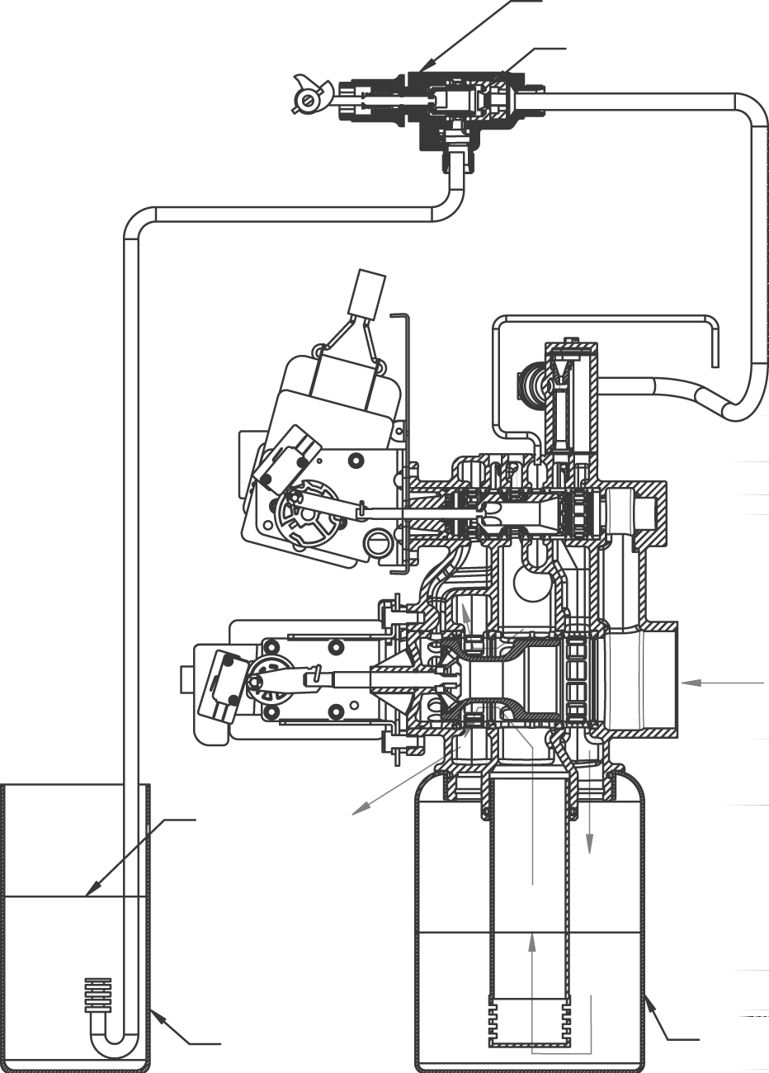INLET
BRINE VALVE

FLOW CONTROL
DRAIN
DRAIN
BRINE LEVEL
OUTLET
BRINE TANK
RESIN TANK

Hard water enters unit at valve inlet and flows down thru the mineral in the mineral tank. Conditioned water enters center tube thru the bottom distributor — then flows up thru the center tube — around the piston and out the side outlet of the valve.

Page 38

Backwash Position

BRINE VALVE

FLOW CONTROL

DRAIN

INLET

BRINE LEVEL
OUTLET

BRINE TANK
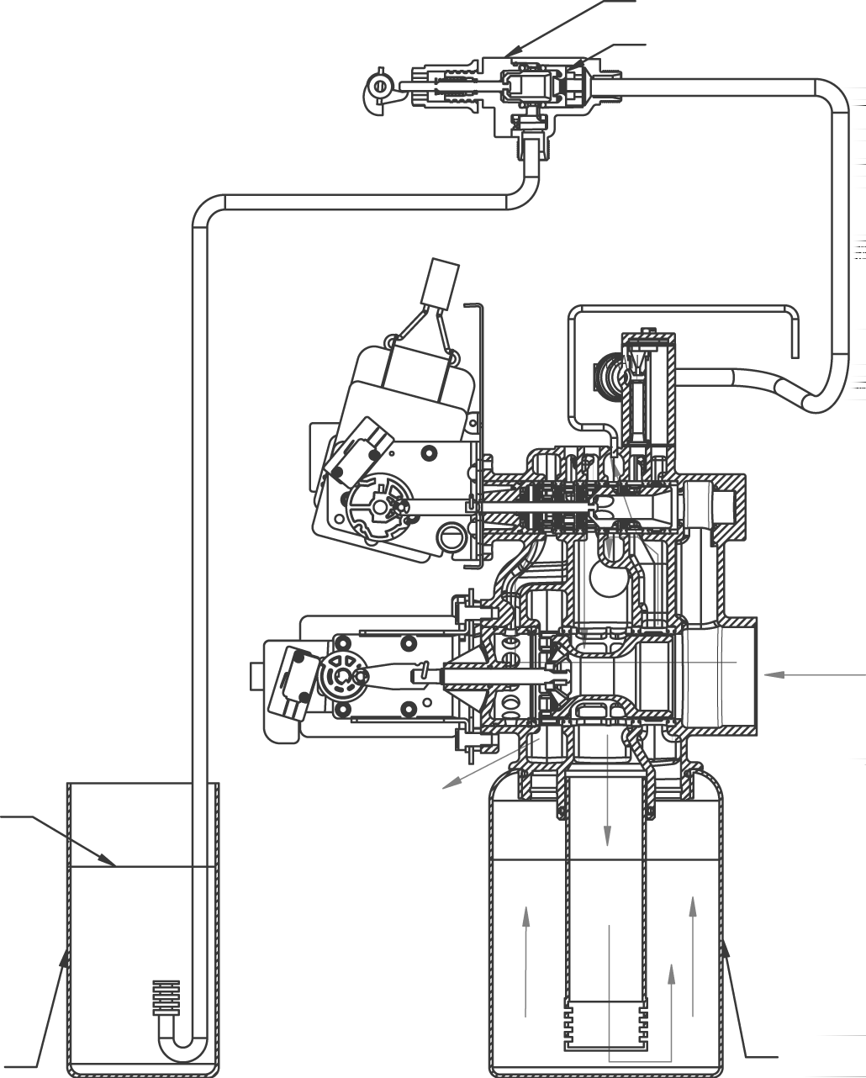

RESIN TANK

Hard water enters unit at valve inlet — flows to the front passage and up through the front passage to regenerating valve — down the center tube — thru the bottom distributor and up thru the mineral — around the piston and out the drain line. If optional no hard water by pass piston is used water flow to outlet is prevented by an extended section of the service piston which closes the outlet port from by pass water until the end of rapid rinse.

Brine Position

BRINE VALVE FLOW CONTROL
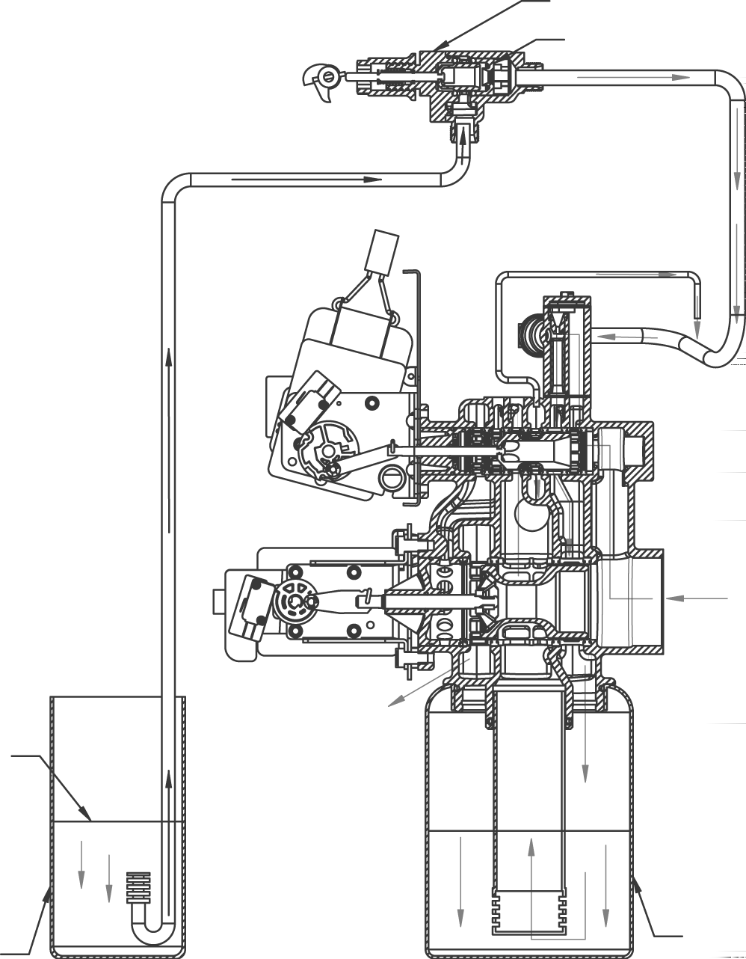

INLET

BRINE LEVEL

OUTLET

BRINE TANK
RESIN TANK

Hard water enters unit at valve inlet — flows up into injector housing and down thru nozzle and orifice to draw brine from the brine tank — brine flows down thru mineral and enters the center tube thru bottom distributor — flows up thru center tube — around the piston and out thru the drain line.

Page 40

Slow Rinse Position

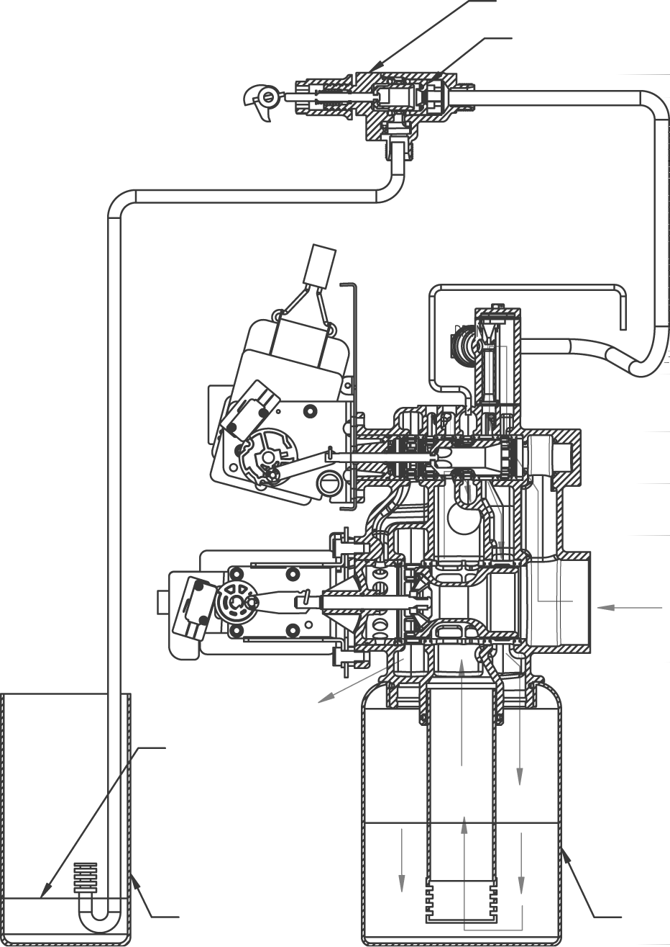INLET
BRINE VALVE

FLOW CONTROL
DRAIN
OUTLET
BRINE LEVEL
BRINE TANK
RESIN TANK

Page 41
Hard water enters unit at valve inlet — flows up into injector housing and down thru nozzle and orifice
— around the piston — down thru mineral — enters center tube thru bottom distributor — flows up thru center tube — around piston and out thru the drain line.

Rapid Rinse

BRINE VALVE
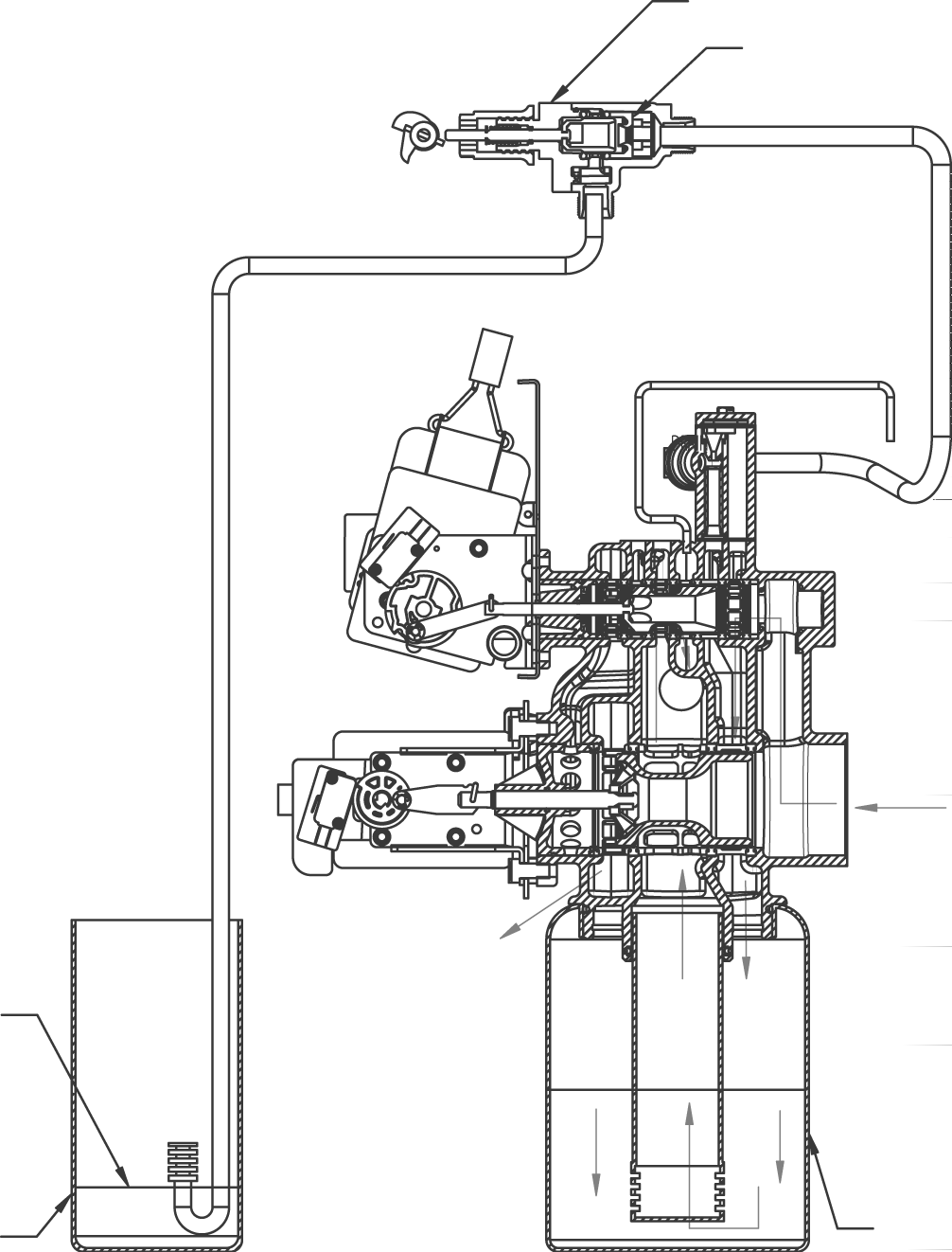

FLOW CONTROL

DRAIN

INLET

OUTLET

BRINE LEVEL

BRINE TANK

RESIN TANK

Hard water flows thru the regenerating valve directly down thru the mineral into the bottom distributor and up thru the center tube — around the piston and out the drain line.
Page 42

Brine Tank Fill Position

BRINE VALVE
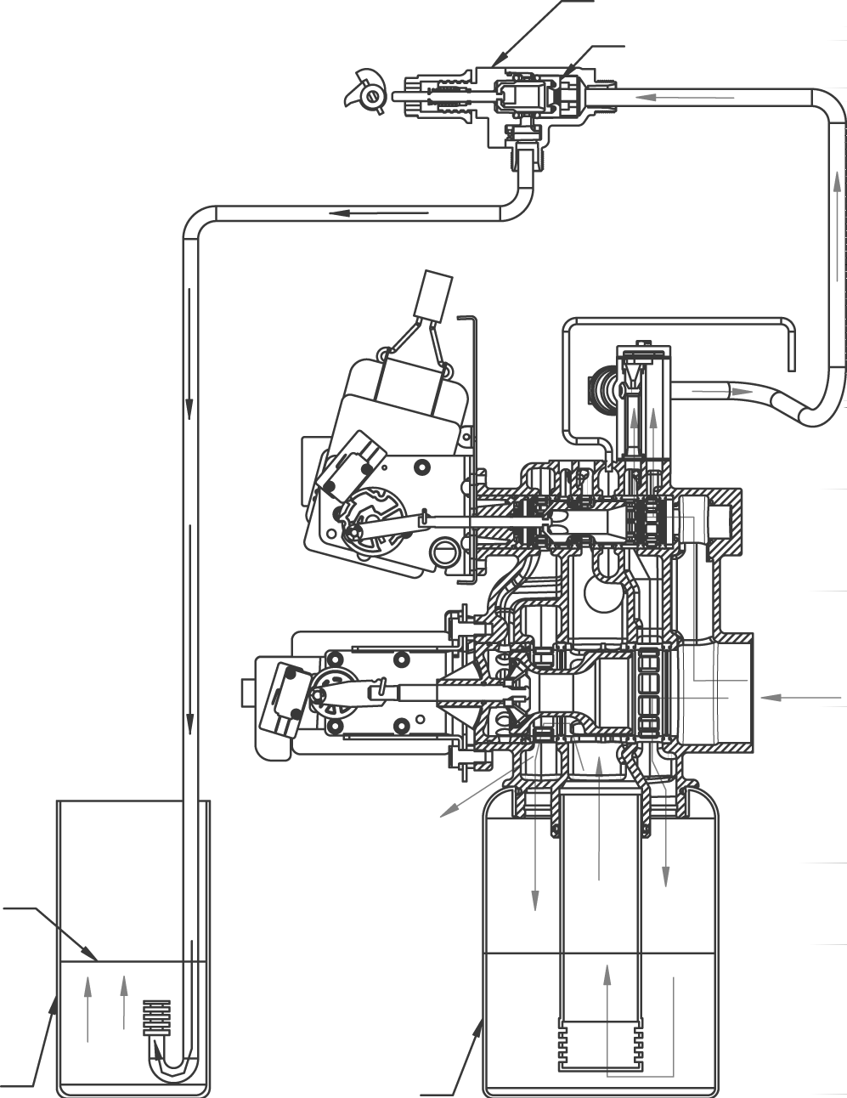

FLOW CONTROL

DRAIN

INLET

INLET

OUTLET

BRINE LEVEL

BRINE TANK

RESIN TANK

Hard water flows thru the service valve and down thru the mineral. Conditioned water enters the bottom distributor — flows up the center tube around the piston to the outlet. Hard water flows to the regenerating valve thru the injector housing and brine valve to fill the brine tank.

Page 43

Flow Data & Injector Draw Rates

30
2900 CPI Down Flow Valve
Backwash(BW), Service and Rapid Rinse(RR) Pressure Differential
Backwash, Service and Rapid Rinse
Pressure Differential

25

20
Pressure Differential - PSID

15

10

5

0
0 10 20 30 40 50 60 70 80 90 100 110 120 130 140 150
Flow Rate - GPM
BW Service RR

30
2900 CPI Treated Water Down Flow Valve
Backwash(BW), Service and Rapid Rinse(RR) Pressure Differential
2900 Treated Water Down Flow Valve Backwash, Service and Rapid Rinse Pressure Differential

25

20
Pressure Differential - PSID

15

10

5

0
0 20

40 60

80
Flow Rate - GPM

100

120

140

BW Service RR

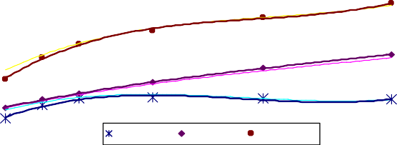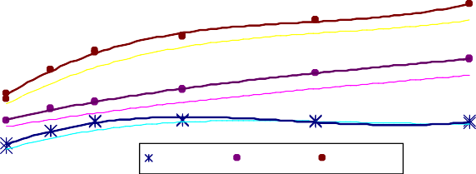Flow Data & Injector Draw Rates
5
4.5
4
3.5
3
2.5
2
1.5
1
0.5
0
1700 4C injector
2900 DRAW 2900 RINSE 2900 TOTAL
20 40 60 PSI 80 100 120
8
1700 5C injector
7
6
5
4
3
2
1 2900 DRAW 2900 RINSE 2900 TOTAL 0
20 40 60 PSI 80 100 120
3.5
3
2.5
2
1.5
1
0.5
0
DRAW
RINSE TOTAL
20 40
60 PSI 80
100
120
1700 3C injector
2.5

2
DRAW
RINSE TOTAL
1600 3 injector
1.5

1

0.5

0
20
40
60 PSI 80
100
120
GPM
GPM
GPM
GPM
GPM
GPM

8 |  |  | 1700 7C injector with 35gpm DLFC
7
6 |  | 10.00
5 |  | 8.00
4

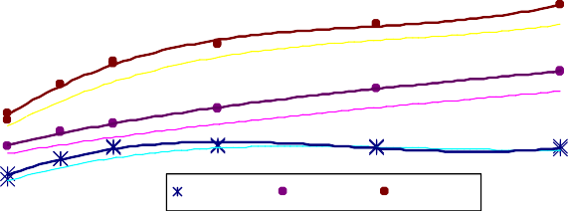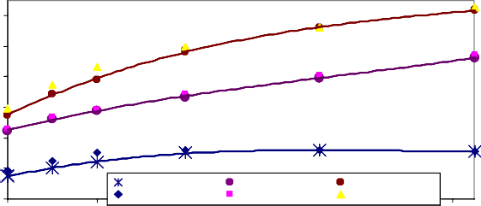TR203941 41606
1700 5C injector
3
2
1 2900 DRAW 2900 RINSE 2900 TOTAL 0
20 40 60 PSI 80 100 120
12.00
6.00

4.00

2.00
2900 DRAW 2900 RINSE 2900 TOTAL
0.00
no DLFC draw no DLFC rinse no DLFC total
20
40
60 PSI 80
100
120

Environmental Backplate Line Drawing

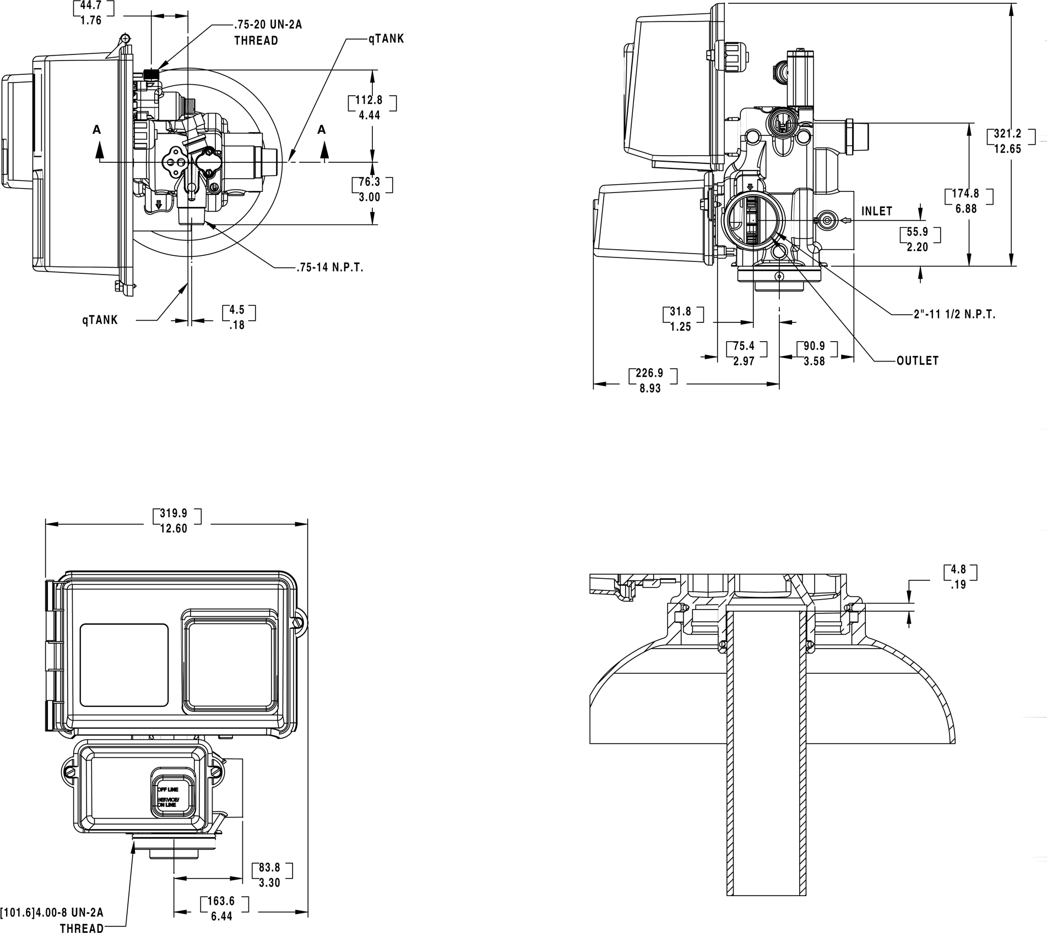

61500-2900LNE

Environmental Designer

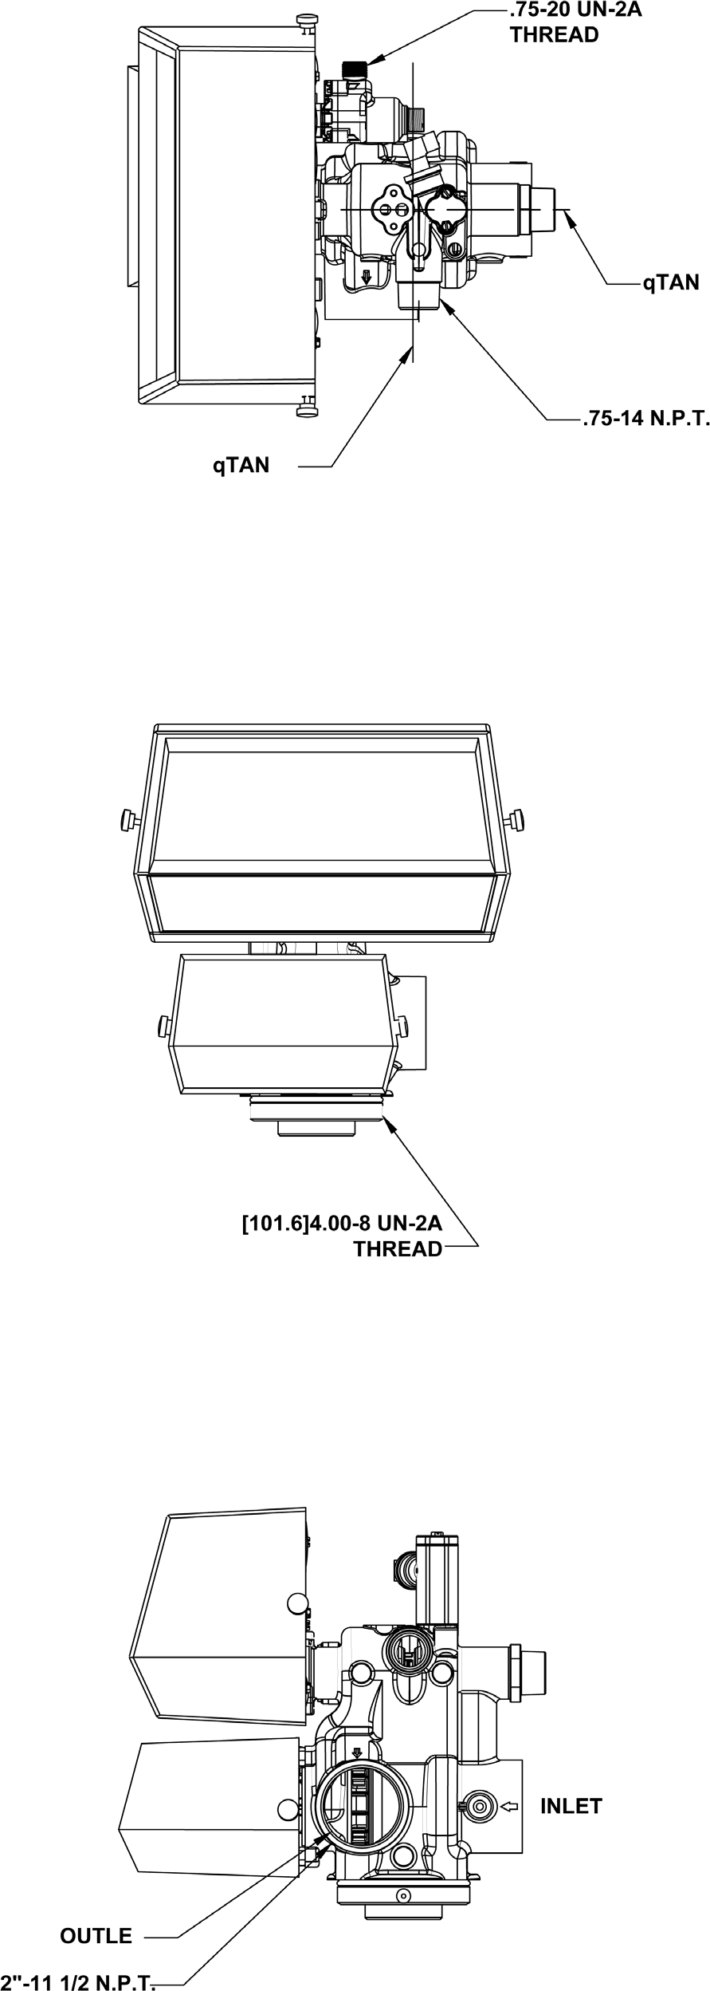

System #4 - Typical Single Tank Installation With Optional Meter

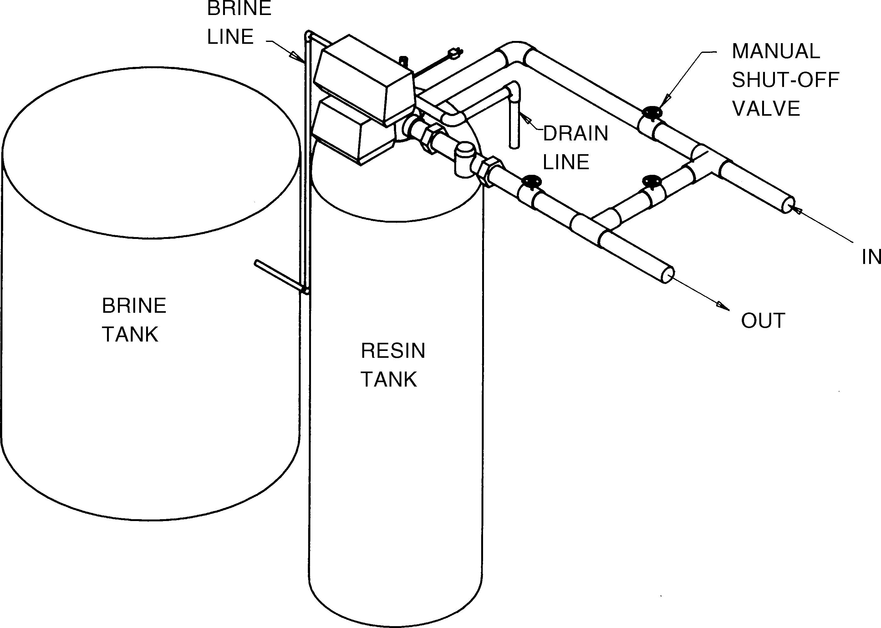

MODEL 2900

System #5 - Interlock - Typical Twin Tank Installation With Optional Meter Interlock And No Hard Water Bypass

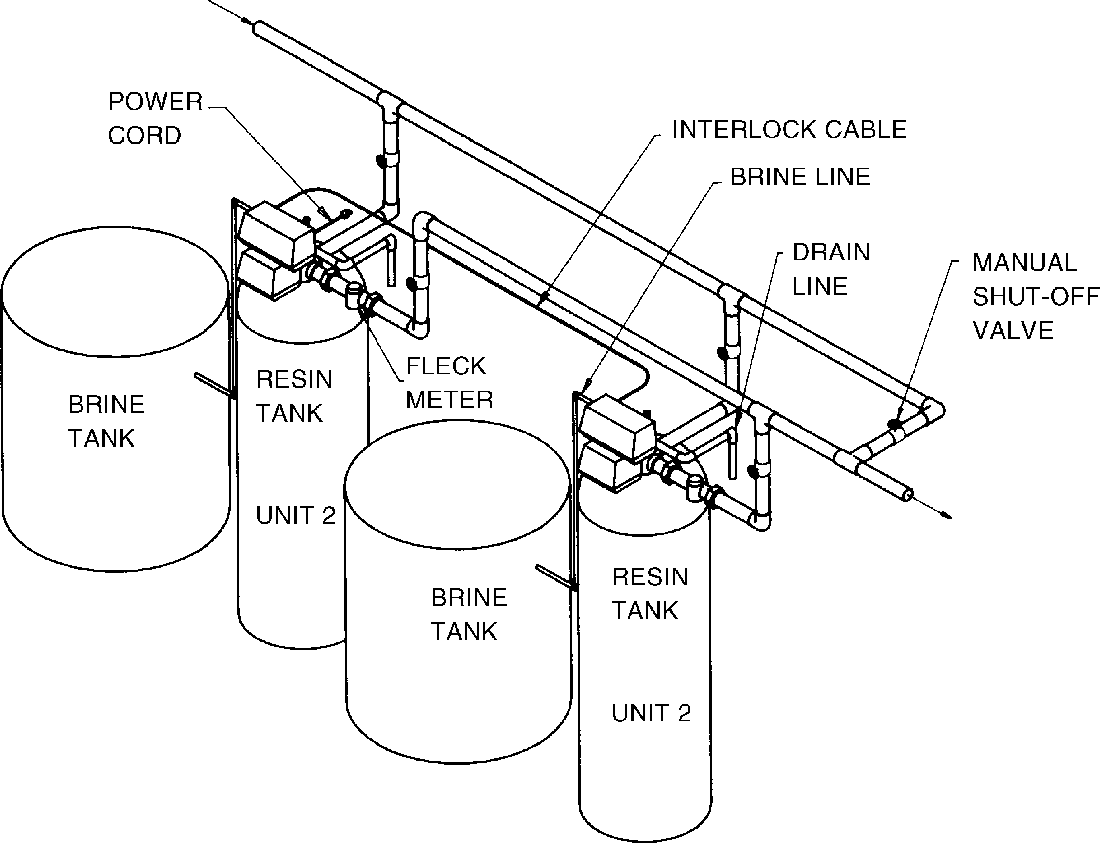

Page 49

Printed in U.S.A.

MODEL 2900

System #6 – Twin Series Regeneration System #7 – Twin Alternator Installation

POWER CORD
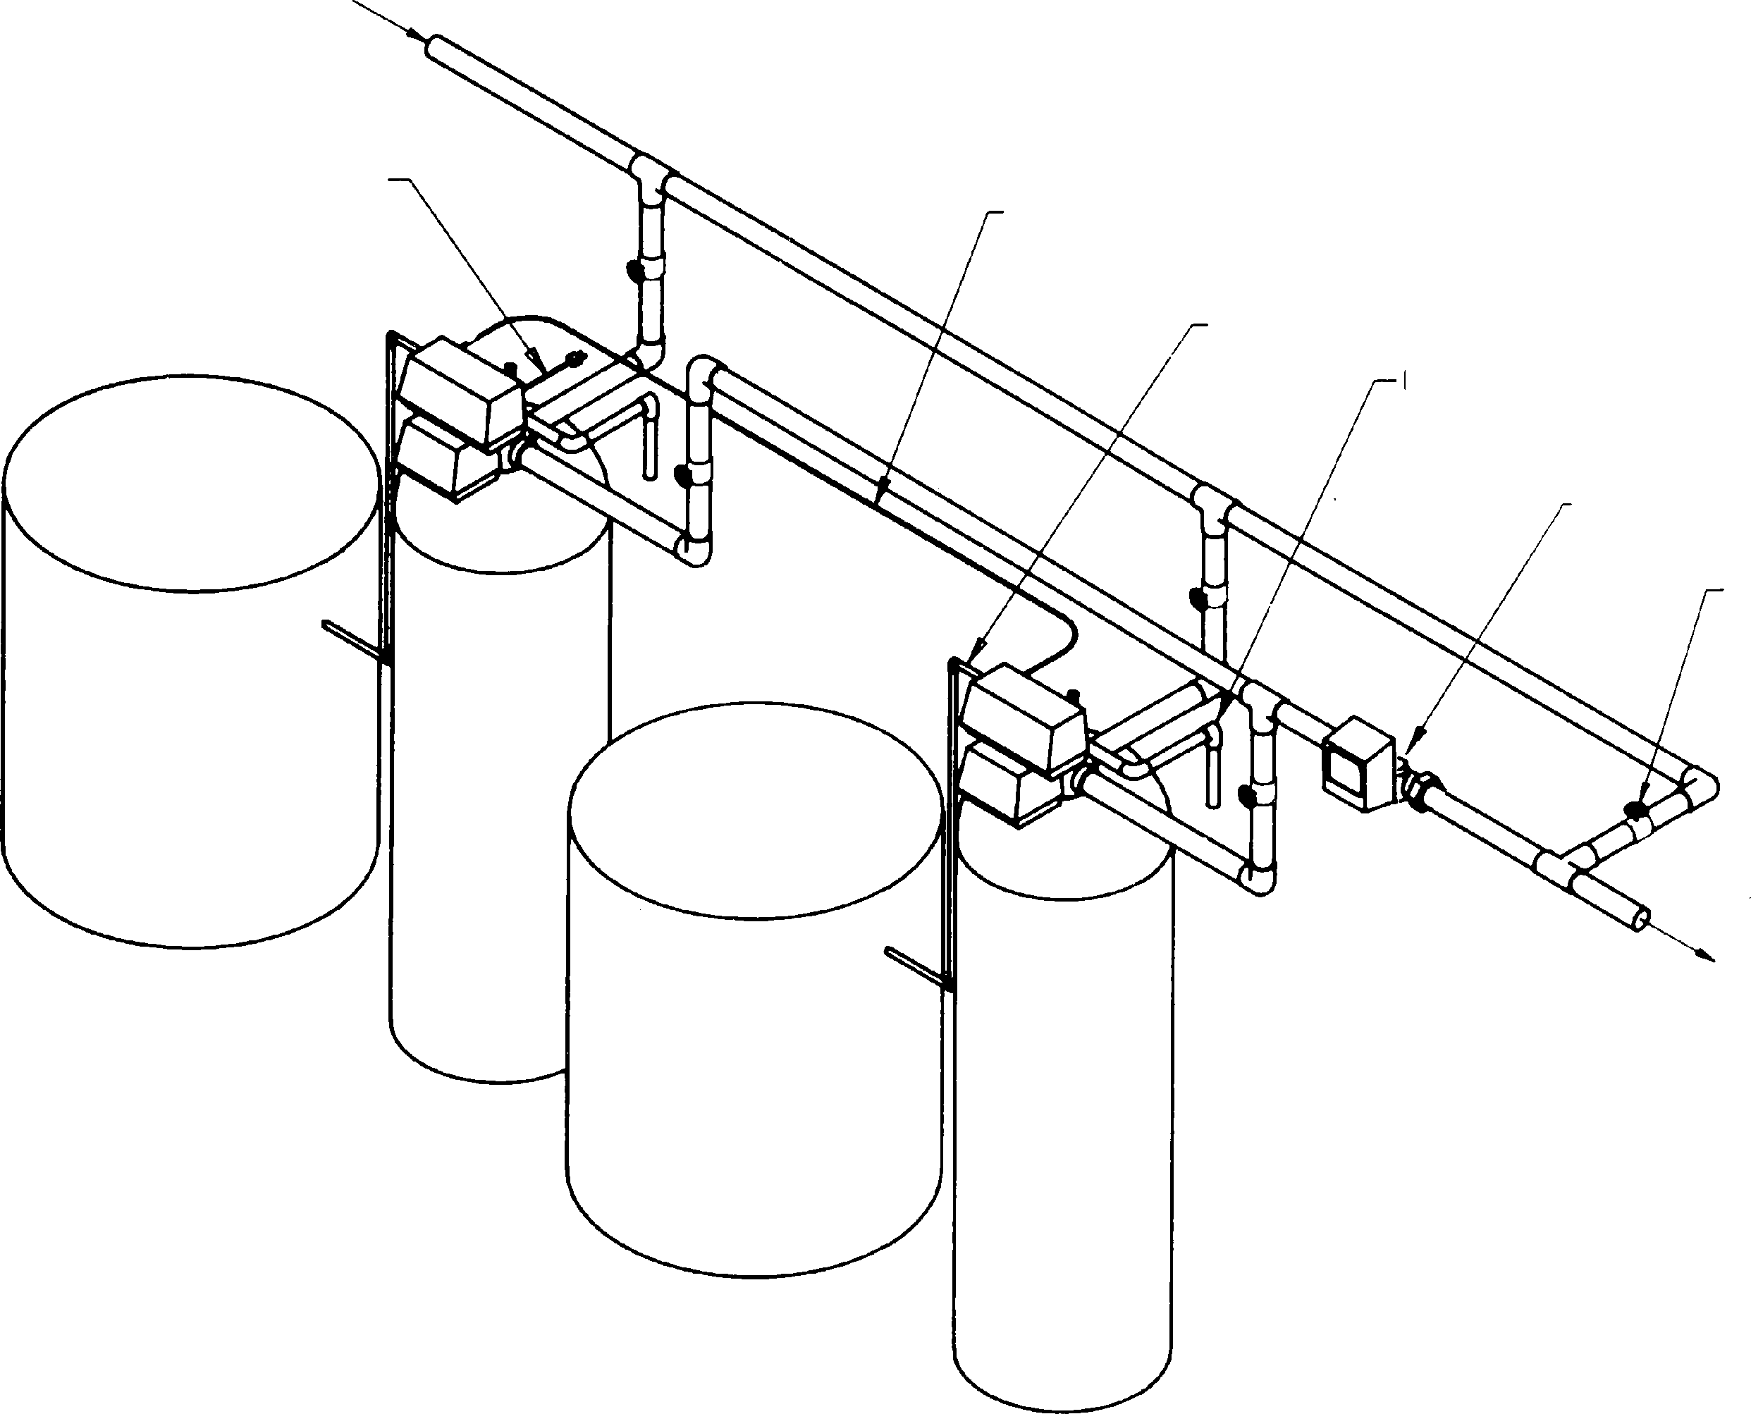

BRINE TANK

BRINE TANK

UNIT 1

INERLOCK CABLE

BRINE LINE

DRAIN LINE

REMOTE METER

MANUAL SHUTOFF VALVE

BRINE TANK
RESIN TANK

UNIT 2

Note: On System 7 power cord is on Unit 2. Note: System 7 only one Brine Tank.

System #4-Single Valve Regeneration Immediate and Delayed Valve Wiring

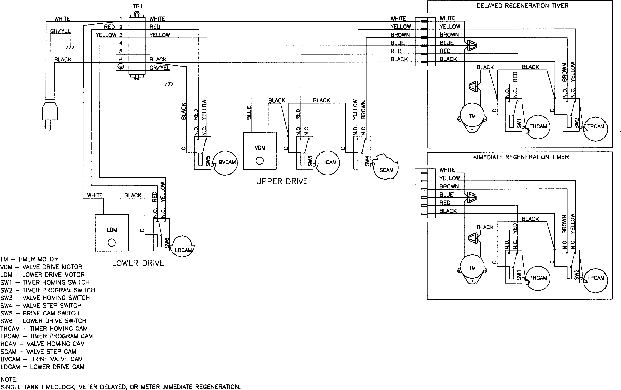

18684

System #4-With Remote Signal Start Valve Wiring

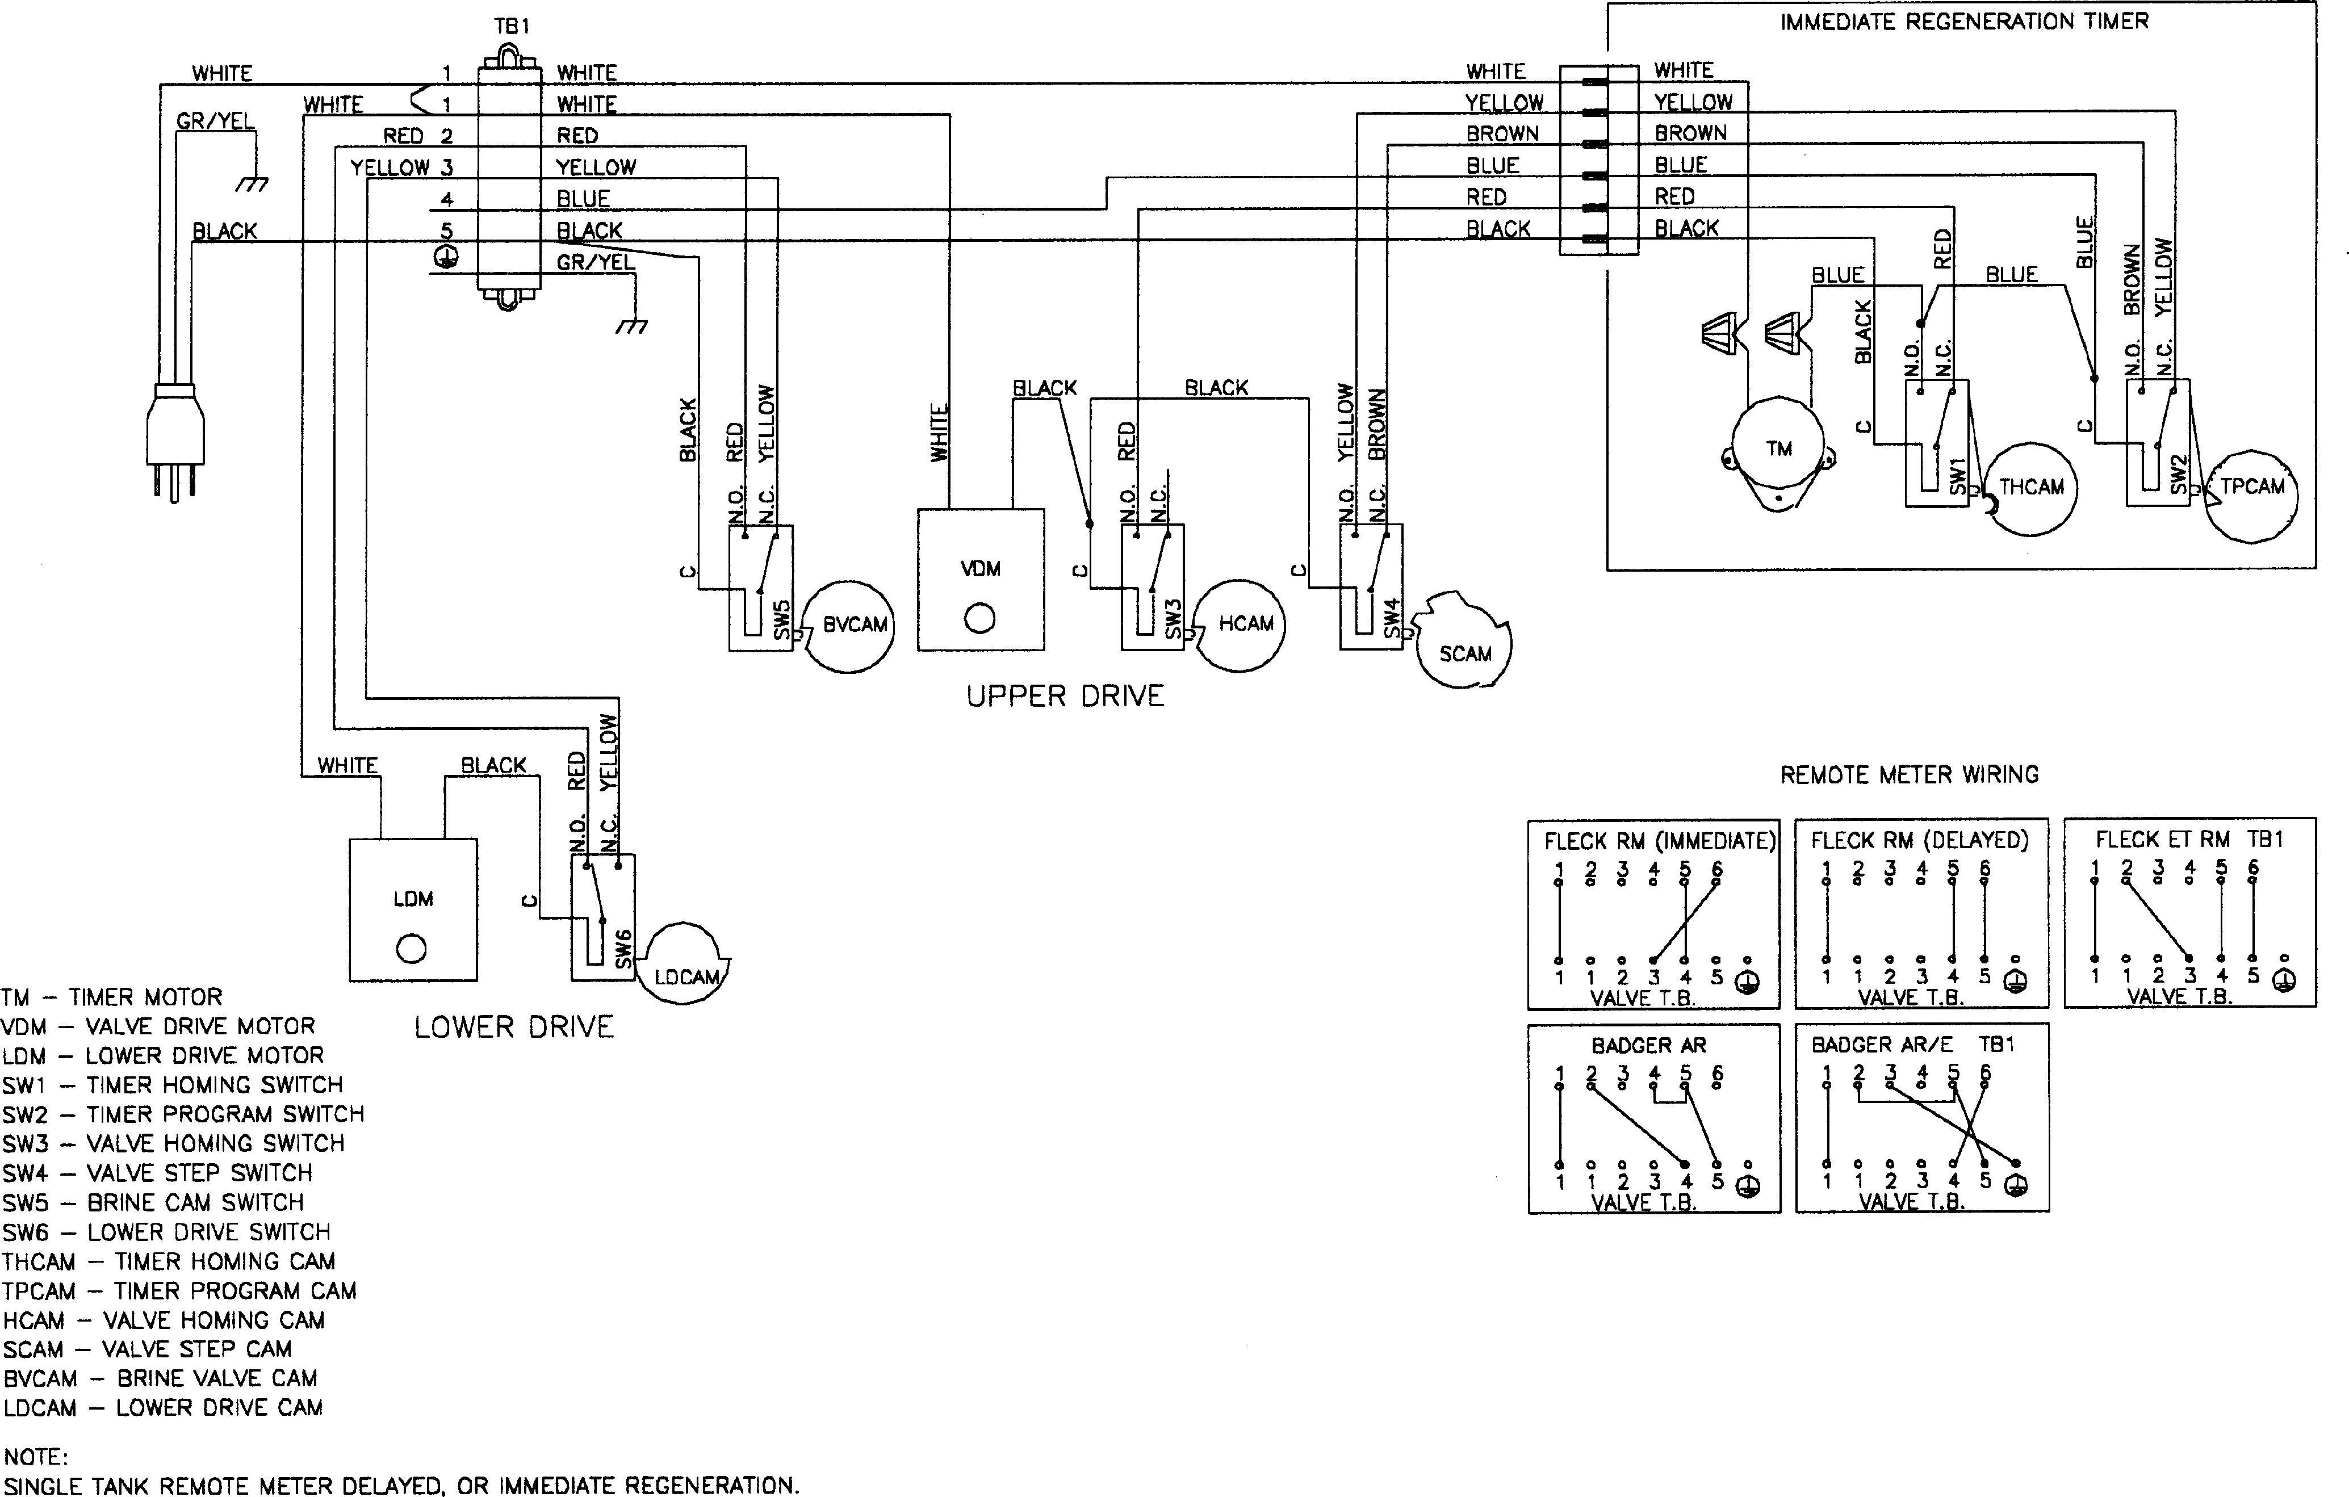

15405

System #5-Interlocked Regeneration Valve Wiring
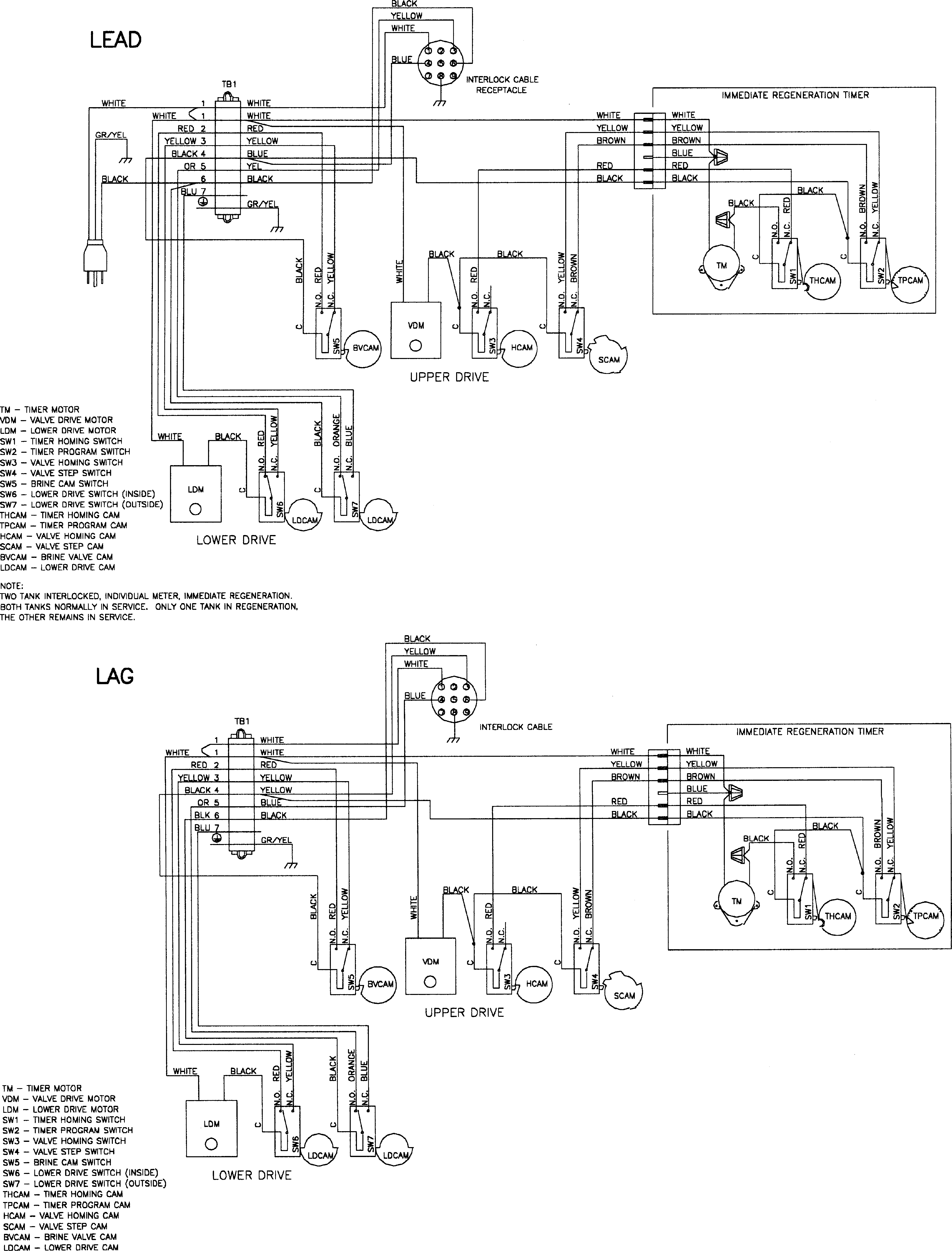

18685-01

18685-02

System #6-Series Regeneration Valve Wiring
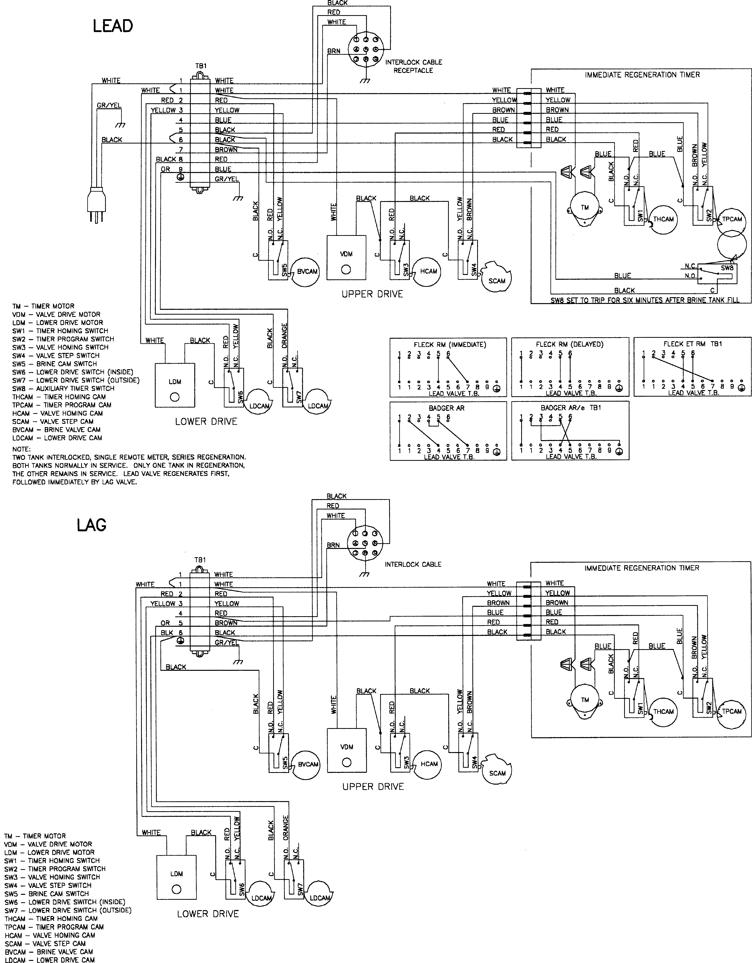

18686-01

18686-02

System #7-Alternating Regeneration Valve Wiring

18687-01
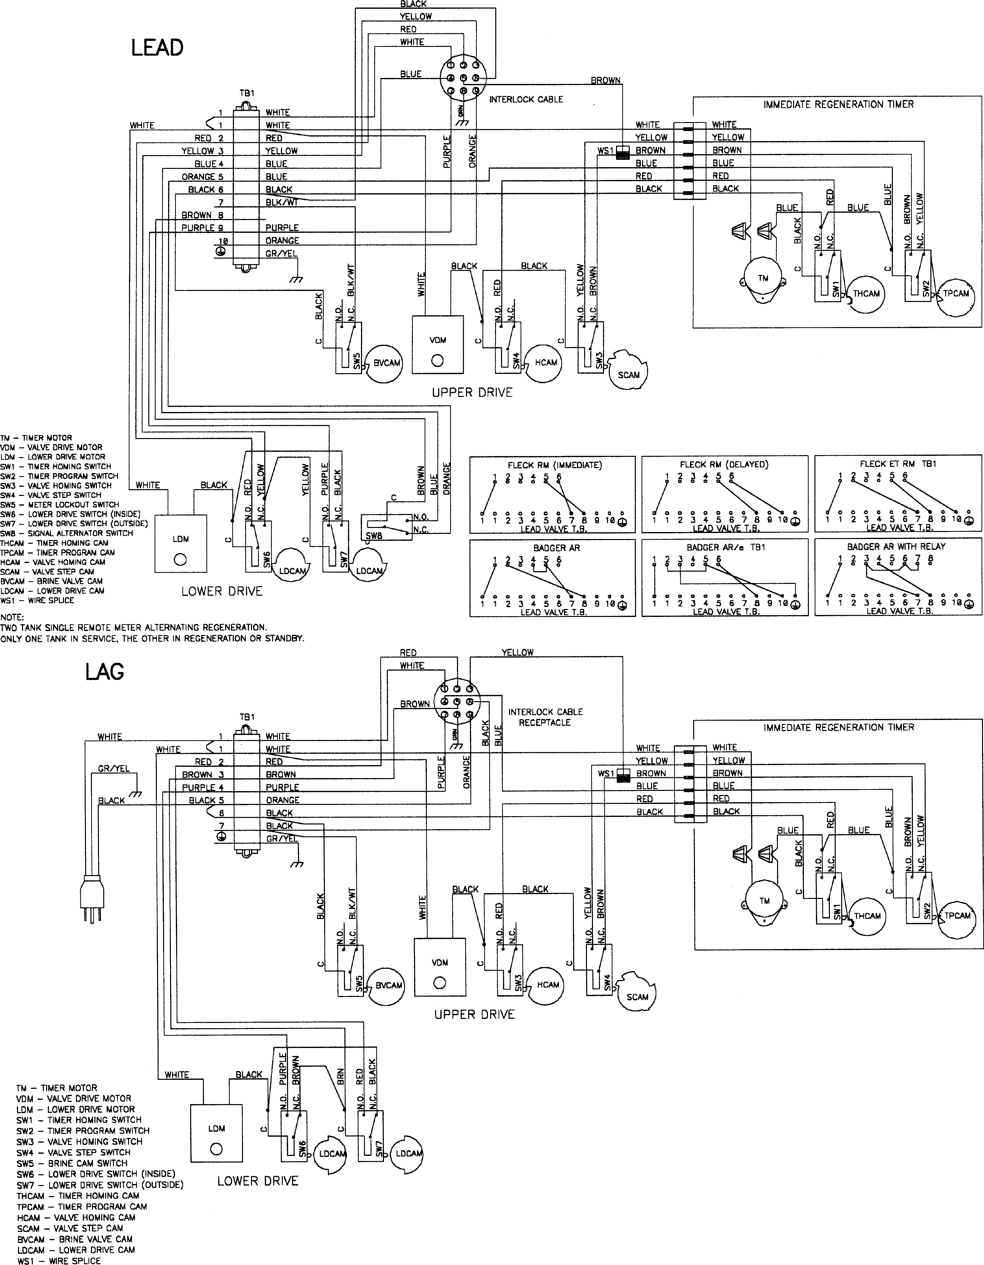

18687-02

System #7-Alternating Regeneration Multi-Valve System Valve Wiring
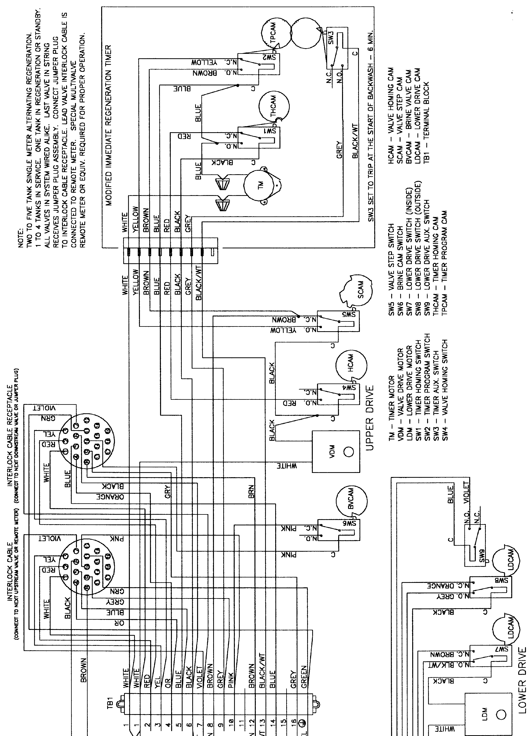

16172

Notes

P/N 15238 Rev. E 03/05

