GV Eye Setup
This document covers the adding of cameras into the GV Eye mobile app for GeoVision systems.

Please obtain a copy of GV Eye from the Google Play store or the Apple App store.

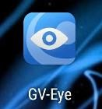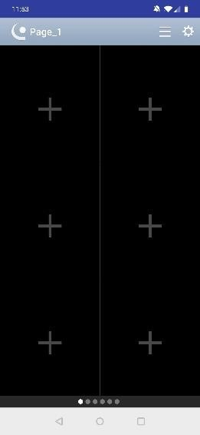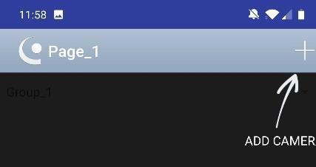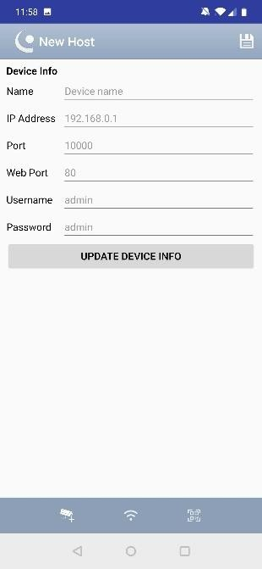

When the app
opens, tap

the
menu in the upper
right corner.

After

installing G
V
Eye,
tap the
icon to
launch the app.

Tap the
+ sign.

Fill in all fields
and tap
“
Update
Device Info.
”

