Remote Viewlog
- Installation
- Adding DVR
- Saving video
- Video Playback
Installation
Download the latest version of GV-Remote Viewlog here: http://www.geovision.com.tw/download/product/GV-DVR

Browse to the location where you downloaded the GV-Remote Viewlog zip file.
Right click on this folder icon and choose “Extract.” Then click “extract” on the bottom right of the popup window.
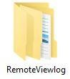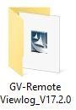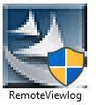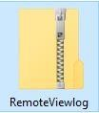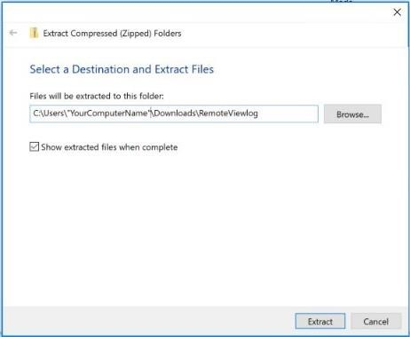

After the file has been extracted, open the unzipped folder
and you’ll find the GV-Remote_Viewlog folder, inside this
folder is the GV-Remote_ViewLog setup applicatio
n.

Extract button

Click “Yes” if prompted with allowing Remote Viewlog to make changes to the system.
Follow the on-screen prompts to complete the installation process.

Once installation has been completed, click on the Windows logo in the bottom left corner. Then scroll down to “Remote Viewlog” and click to launch the program.
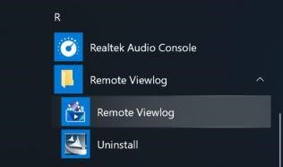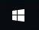

When “Remote Viewlog Account” has opened, you will be prompted with adding a local account to the current system. Click “Ok” when completed.
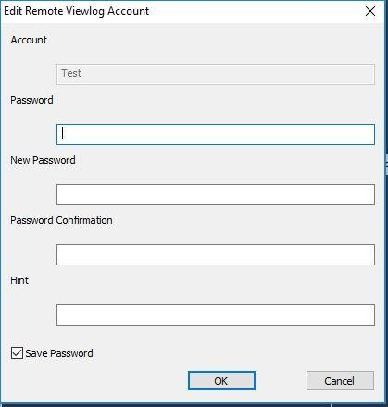

Complete each field

Adding a DVR
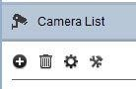

Click on the “Plus”
button under
“Camera List.”

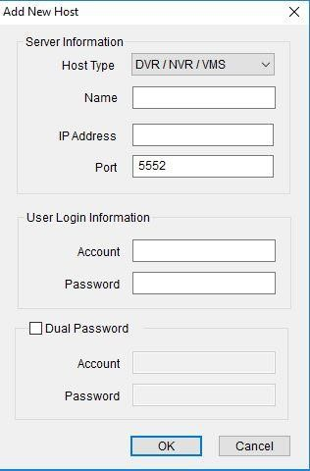
  - For the “Host Type” make sure “DVR/NVR/VMS” has been selected.
  - Assign a Name.
  - Enter the Public IP address and Port of the DVR system. To find your public IP address simply type “ipchicken.com” into any web browser when you are at the wash, and connected to the internal wifi.
  - Enter Login information for the system.
  - Click “Ok”

After the DVR system has been added, click the “+” sign beside the DVR name in the left pane in order to expand the list of cameras.

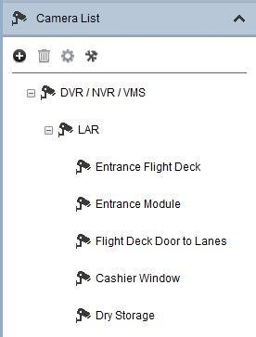
“+” Sign becomes a
minus sign “
-
“ when
list is expanded.

To view a camera, left click and drag it from the left pane into an available slot on the
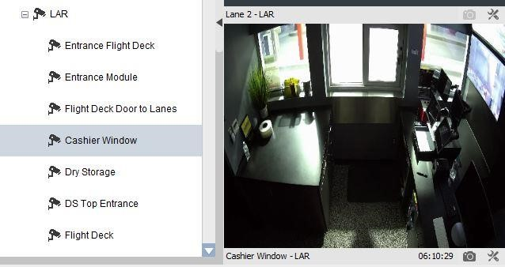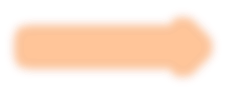
right.

Name of camera
being viewed

Selected time from
the time viewing

Video
options

Take a snapshot

The red indicates activity during the displayed time.
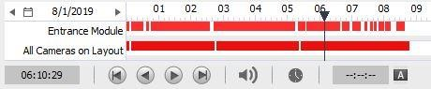

Current time
selected on the
activity bar

Control panel

Saving Video
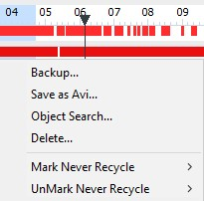
Right-click and hold inside the activity bar. Then drag the mouse to the desired time frame.

Select “Backup” or “Save as AVI.”
- Backup – Allows you to select up to 4 cameras at a time to backup.
- Save as AVI – Allows you to save the current camera feed as an AVI file.

Note: Save times can vary greatly depending on long the recorded time frame is. It may appear as your PC may not be functioning or running slow during this time. Please allow the backup to complete. Or choose shorter time frames.

Camera Selection for Backup |  | Storage location
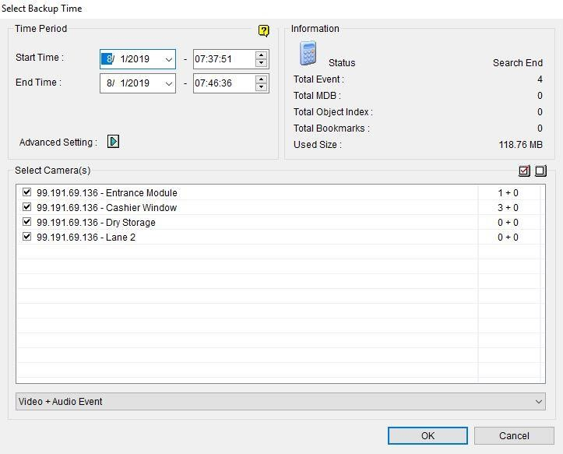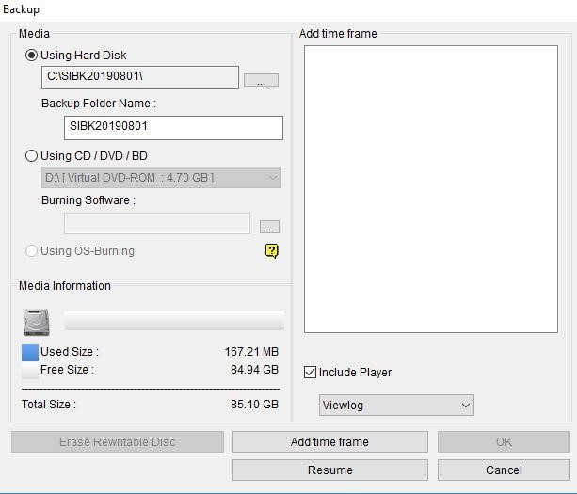

It is advised to save the media to the hard disk, then transfer to a removable source.

Video Playback
Browse to the location where the backup is stored. Double-click the “CodecEXE” file. This will allow for video playback on the current system. (Nothing will appear on the screen)
Scroll down and find “GVSinglePlayer.exe” and double-click.
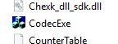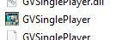

When GVSinglePlayer launches you will see a blue screen. This indicates the program is ready for a video file to be loaded.

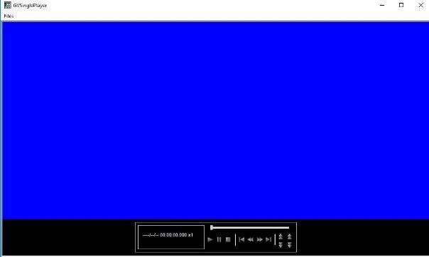
Loading a video file
- Click Files
- Open Folder
- Click on associated camera folder
- Click “Ok” and video begins to play

