<August 5, 2019>
Network Cable – RJ45 Troubleshooting

This document will describe various methods for detecting a defective network cable.

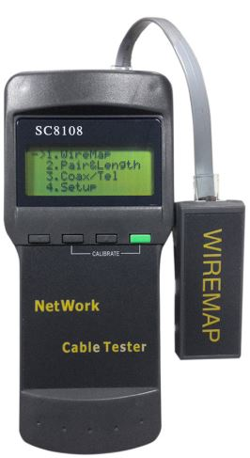
- Connect 4-pair cable tester to the ends of the cable. Follow the directions of the tester to determine if the cable is good or bad. If you test the cable and do not get good continuity than examine the connectors or patch panel port on each end. Replace or re-terminate them as necessary. If it tests good then try the continuity again but this time with and through the patch cords on each end.
Network/RJ45 Cable with Ends
Cable tester
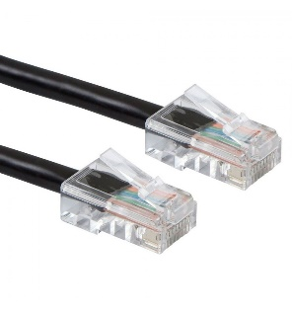

- If an extra cable is available, connect it in place of the current cable. This will assist in isolating the issue to the cable only.
- Another indicator of no signal would be watching the activity lights on the back of a router/switch and the other device the cable is connected to.
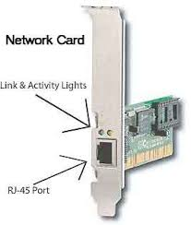
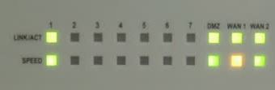
Activity lights

Note: Activity light layout will vary with router/switch installed on the network.

