
How to fix Gift Card Gray camera on Tommy POS app
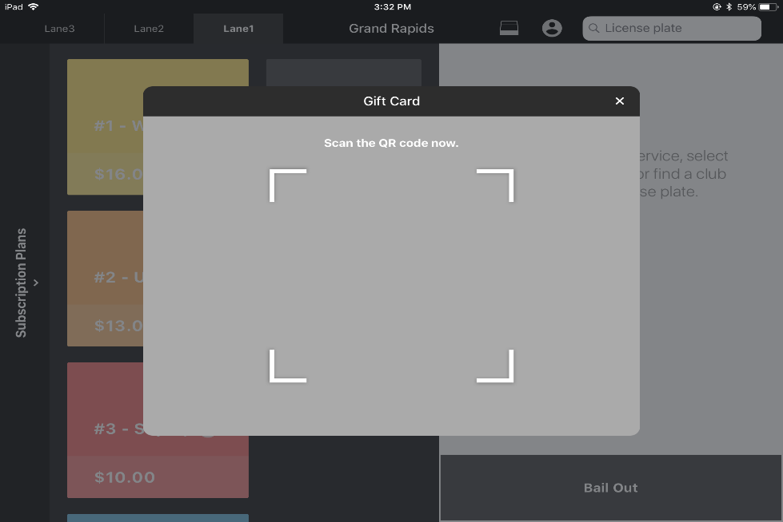
e.g.

1. To fix this issue go to iPad settings on the Tommy POS iPad.
2. Scroll down to the bottom until you see “Point of sales” then select it.
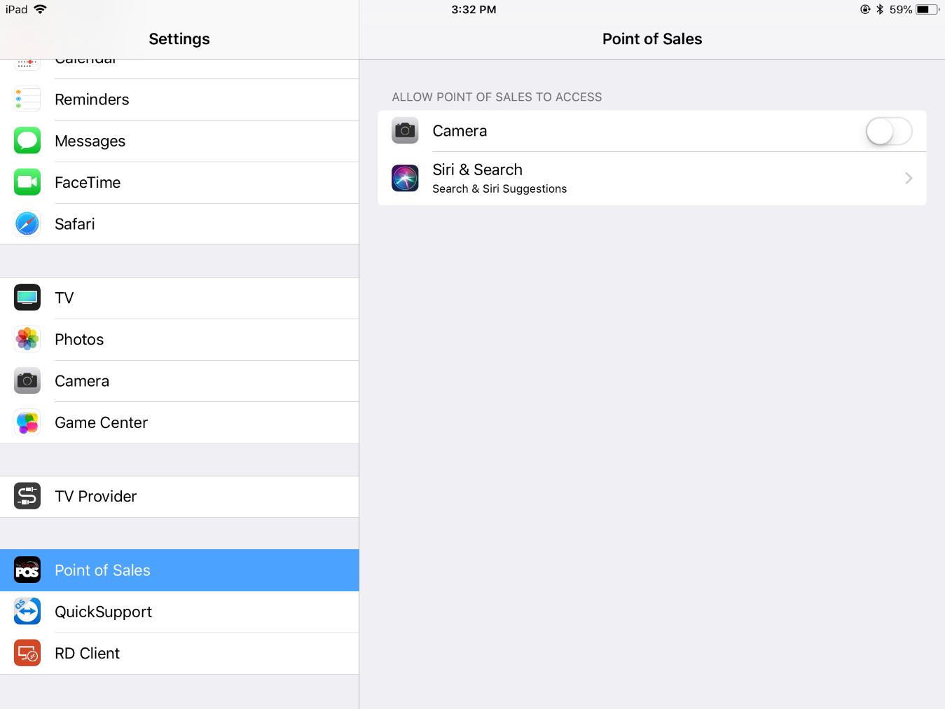
3. Click the button next to “Camera”, This will allow the Tommy POS app to have permission to use the camera.

3.
2.

