Desiccant and Sealing Tips for GeoVision Cameras

I. Introduction
A. Purpose of the document
B. Importance of maintaining low moisture levels in extreme environments for GeoVision cameras

II. The Importance of Low Moisture Levels in Extreme Environments
A. Effects of high moisture levels on camera components
B. Importance of maintaining low moisture levels for optimal performance and extended lifespan

III. Recommendations for Desiccants for GeoVision Cameras
A. Use of desiccant packs to reduce moisture levels
B. Recommended blend of 8:1 3A molecular sieve and indicating silica
C. Formula for creating desiccant packs
D. Adjusting the ratio based on specific environmental conditions

IV. Material Type for Desiccant Packs
A. Recommended moisture-resistant materials
B. Benefits of using high-quality materials

V. Additional Recommendations
A. Sealing the camera/camera mount to its mounting location
B. Sealing the dome to the camera body
C. Other material types to consider
D. Waterproof Rubber Set Recommendations

VI. Conclusion
A. Importance of following recommendations for maintaining low moisture levels
B. Summary of key points

Introduction

- Purpose of the document:

The purpose of this document is to provide recommendations for maintaining low moisture levels in extreme environments for GeoVision cameras. High moisture levels can lead to damage and corrosion on the camera's components, which can ultimately compromise its functionality and lifespan. This document will offer guidance on using desiccants to reduce moisture levels, recommended material types for desiccant packs, and additional measures to ensure optimal performance and longevity of GeoVision cameras in extreme conditions.

- Importance of maintaining low moisture levels in extreme environments for GeoVision cameras:

Maintaining low moisture levels in extreme environments is critical to ensuring optimal performance and extended lifespan of GeoVision cameras. High moisture levels can lead to condensation and corrosion on the camera's components, which can result in malfunctioning cameras and a shorter lifespan. By keeping moisture levels low, users can avoid these issues and enjoy longer-lasting, better-performing cameras.

Note: We recommend obtaining replacement desiccant packets from GeoVision or the vendor directly. They have been formulated for the cameras specifically. (This May Require a Bulk Purchase and vary per model type)

The Importance of Low Moisture Levels in Extreme Environments

- Effects of high moisture levels on camera components:

High moisture levels can lead to condensation and corrosion on the camera's components, which can ultimately result in malfunctioning cameras and a shorter lifespan. These effects can be particularly pronounced in extreme environments with high levels of moisture and humidity.

- Importance of maintaining low moisture levels in extreme environments for GeoVision cameras:

Maintaining low moisture levels in extreme environments is critical to ensuring optimal performance and extended lifespan of GeoVision cameras. High moisture levels can lead to condensation and corrosion on the camera's components, which can result in malfunctioning cameras and a shorter lifespan. By keeping moisture levels low, users can avoid these issues and enjoy longer-lasting, better-performing cameras.
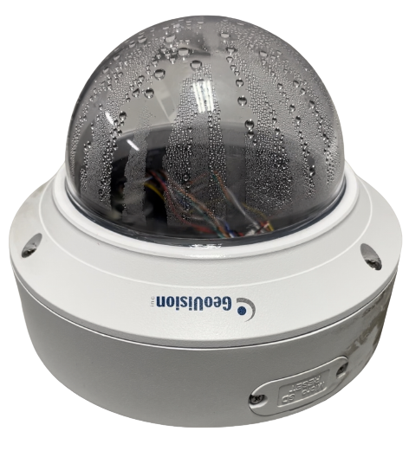

Recommendations for Desiccants for GeoVision Cameras

- Use of desiccant packs to reduce moisture levels:

Desiccant packs are an effective way to reduce moisture levels in extreme environments. By absorbing moisture from the air, desiccant packs can prevent condensation and corrosion on the camera's components, ultimately resulting in better performance and a longer lifespan.

- Recommended blend of 8:1 3A molecular sieve and indicating silica:

To effectively reduce moisture levels in extreme environments, we recommend using desiccant packs containing a blend of 8:1 3A molecular sieve and indicating silica. This blend has been proven to be highly effective in reducing moisture levels in a wide range of environments.
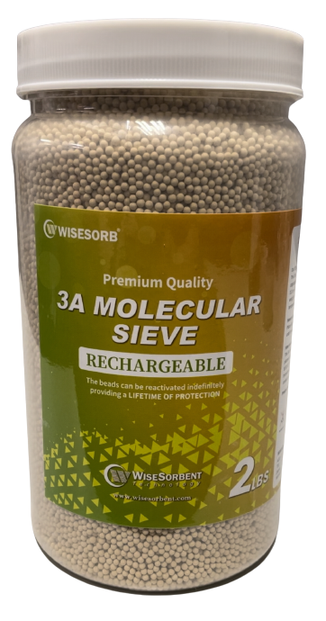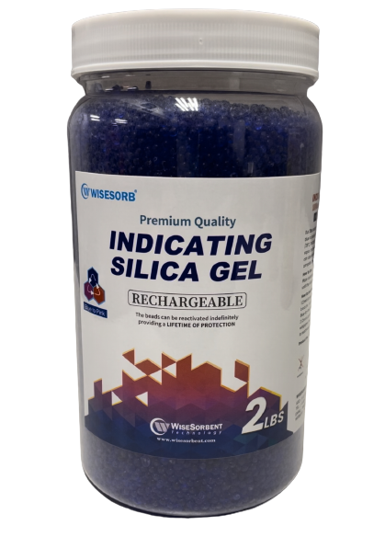

- Formula for creating desiccant packs:

To create desiccant packs containing the recommended blend of 8:1 3A molecular sieve and indicating silica, follow the formula provided in the document. This formula has been optimized for extreme environments but can be adjusted as necessary based on the specific conditions of the environment.

- Mix 8 parts of 3A Molecular Sieve with 1 part of Indicating Silica Gel.
- Example: For a ratio of 8:1 (3A Molecular Sieve to Indicating Silica Gel), use 4 level scoops of 3A Molecular Sieve and 1/2 scoop of Indicating Silica Gel per tea bag.

- After mixing the components in a cup or package, seal the bag and place it inside the camera. In this example I used a tea bag for 8:1. The bag is (3.45 x 2.75 inch).
- To secure the bag, you can use a "Medium Duty Double-Sided Foam Tape".

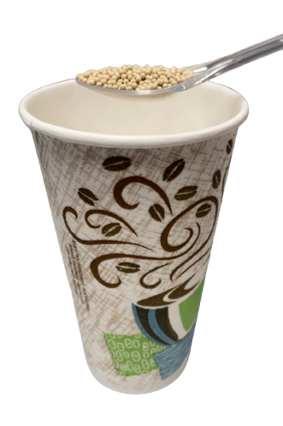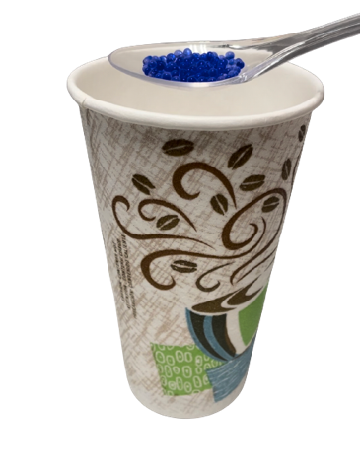

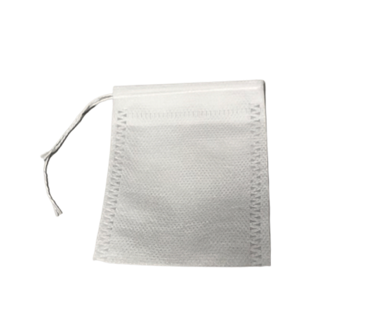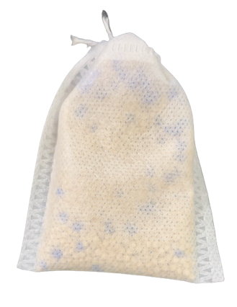

- Adjusting the ratio based on specific environmental conditions:

The recommended blend of 8:1 3A molecular sieve and indicating silica has been optimized for extreme environments, but it may need to be adjusted based on specific environmental conditions. Factors that may influence the necessary ratio of molecular sieve to indicating silica include temperature, humidity, and the volume of air being absorbed by the desiccant pack. To determine the optimal ratio for a specific environment, it may be necessary to conduct testing and monitoring of moisture levels over time.

Note: The 8:1 formula is recommended for extreme environments. If the moisture level in your location is low, you can adjust the ratio to 6:1 or 4:1. It's recommended to gradually reduce the ratio and monitor the moisture level. Conversely, if the moisture level is high, you may need to increase the ratio to 10:1 or 12:1 to effectively absorb excess moisture. Again, it's recommended to gradually adjust the ratio and monitor the moisture level until you find the optimal ratio for your environment. The 3A Molecular Sieve is responsible for absorbing moisture, while the Indicating Silica Gel beads change color to indicate when the 3A has reached its maximum absorption capacity. Once the Indicating Silica Gel beads change color, it's time to replace the desiccant to ensure optimal moisture control.

Material Type for Desiccant Packs

- Recommended moisture-resistant materials:

To contain the 3A molecular sieve and indicating silica, we recommend using a high-quality, moisture-resistant material, such as Tyvek or Mylar. These materials are durable and can withstand extreme conditions without breaking down or degrading over time. Tyvek and nylon are both highly resistant to moisture and can provide an effective barrier against moisture entering the desiccant pack.

(Example: I used a disposable tea bag)

Tyvek | Mylar
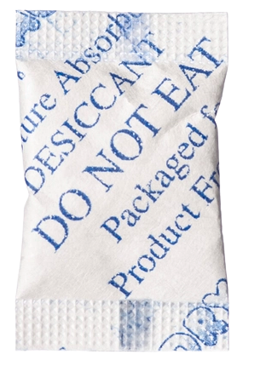 | 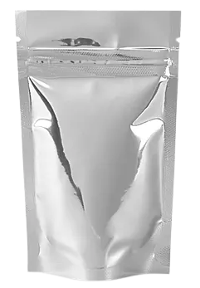

- Benefits of using high-quality materials:

Using high-quality materials for desiccant packs can offer several benefits, including increased durability and longevity. High-quality materials are less likely to break down or degrade over time, ensuring that the desiccant pack remains effective for longer. Additionally, high-quality materials can provide a better barrier against moisture, reducing the risk of moisture entering the desiccant pack and compromising its effectiveness.

Additional Recommendations

- Sealing the camera/camera mount to its mounting location:

To further reduce the risk of moisture entering the camera or camera mount, it may be beneficial to seal the camera or camera mount to its mounting location. This can be achieved using a sealant, such as silicone or rubber, around the perimeter of the camera or camera mount between the wall and mount or camera and wall.

Example: Seal mount/camera to the wall using outdoor all weather rated silicone that has a temperature range for you location, keep in mind all seasons.

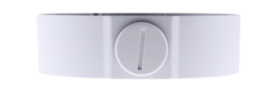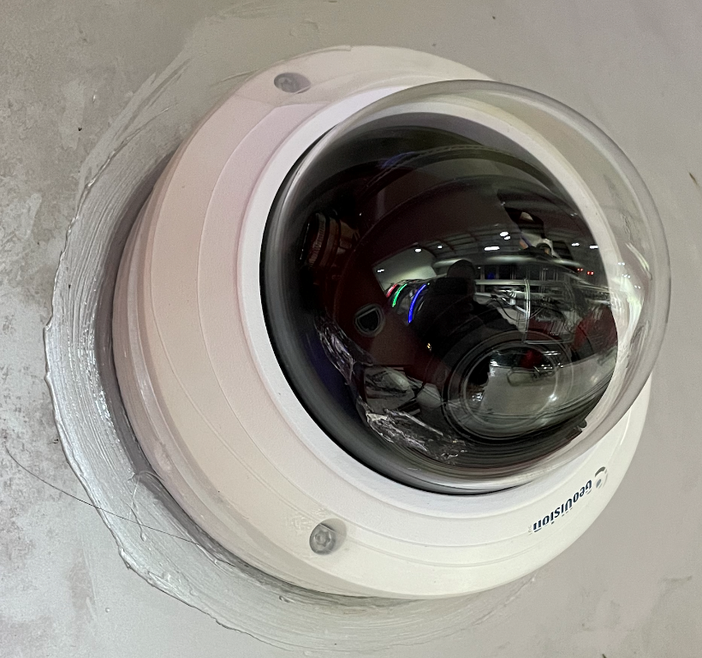

- Sealing the dome to the camera body:

In addition to sealing the camera or camera mount to its mounting location, it may also be beneficial to seal the dome to the camera body. This can be achieved using a sealant, such as silicone/Silicone Tape or rubber, around the perimeter of the dome. By sealing the dome to the camera body, users can further reduce the risk of moisture entering the camera and compromising its performance.

RTV Silicone Sealant – Easy to apply and can add additional protection between the dome lens and lid.
Picture Example: Apply RTV sealant around the dome to create a tight seal between the dome lens and lid. To achieve a clean seal, wrap tape around the lens and lid before applying, then remove the tape and allow the sealant to dry according to the manufacturer's instructions.
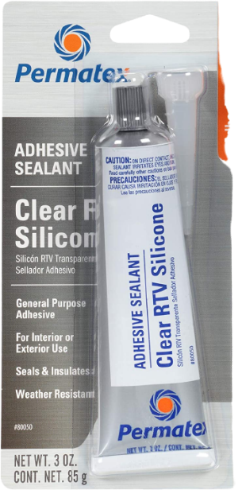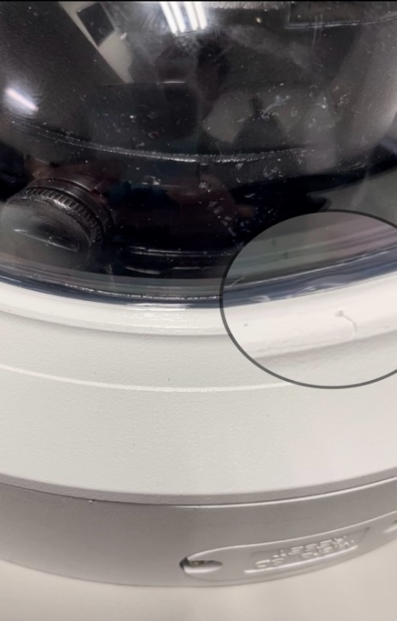

- Silicone Tape – Easy to use, it can stretch twice its length or more and is a dry material that will adhere to itself.
Silicone Tape Example: Surrounds the dome in this picture, covering the screws and the seal between the body and dome to ensure a secure fit.
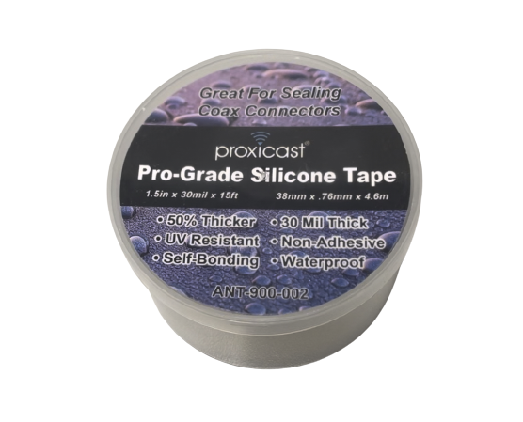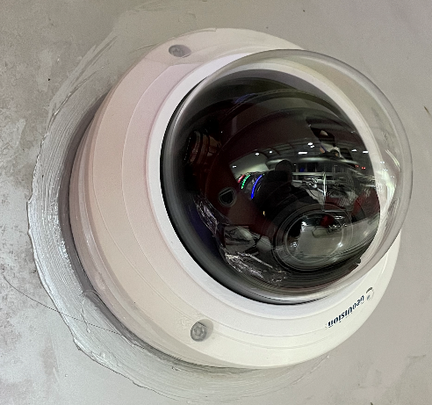

- Indicating Moisture Strips: Can be placed inside the camera dome outside of the view of the lens as an indicator that the moisture has reached 20% inside the body and the desiccant needs to be replaced.
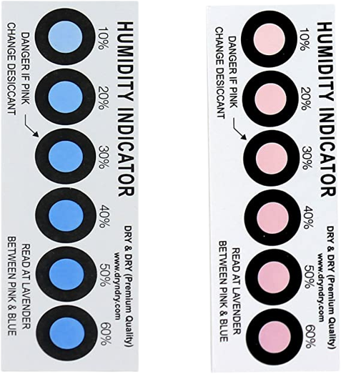

- Other material types to consider:

In addition to Tyvek and nylon, other materials may also be suitable for containing desiccant packs. For example, some users may prefer to use foil pouches or other types of moisture-resistant packaging. When selecting a material for a desiccant pack, it is important to consider factors such as durability, resistance to moisture, and ease of use.

- Polyethylene (PE): Polyethylene is a popular plastic material that is lightweight, flexible, and resistant to moisture, chemicals, and impact. It is commonly used for desiccant packaging due to its low cost and ease of manufacturing.
- Polypropylene (PP): Polypropylene is another plastic material with good moisture resistance, chemical resistance, and strength. It is often used for desiccant containers or canisters, and it can be injection-molded or blow-molded into various shapes.
- Polycarbonate (PC): Polycarbonate is a strong, durable plastic material that is resistant to impacts, high temperatures, and moisture. It is often used for housing desiccant in harsh environments or where visibility of the desiccant is required, as it can be made transparent.
- Acrylonitrile Butadiene Styrene (ABS): ABS is a tough, impact-resistant plastic material that is commonly used for housing desiccant in various applications. It has good moisture resistance and can be easily molded into various shapes and sizes.

- Waterproof Rubber Set Recommendations
- Add desiccant beads inside the waterproof bolt prior to sealing. This will help protect the RJ4 connections from moisture.

Steps
- Feed the cable through the end cap on the side where the rubber insert sits.
- Apply the spliced rubber seal over the ethernet cable above the cap.
- Apply the waterproof bolt body after the rubber insert.
- Connect the Ethernet cable to the female Ethernet port of the camera.
- Slide the waterproof set toward the camera and insert the rubber insert into the waterproof bolt body close to the camera.
- Now with the insert plugging one end of the waterproof bolt you can now place 6-20 desiccant beads inside the waterproof bolt body. (Careful not to spill in step “7”.
- Now mate the female Ethernet cap on the camera to the waterproof bolt body. “Careful when sliding the connector up the cable, the rubber insert may try to pop out. You can help it along the cable to ensure that it stays in.”
- Now screw on the end cap on the rubber insert side.
Note: (Careful to not over tighten, this includes the side with the O-ring on the female Ethernet end on the camera, it seals are over tightened it will cause issues. Adjust as needed, should look like the picture below when complete.)

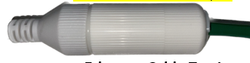

- For the sealing step, I recommend using silicon sealing tape or rubber sealing tape that is resistant to UV rays, heat, and cold, suitable for your local climate.
Begin by wrapping the tape around the Ethernet cable, covering the entire connection. Start approximately 1.5 to 2 inches before the female connector of the camera, wrap tightly around the cable, and continue over the waterproof rubber set/bolt. Finally, extend the wrapping over the Ethernet cable that leads back to the switch, again by about 1.5 to 2 inches. (Ensure no gaps between the wraps, also be sure to overlap a little to ensure a seal)
VI. Conclusion:

A. Importance of following recommendations for maintaining low moisture levels:
Maintaining low moisture levels in extreme environments is critical to ensuring optimal performance and extended lifespan of GeoVision cameras. By following the recommendations outlined in this document, users can reduce the risk of condensation and corrosion on the camera's components, ensuring better performance and a longer lifespan for their cameras.

B. Summary of key points:
To summarize, this document has provided recommendations for maintaining low moisture levels in extreme environments for GeoVision cameras. These recommendations include using desiccant packs containing a blend of 8:1 3A molecular sieve and indicating silica, using moisture-resistant materials for the desiccant packs, and additional measures such as sealing the camera or camera mount to its mounting location and sealing the dome to the camera body. By following these recommendations, users can ensure optimal performance and extended lifespan for their GeoVision cameras in even the most extreme conditions.

